Following on from yesterday’s lesson, you were asked (on the last slide of the power point) to research about an animal. The children within school did not even start this part of the lesson so therefore they are covering it today. (I’m guessing it is the same for those that are studying from home.)
A reminder:
Next lesson (NOT TODAY), you are going to be writing a diary entry from your chosen animal’s perspective. This will form an assessed piece!
Audience: Year 5/6 children + your teacher
Purpose: to inform – about plastic pollution. To persuade – encouraging others to use less plastic.
TODAY
Firstly, you need to learn about your chosen animal:
- Habitat
- Diet
- Physical Characteristics
- How plastic pollution could impact this animal?
We thought it would be nice to present this piece of research with an illustration. For example:
- Choose your animal, draw it and complete.
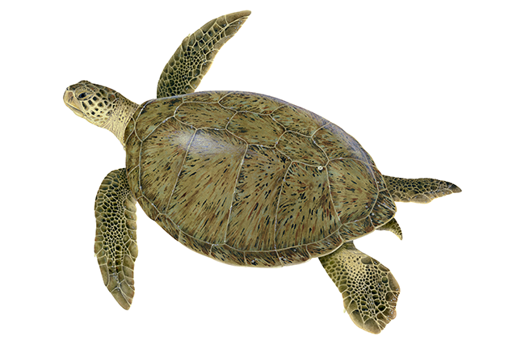
Outside of the Green Sea Turtle:
How plastic pollution could have an impact upon this animal.

Inside the Green Sea Turtle:
Facts all about the animal, including: habitat, diet, physical characteristics.

