Writing Assessment: A diary entry from a (your chosen animal) ‘s perspective.
Before starting this lesson, please make sure that you have caught up with the lessons from earlier on this week or from last week if you are starting this on Monday, 23rd March. I gather that everyone has written an acrostic poem based on your plastic pollution research, but some of you have not researched an animal? If that’s the case, please complete the task called ‘Topic guidance 18.3.2020’. It is important that you know information about your chosen animal before writing a diary entry from its perspective.
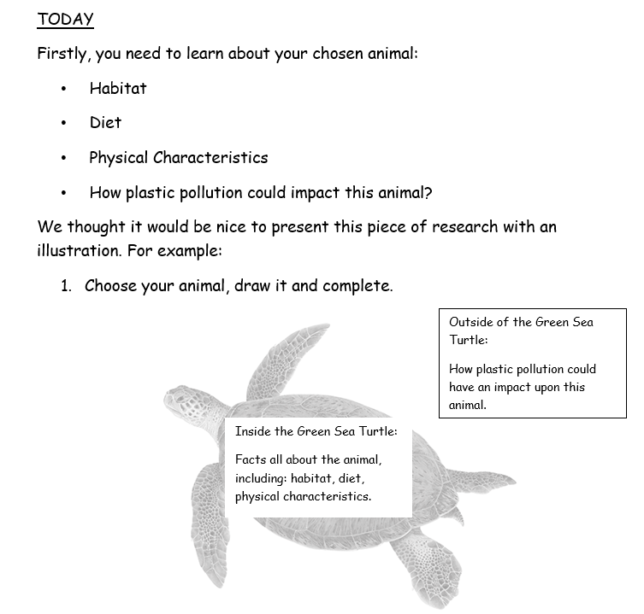
Once this is complete, please see the ‘Box Criteria Planning Document’.
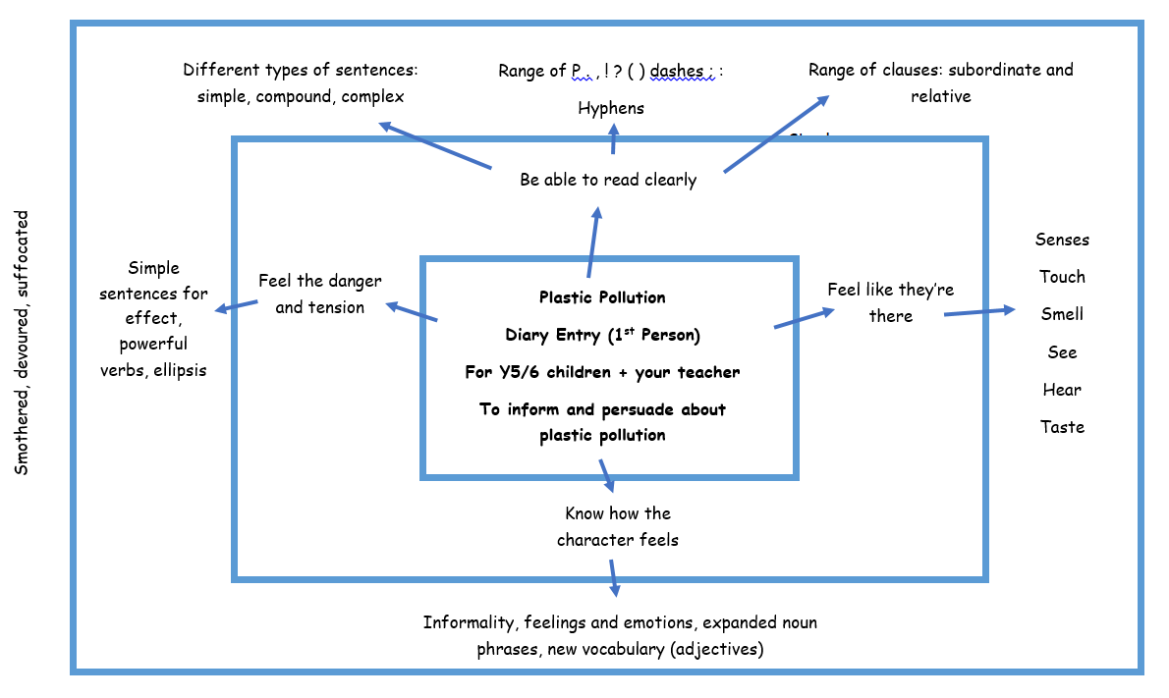
Task
I have completed the planning ideas for you as we have not used this form of planning before. Over the next few weeks, you might be asked to use this format again, but you will be doing the planning yourself. The idea is that it breaks down your thoughts and ideas but all stems from the focal point of the audience (who you are writing to) and the purpose (why you are writing). This plan is not complete and that is where you come in. Around the outside of the box (as you can see smothered, devoured, suffocated), you will write your ideas that link to the idea on the inside. For example: simple sentences for effect, powerful verbs, ellipsis. I have then written the 3 powerful verbs: smothered, devoured, suffocated that I will use in my writing next week.
Jot all your ideas around the edge of the box (or in your book if you don’t have access to a printer). The more ideas you gather during the planning, the easier it will be to write on Monday!

