Art Project: Plastic in the Ocean
I understand that all of you will have different resources at home however this project comes solely from your recycled plastic. Your task is to create a sea creature out of plastic. This will not be completed this afternoon as you will need to collect your recycled plastic over a number of days. Today, I would like you to plan your piece of art and annotate around the edge ‘common plastic items’ that you know will be recycled in your household soon. This will then enable you to create the art when you have gathered all of your items. The choice is yours: it can link to your chosen animal from your diary entry or it can be a completely different one. You don’t need to recreate one of the ideas below; you can design something original. They are just there to support you.

Ideas
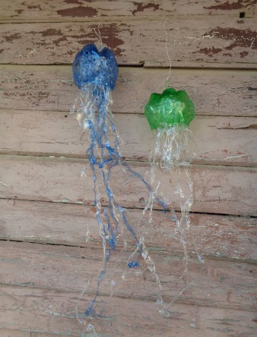
Giant Jellyfish

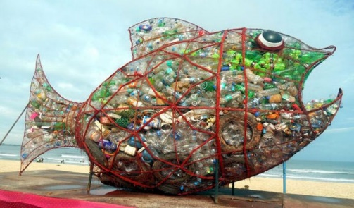
Wire/vine structure stuffed with plastic

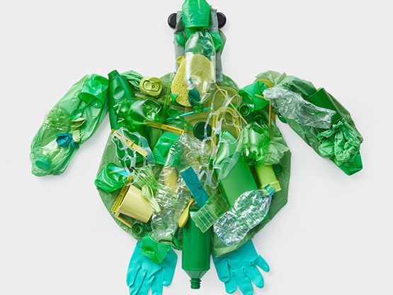
Turtle Plastic Collage

Design

