Working in Factories

The factories and mines of the late 18th century and early 19th century were dangerous and unforgiving places to work in. The working conditions that working-class people faced were known to include: long hours of work (12-16 hour shifts), low wages that barely covered the cost of living, and workplaces with little or no rights. These conditions were difficult for all workers but especially so for children. As such, children often faced incredible hardships and suffered abuse in the workplace. There were little to no rules in place for workers in the Industrial Revolution, and the wealthy owners could act in any manner that they wanted. For example, the factories and mines were incredibly dangerous places with very few safeguards.

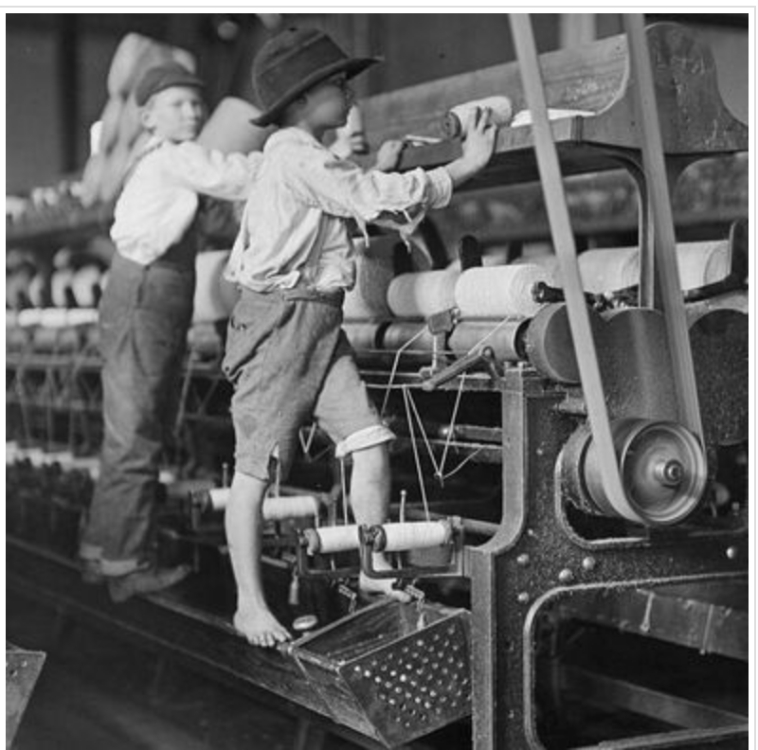
Spinning machines in textile mills were often left unguarded and posed a serious risk. For instance, a report from the British House of Commons in 1832 commented that “There are factories, no means few in number, nor confined to the smaller mills, in which serious accidents are continually occurring, and in which, notwithstanding, dangerous parts of the machinery are allowed to remain unfenced.” This situation caused children to become injured, as they were working dangerously close to spinning belts and shafts that powered the machines. Furthermore, children were often required to work on machines that they were not tall enough to operate safely. For example, in the image to the left the boy is too short to operate the machine and must stand on top of it in order to reach the spindles. As well, in the image a large spinning belt is clearly shown and it is not guarded. Any loose fitting clothing could easily become clogged and pull him violently into the workings of the machine.

