Last week, you started to look at the role of children in the Industrial Revolution. This week we want you to delve deeper into this aspect of the Revolution by writing from the perspective of a child who either works on a machine in a factory or in a coal mine.

Step 1 –

Firstly, you need to gather information about your chosen job role. There are links and documents on our class pages to help you.

In addition to this, consider your home outside of work. Once your long working day is over, where do you go? What is your home like? Do you have access to decent food? How often do you get clean clothes?

Please read the document ‘A Diary Entry from the Workhouses’. This is written from the perspective of a wealthier child who visited a workhouse. Although this is written from a different perspective from the diary you will be writing, it is a fantastic resource to gather ideas and information that you may wish to incorporate into your diary.

Step 2 –

Watch the video on our class page.
Examine the pictures by pausing the video.
We want
- The work that you’re doing
- The conditions your working in
- Your living and eating conditions (including what you may be eating)
- How your superiors (bosses) communicates with you
- The injuries you might sustain from completing this work

Now think about how all these factors would make you feel and the thoughts you have. You may want to gather your thoughts using mind maps –
Feelings are personal responses to a situation and have an impact on the reader. In this case, you want the reader to feel sorry for the child writing the diary entry. These can refer to physical feelings as well as emotional.
The slashes across the balls of my feet make it unbearable to stand let alone complete my work.
The fear and terror of potential punishment is excruciating.

Feelings

I’m exhausted! How I long for my crooked floorboards and threadbare blanket.

Thoughts express informality and share opinions on the situation -
I’m as hungry as a stray dog scavenging for food.
The bosses are hounds – I just don’t get a minute.
These working conditions are not fit for humans.
Thoughts

Step 3 -

Take a look at these two diary entries –
https://industrialchangeovertime.weebly.com/diary-entries.html

They are written from the perspective of children working in factories and workhouses. One child is 9 year olds and the other is 14 years old and there is a clear difference in the way it has been written – this is something to consider when writing your diary entry.

Step 4 -

Write your diary entry.

Remember to use your SPaG checklist.

You may want to use this to help you structure your diary entry –

 | Dear diary,
Paragraph 1 | Short summary of your feelings towards the day – don’t go into too much detail.
Paragraph 2 | Your working day –  - What was your day like before leaving for work?  - Arriving at work
Paragraph 3 | Your working day continued –  - Working in the factory  - Either you or your friend makes a mistake  - Consequences of the mistake - do you get punished? Do you get injured?
Paragraph 4 | Returning from work  - How long has your working day been?  - Did you eat when you got home?  - Do you complete any chores?
Paragraph 5 | - Summary of the day  - Conclusion of the day – at this point you may want to write in present tense  - Bed time

You may want to use this checklist to help structure your diary entry -

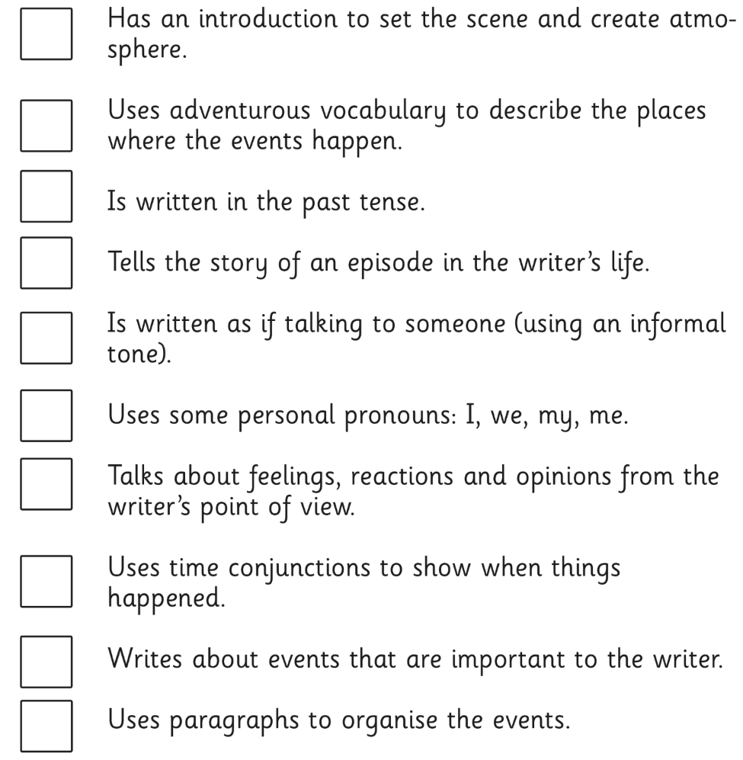

If you would like feedback on your diary entry, please email it to us.

