Inheritance
Art Link: Portraits
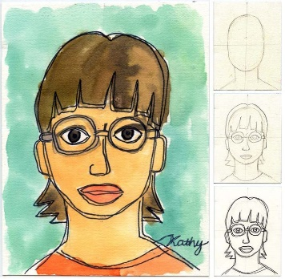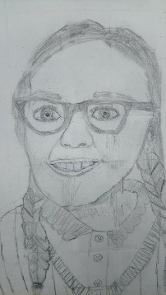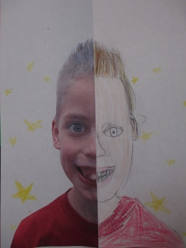
Last week, you looked at inheritance. You were able to explore with photographs of your parents to see similarities and differences within yourself. Some of your similarities and differences are inherited characteristics, whilst others are acquired characteristics.
This week, I would like you to produce a piece of art based on this concept.
You will need:
- Plain paper or card, you could always use your workbook if you don’t have access to this.
- A pencil for sketching
- A ruler
- A mirror
- A picture of your parent/parents or a parent who is willing to sit opposite you whilst you draw them
Task: to draw a portrait.
Choice:
- A self-portrait
- Two portraits (one of yourself and one of a parent)
- A combination (half of your face, with half of your parent’s face)
- Half of a photograph – you then complete the other half
Support:
Use the power point that is uploaded with this document. You can follow the steps to help you draw your portrait so that it is in proportion with other facial features.
Annotate:
Underneath or around your artwork, I would like you to identify characteristics that you feel you have inherited from your parent/parents.
Photograph: It is always lovely to see how you’re getting on and how you are doing with your ‘home lessons’. If you want to capture your piece of art, email your pictures to me!

