As you know, the Industrial Revolution took place approximately 200 years ago. During this time, Britain experience rapid change. Life was completely different for the population: methods of transport advanced; machines, that aided mass production, were developed; the number of houses, building and factories increased; job prospects and education changed for many.

Your task this week is to fast forward 200 years into the future, to the year 2220, and consider how life will have changed. To do this, you will need to consider –
- What transport looks like – think about the different methods of transport.
- What new job opportunities there will be and what work places look like.
- What houses will look like.
- What education will look like.
- What new inventions have occurred between now and then.

Please find a variety of tasks below – you can complete all of the tasks or choose the ones that interest you the most.

Task 1

Create a futuristic transport design

To do this, you could -
- Make a 3D model using a variety of materials.
- Sketch a design, labeling the different elements of your mode of transport.
- Create a video starring you (and maybe your family) on this new mode of transport.
- Create a television advert to promote your new mode of transport.

Task 2

Create a futuristic house design

To do this, you could –
- Use the 3D modeling program ‘Sketch Up’ – this is a software you can access on the internet using a 30-day free trial.
- Make a 3D model using a variety of materials.
- Sketch a design, labeling the different elements of your house.

Task 3

Think back to a few weeks ago when we compared these two images –
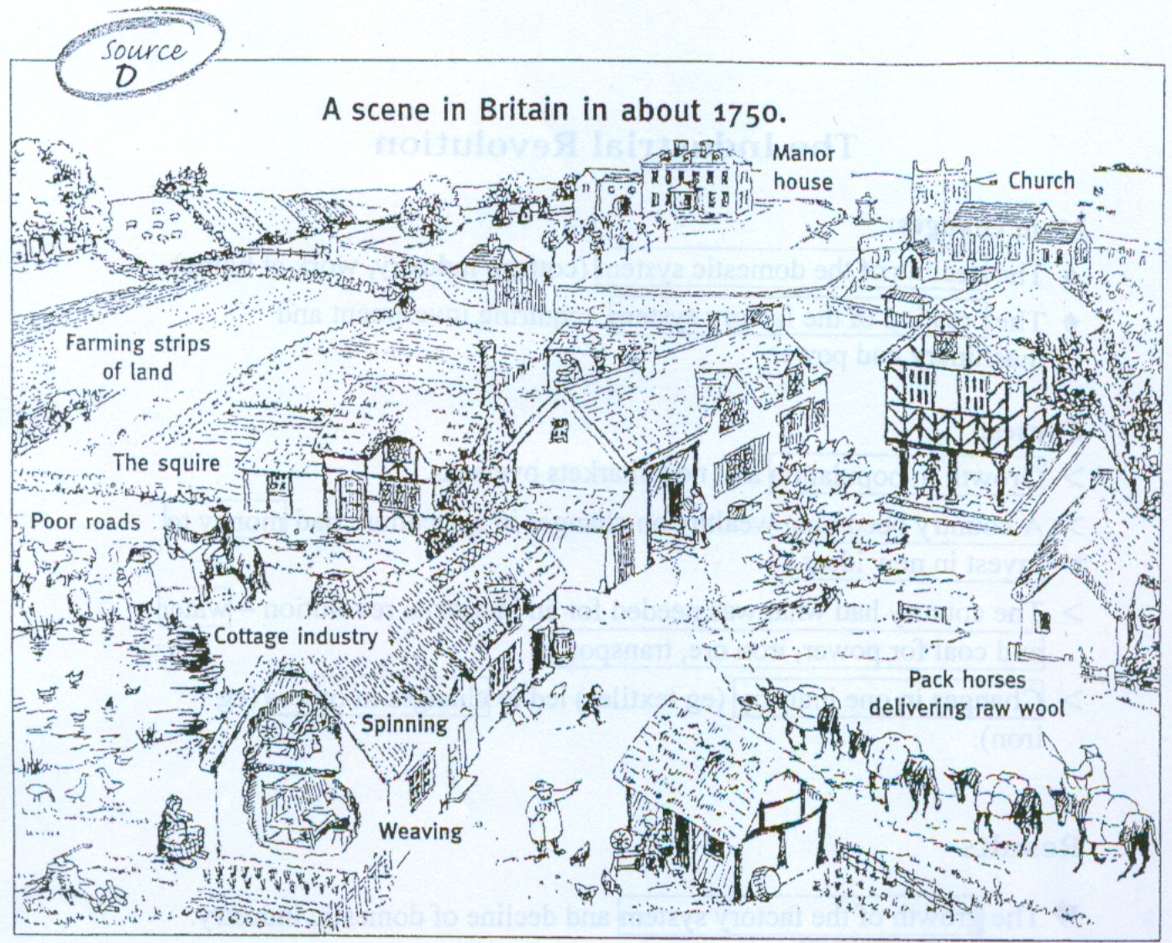

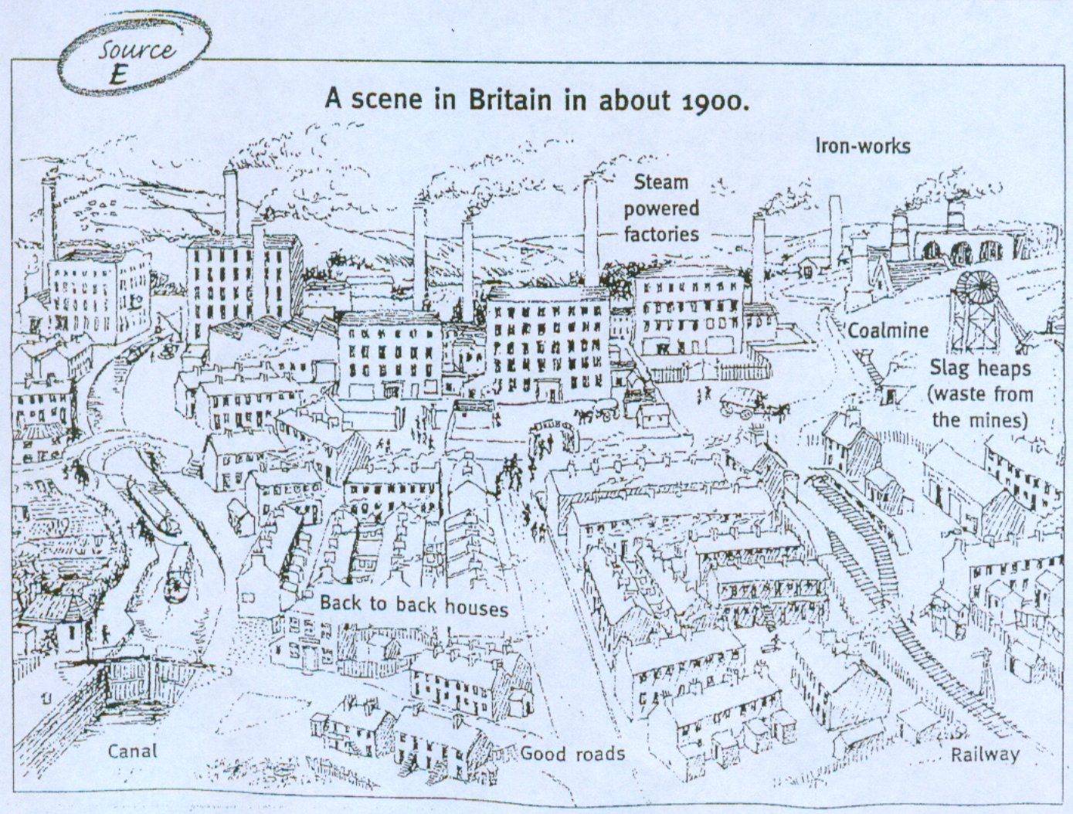

Use this map of Seighford and its surrounding area, to consider how it will have changed in the next 200 years.
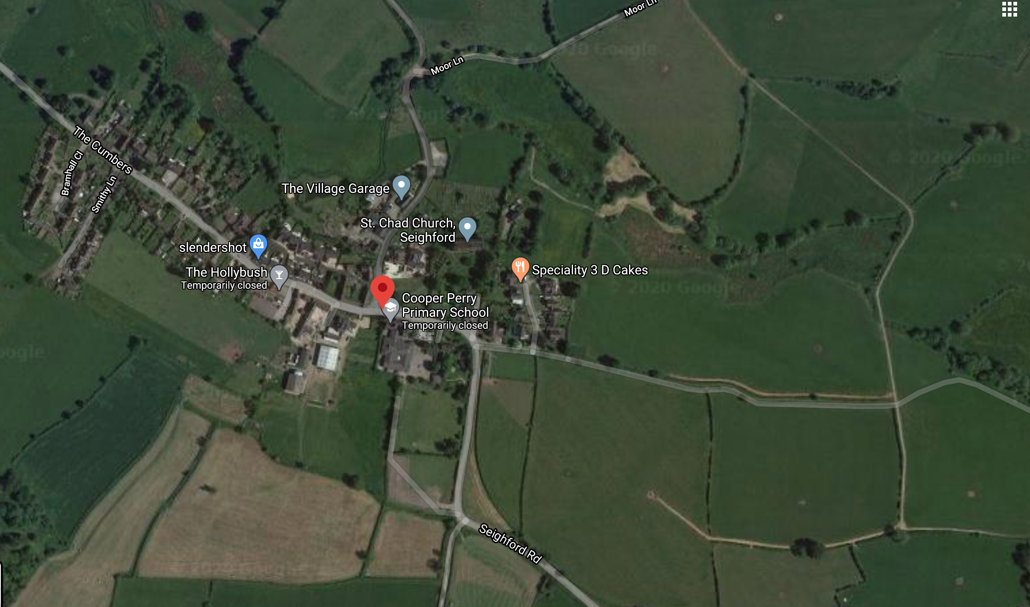

You could –
- Annotate the map to show how the village and its surrounding area will have developed – you may want to do this by printing the map and drawing over the top or importing the image into ‘Paint’ on your computer.
- Create an overlay (thin paper, tracing paper or baking paper is best for this) to show the changes.
- Create your own map for Seighford in 2220 to show the comparisons between the two time periods.

Task 4
Create a job advert for a new, innovative job role in the year 2220.

You will need to include –
- A job title
- A summary of the job role, including details of what they will expect to do.
- Salary (how much they will get paid)
- Person specification – what does the ideal person need to be able to do and what are they like as a person.
- Are there any prospects for future promotions?

