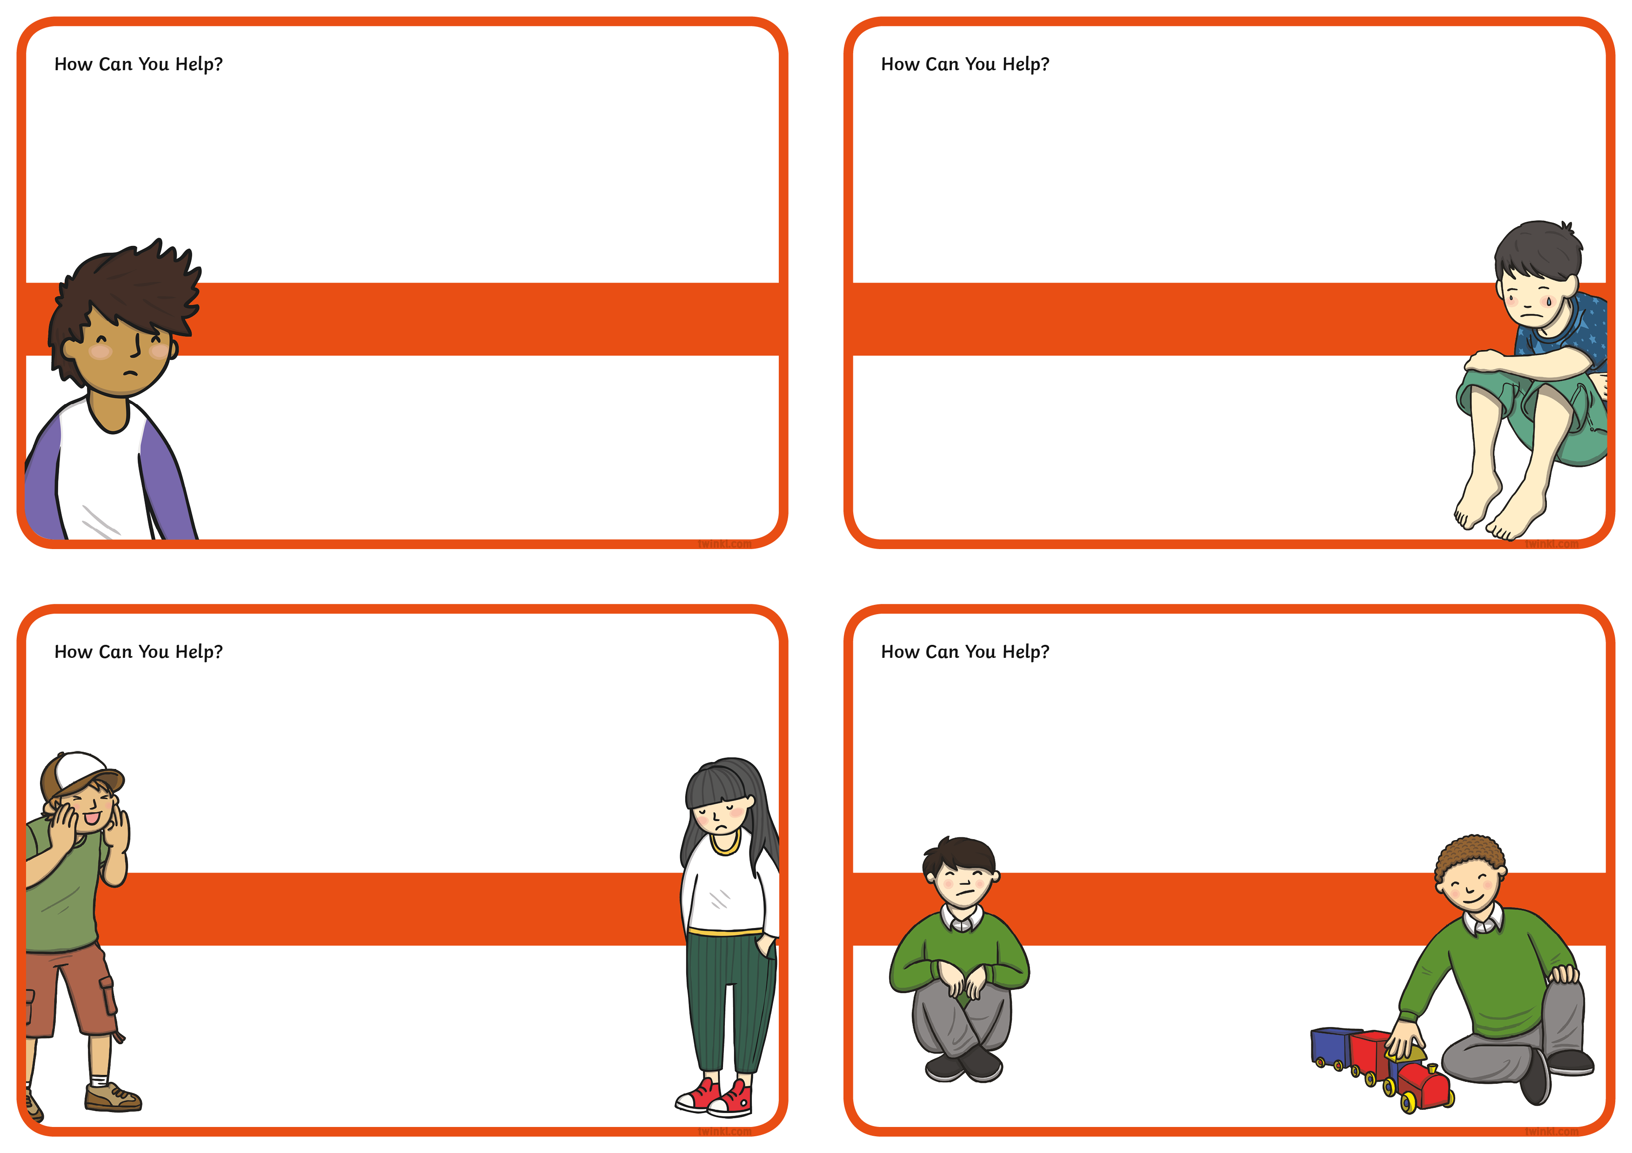
Someone called Toby a baby because he was upset.

Noah is playing with a ball in the playground
when another child takes it away from him.
Jack was not letting Lily join in with his game.

How do you think Lily is feeling?
No one will play with Oliver at playtime, even though he asked to join in the games.
How can you help Oliver?
How do you think Toby was feeling?
How can you help Noah?
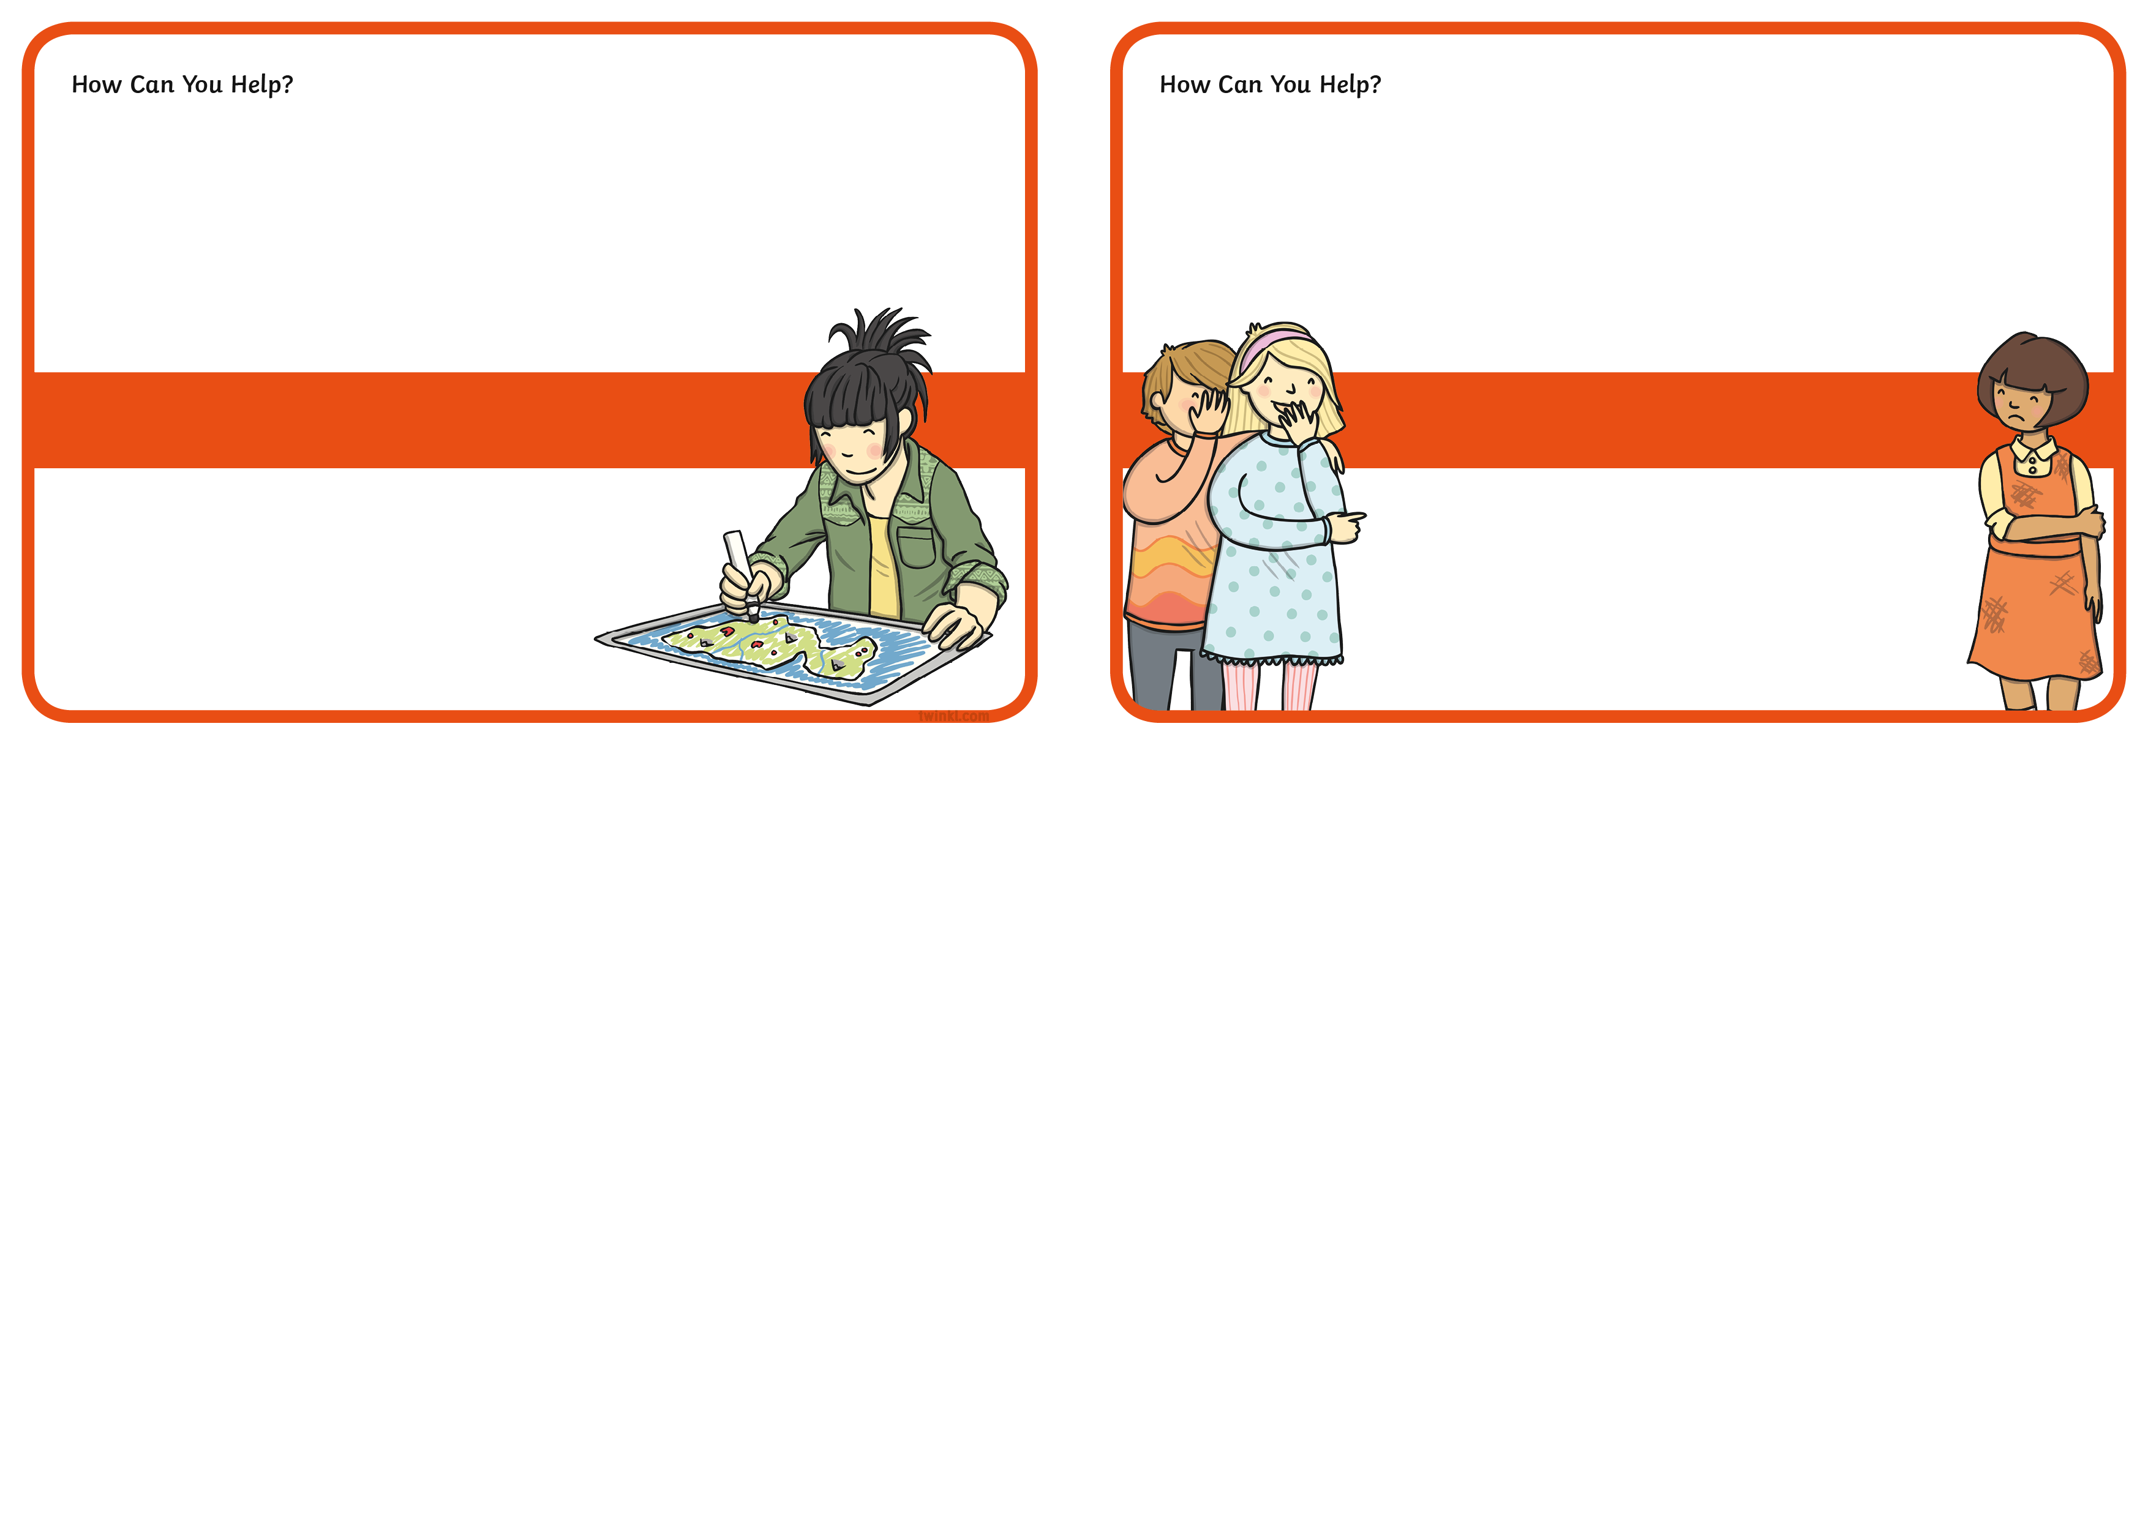
How do you think this made Emily feel?
Amelia is upset because her friends are snatching her toys.
Emily spent ages drawing a lovely picture but someone scribbled all over it and ruined it.

How can you help Emily?

