Carbon Footprint


- Read through the power point to develop an understanding of what the term ‘carbon footprint’ means.
- Answer the questions as you go on the power point to see if you get mostly reds, ambers or green.
- Either use the WWF carbon footprint calculator to work out your own carbon footprint https://footprint.wwf.org.uk/?pc=ATC001002&gclsrc=aw.ds&ds_rl=1263542&ds_rl=1263542&gclid=EAIaIQobChMI39nVrcah6AIVirHtCh1_OAa0EAAYASAAEgLX_PD_BwE&gclsrc=aw.ds#/ or look at Miss Harrison’s carbon footprint below.
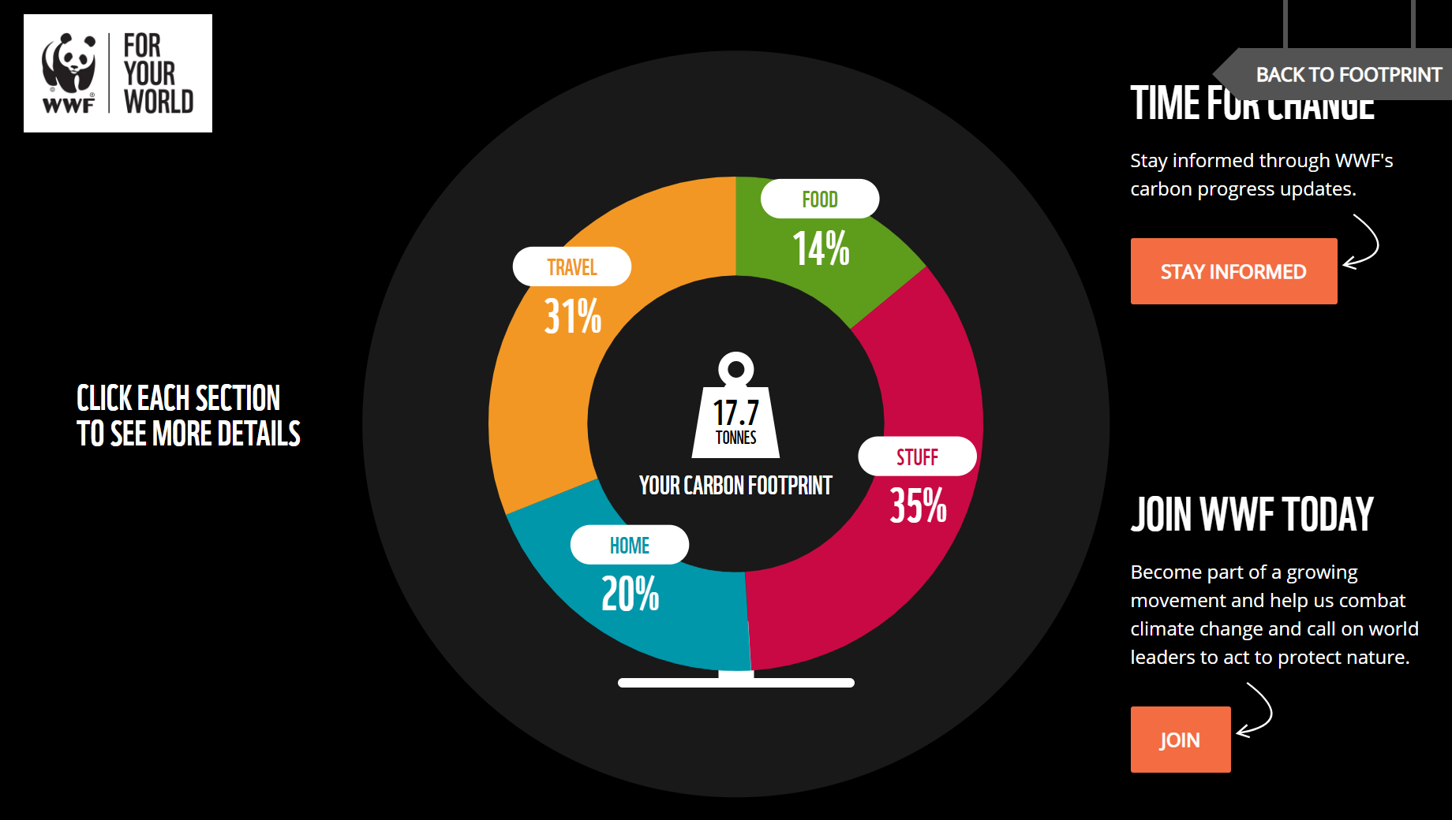
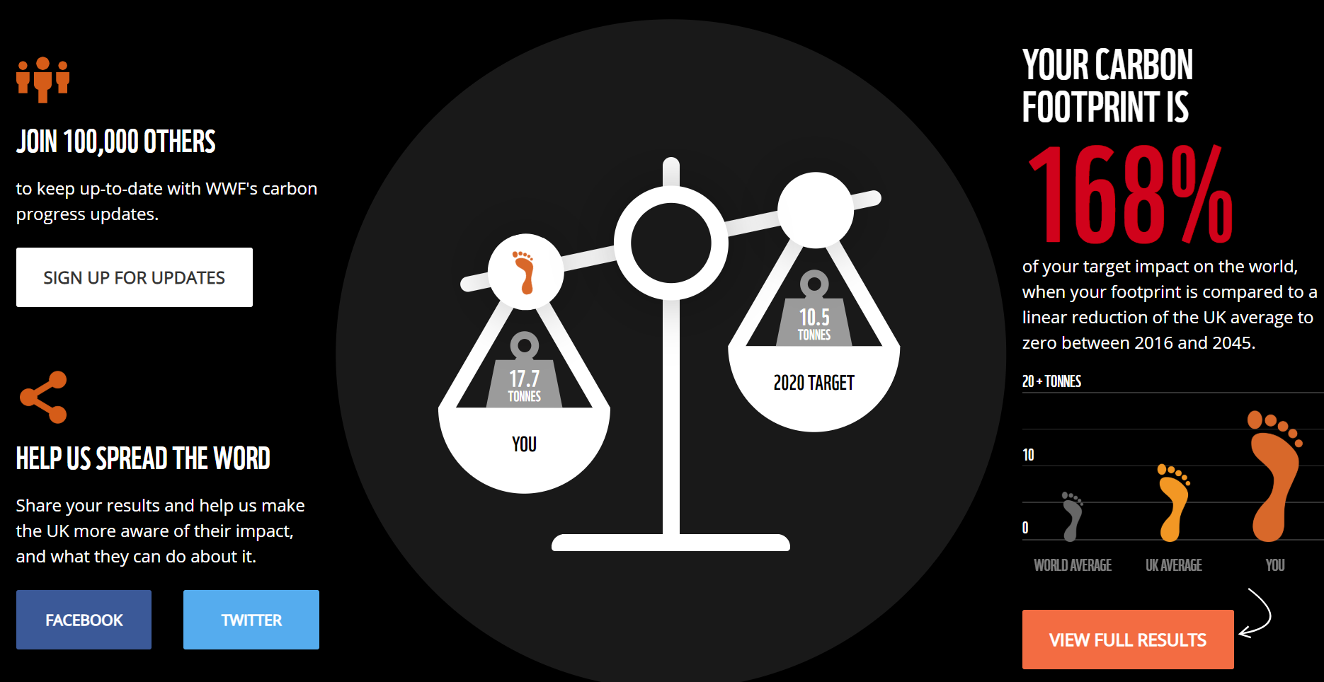

- If you do have access to a printer, you can print out my screenshots above, or screenshot your own carbon footprint to be printed. If not, you can complete your writing separately without the pictures.
- You need to make suggestions for how you or I (Miss Harrison) could lower our carbon footprint to get in line with either the UK average or the world average. I know for myself that I need to be more conscious about turning lights off in rooms that I am not using in my house. Around the first screenshot (circle with different colours), make suggestions for each of the sections: travel, food, stuff, home.

