Cooper Perry Primary School
World War One
Does Conflict Always Result in Sacrifice?
YEAR 5 and 6: Autumn 2
Service | Peace | Conflict | Sacrifice

Coverage  - Investigating how the war started.  - Identifying the countries involved and the Triple Entente and Triple Alliance.  - Exploring how the borders of Europe have changed over time.  - Exploring the enlisting rules, and how they change over time.  - Examining the impact of propaganda.  - Analysing sources to learn about life in the trenches.  - Exploring the roles of men, women, children and animals during the war.  - Exploring remembrance. | KEY VOCABULARY:  Propaganda  Armistice  Home Front  No Man’s Land  Warfare  Trench  Alliance  Triple entente  Triple Alliance  Trench warfare  Front line  Victoria cross  Remembrance  Flanders Field | KNOWLEDGE AND FACT SHEET  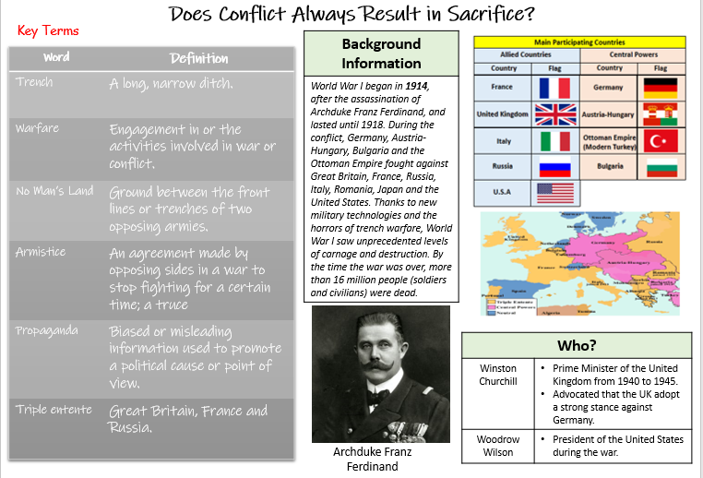  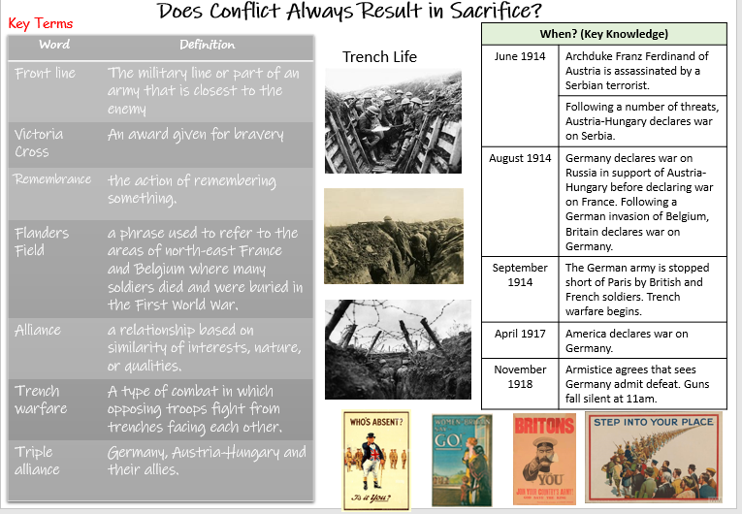  KEY QUESTIONS:  - Why did the war start?  - Which countries were involved?  - How has Europe changed since the war?  - Who fought in the war?  - How did enlisting requirements change over time?  - What is propaganda?  - What was life like in the trenches?  - What were the roles of women during the war?  - What were the roles of children during the war?  - What weapons were used?  - What were the roles of animals in the war?  - Why did the war end?  - How do we remember?
KEY SKILLS AND KNOWLEDGE
Year 5 | Year 6
I can recognise and interpret primary and secondary sources.  I can analyse a range of primary and secondary sources to find out about an element of the past.  I can find and analyse reliable sources of evidence to answer questions, realising there is not always a single answer to a historical question.  I can evaluate the reliability, validity and effectiveness of multiple sources.  I can describe the changes from the past, using key words and phrases to refer to chronology, including: BD, AD, modern, ancient, century and decade.  I can sequence changes, people, places and events on a timeline.  I can theorise about and justify the chronology of key events within a period of history.  I can reflect on the relationship between key events.  I can explain the causes of events and impacts they had on people.  I can evaluate how historical events studied influence life today.  I can evaluate change over time, considering its impact on peoples’ lives.  I can identify and explain reason for and results of historical events and changes within and across a period studied.  I can distinguish between reliable source and misinformation and explain that some evidence from the past is propaganda or opinion and that this affects interpretations of history.  I can justify why there may be different accounts of history. | I can recognise and interpret primary and secondary sources.  I can analyse a range of primary and secondary sources to find out about an element of the past.  I can question the reliability of sources.  I can question omissions and the means to finding out.  I can hypothesis about the past, using sources to support my ideas.  I can evaluate the reliability, validity and effectiveness of multiple sources.  I can describe the changes from the past, using key words and phrases to refer to chronology, including: BD, AD, modern, ancient, century and decade.  I can sequence areas of study on a timeline in relation to other areas of study.  I can sequence changes, people, places and events on a timeline.  I can theorise about and justify the chronology of key events within and across a period of history.  I can reflect on the relationship between key events.  I can identify the beliefs and behaviours of people from the past.  I can compare and contrast the beliefs and behaviours of people across different periods of history.  I can explain the causes and effects of past events using several pieces of evidence to support.  I can evaluate how historical events studied influence life today.  I can evaluate change over time, considering its impact on peoples’ lives.  I can evaluate change over time and argue whether it has had a positive of negative impact on peoples’ lives.  I can draw upon my increasing knowledge to describe past societies, making links between them.  I can identify and describe reasons for and results of historical events, situations and changes in periods studied.  I can explain how opinions of people now and in the past have an impact on historical interpretations.  I can justify why there may be different accounts of history, linking this to factual understanding of the past.

ENRICHMENT:  WOW Day  Cross curricula links – DT, Poetry and Writing  Creative homework projects | PUPIL LEADERSHIP:  Group projects

