Cooper Perry Primary School
Climate Change and Global Warming
How Can YOU Change the World?
YEAR 5 and 6: Spring 2
Responsibility | Consequences | Protest | Sustainability

Coverage  - The meaning of climate change and global warming and the impact it is having on the world and the future.  - A study of how the climate is changing through data analysis.  - The meaning of our global footprint and how this can be reduced.  - To understand what is meant by the term ‘plastic pollution’.  - To study the impact plastic is having on the world’s oceans and its wildlife.  - To explore strategies that reduce the amount of single use plastic that is being used.  - To study the amount of single use plastic used by the UKS2 team, and use this to inform predictions for the school, the village and the local town.  - To develop further ideas and strategies to reduce the amount of single use plastic used by consumers by sharing ideas with a local supermarket.  - To study famous activists.  - To plan and lead a whole school plastic free day.  - To study how graffiti can be used to promote views and ideas. | KEY VOCABULARY:  Global Warming  Pollution  Climate Change  Recycling  Consequence  Protest  Activist  Campaign  Adaptation  Fossil fuels  Ozone Layer  Greenhouse Gases  Renewable Energy  Carbon Footprint  Sustainability  Glacier  Carbon Footprint | KNOWLEDGE AND FACT SHEET  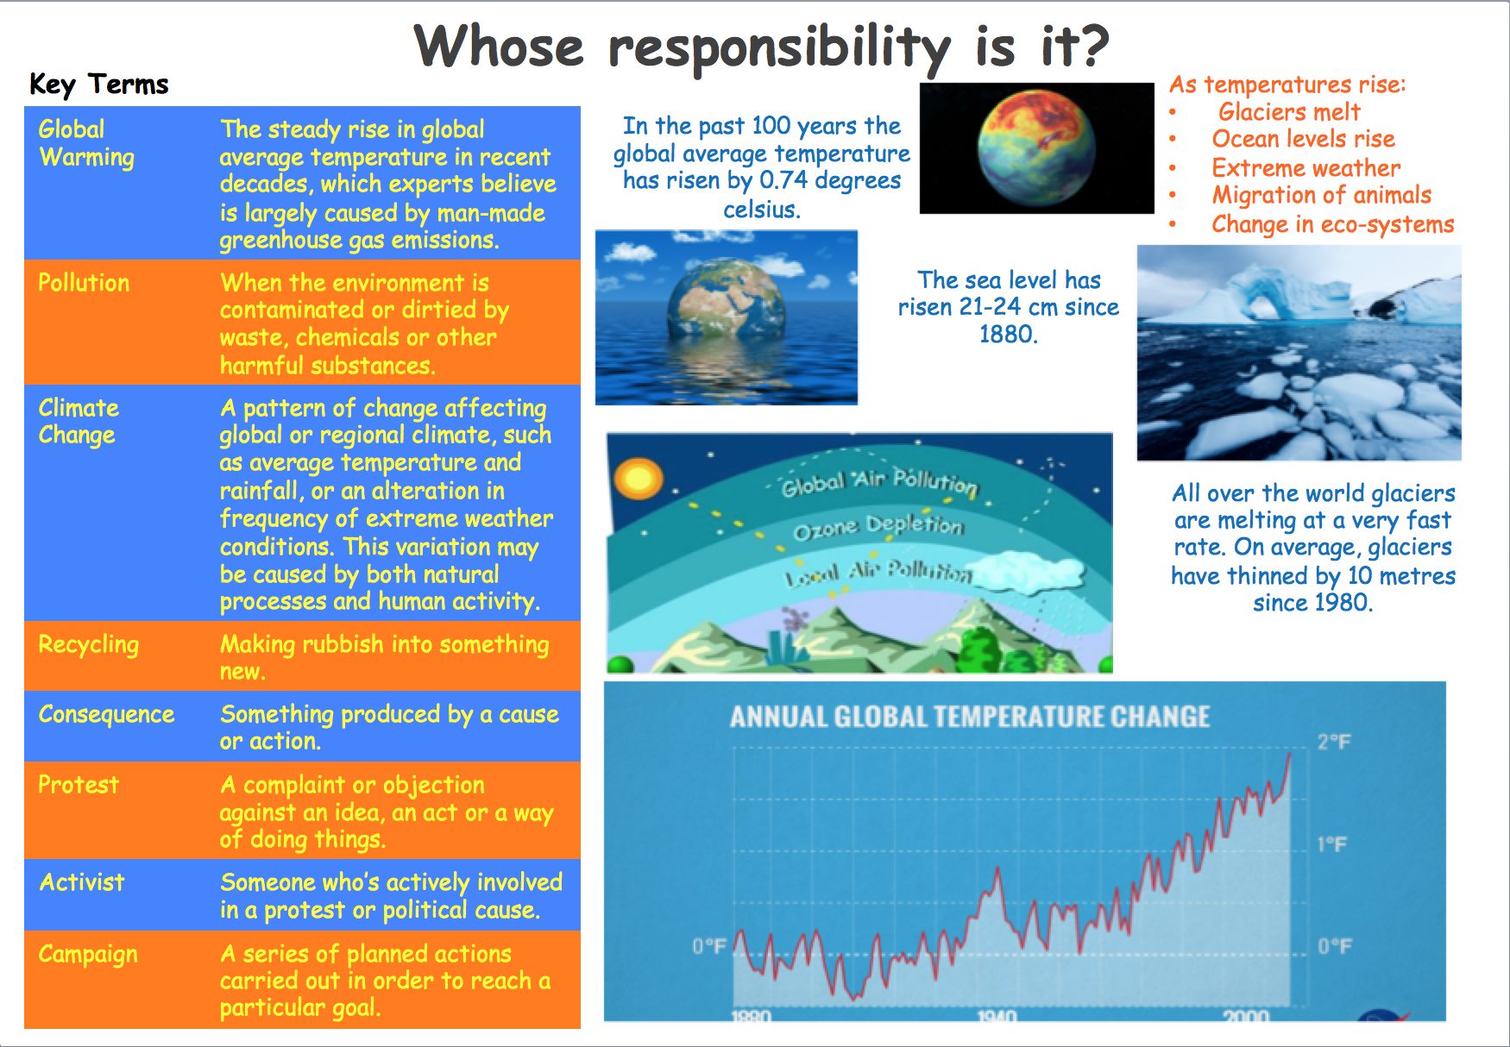  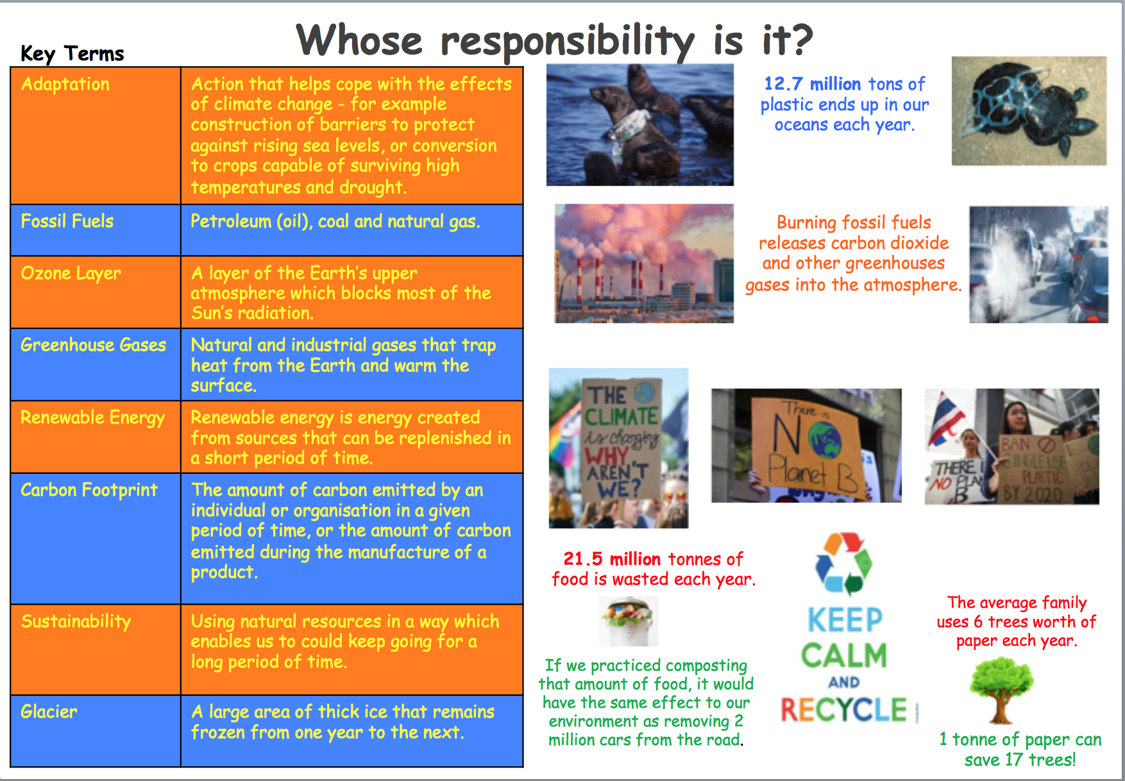  KEY QUESTIONS:  - What is global warming?  - What is climate change?  - What does the term ‘carbon footprint’ mean?  - How do we contribute to climate change?  - How is the world changing?  - How does plastic pollution impact the environment?  - How can we reduce our carbon footprint?  - How can we alter the ethos at our school?  - How can we influence change?  - How do people respectfully share their views to influence change?
KEY SKILLS AND KNOWLEDGE
- I can explain and evaluate the impact of human activity on the environment.

- Justify ways humans damage and improve the environment.
- I can collect and analyse statistics and other information unaided in order to draw clear conclusions about locations.

ENRICHMENT:  WOW Day – planning a plastic free day, protest | PUPIL LEADERSHIP:  WOW Day – planning a whole school single use plastic free day  Art projects  Protest

