Tuesday 5th January 2021
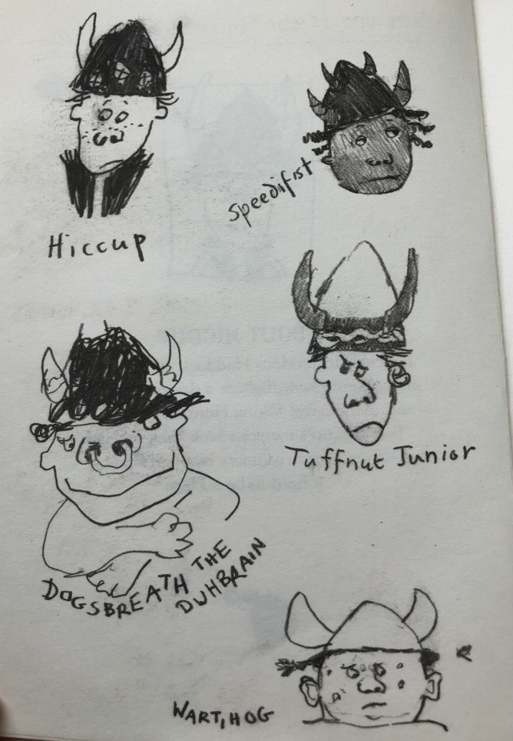
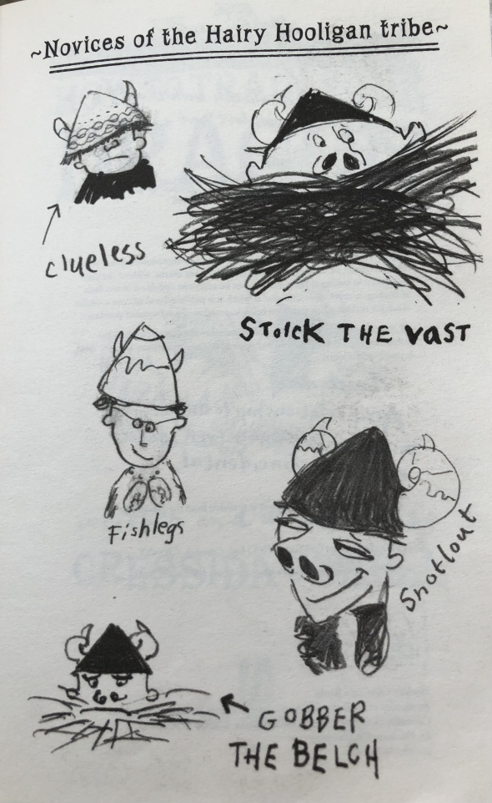
I can make predictions using evidence from the text.

Choose at least 3 of the characters from ‘How to Train Your Dragon.’ What do you think they are like? Use their appearance and their name to give you clues.
e.g. Clueless – Clueless is very clumsy and always bumping into things due to his large Viking helmet. He doesn’t know what’s going on half the time!

