Tuesday 5th January 2021
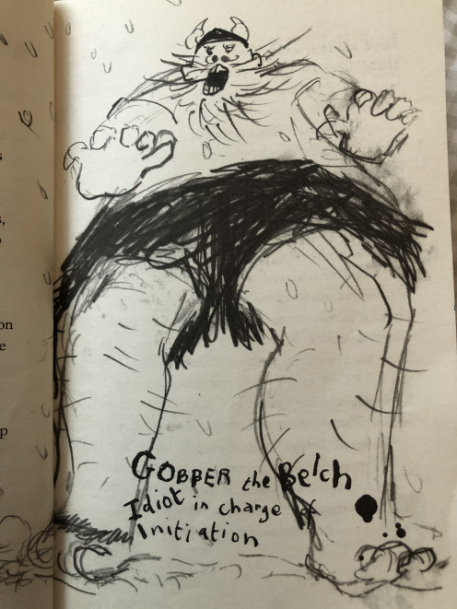
I can describe use adjectives to describe.

Yesterday we started reading ‘How to Train Your Dragon,’ and we wrote a character description of Hiccup (the main character).
Look at this picture of Gobber the Belch. Write a character description using adjectives to describe his appearance and personality.
Challenge – Can you include commas in a list?

