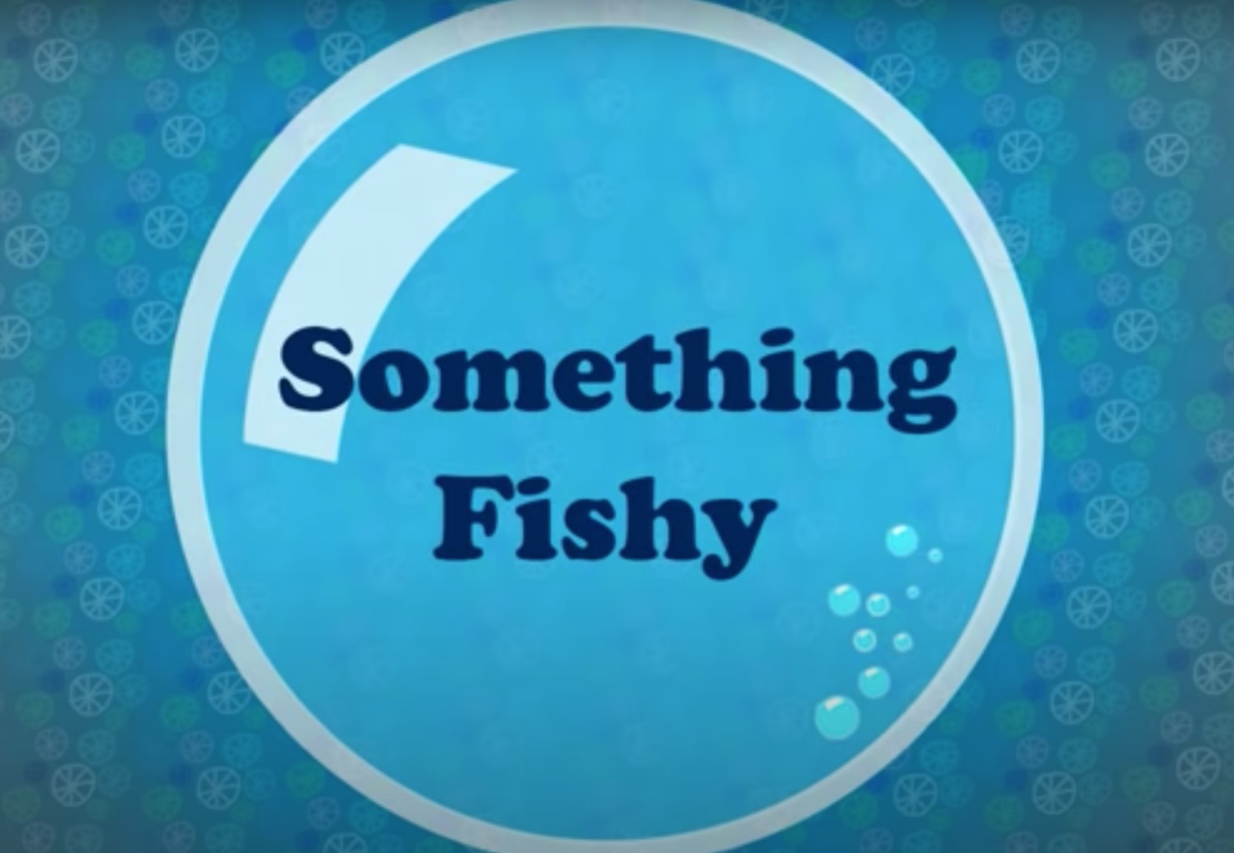

This week, your art is inspired by the video Something Fishy. As you know, during the video, items of clothing come to life to create an under the sea scene. Your task this week is to use the contents of your wardrobe to create your very own ocean themed art.
You could:
- Fold and manipulate your clothes
- Recycle old items by redesigning them and decorating them
- Hang and display items of clothing
- Wear your clothes and star in your own piece of art


