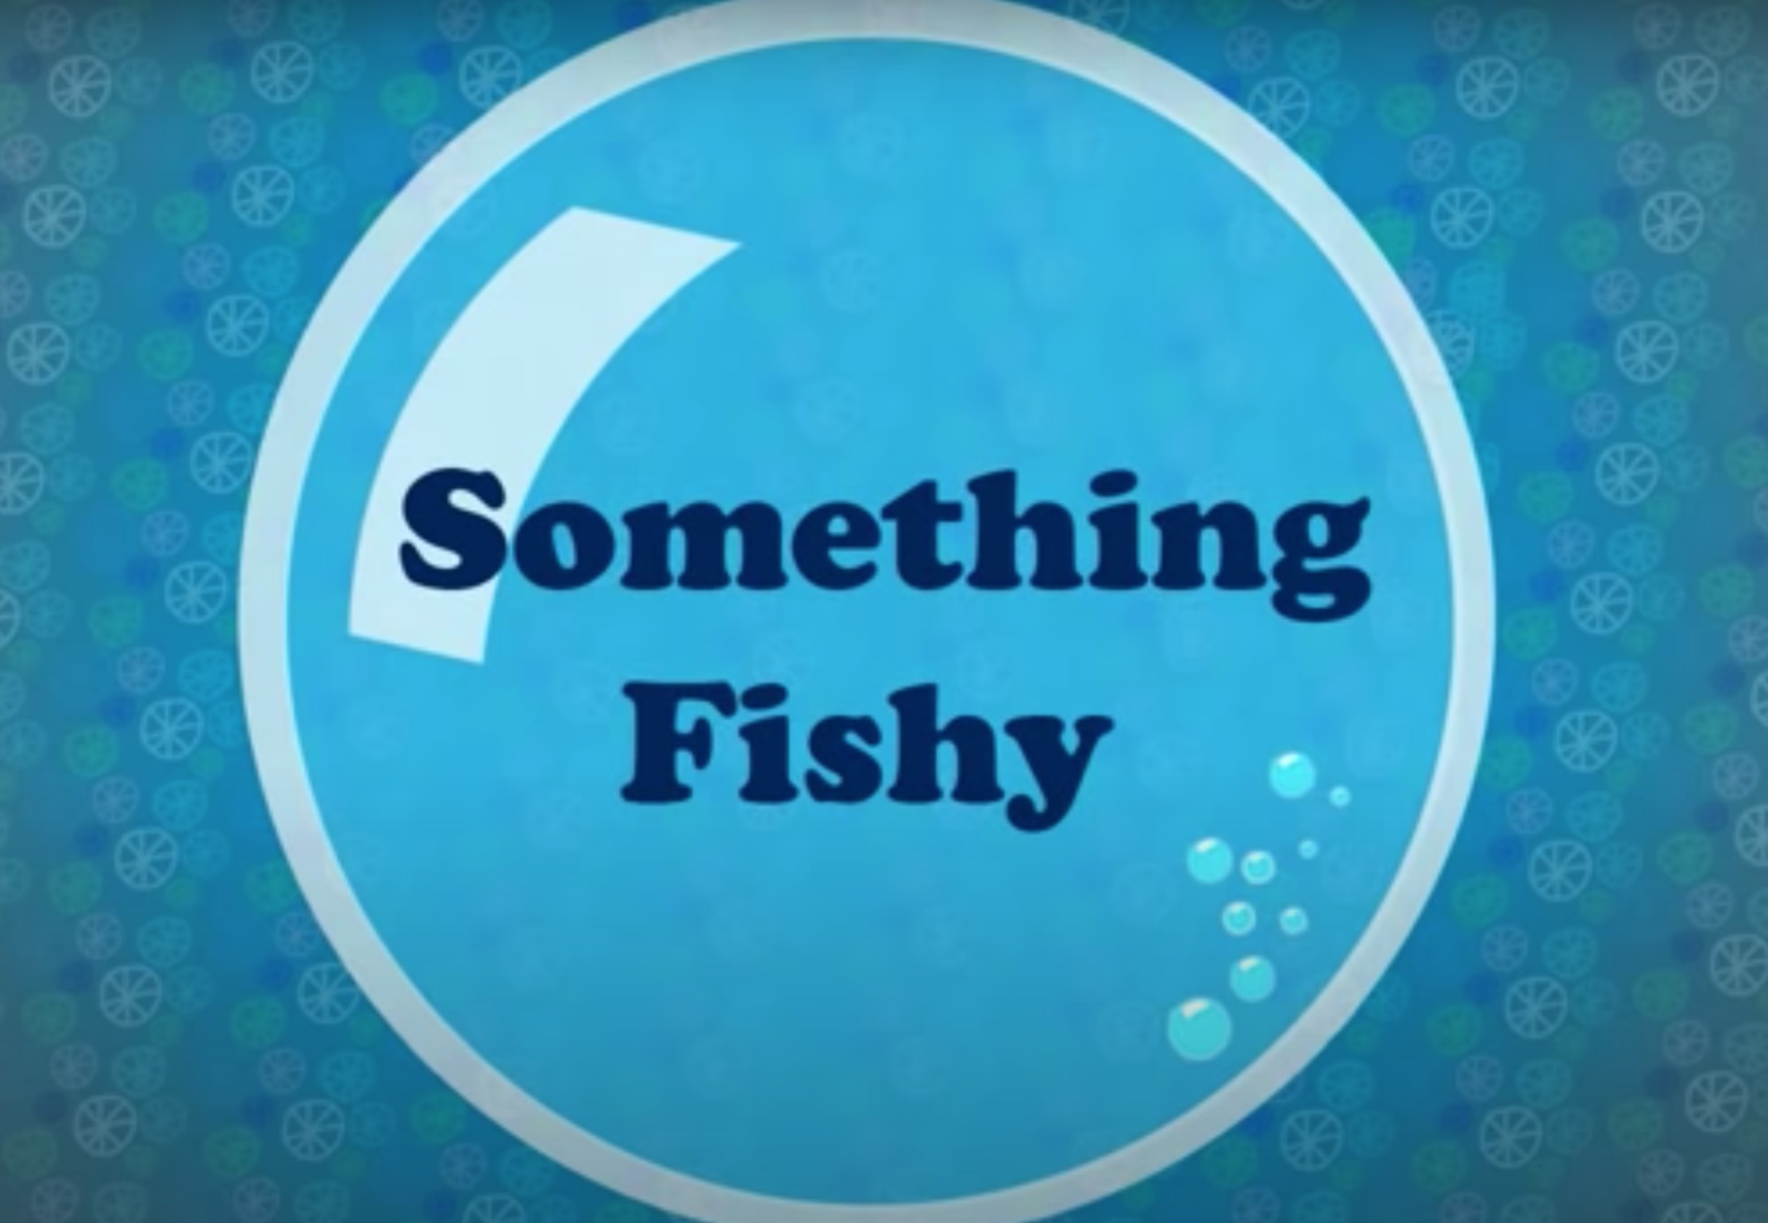

Now that you are equipped with lots of descriptive and emotive language, it’s time to write your diary entry.

You may want to use our example as inspiration -

Dear Diary,
Today has been a day to remember. When I woke up this morning, the feeling of dread hit me like a ton of bricks because I knew I had to make my painfully boring weekly visit to the launderette. After I finally found the motivation to get out of bed, I had a scrumptious banana milkshake and I headed there, feeling a little more positive than before. I can’t say the positivity lasted long because as soon as I sat down, the boredom grew. Yawn!
Just as I was drifting off to sleep, a beam of light caught my eye. What was this unexpected sight? Entranced by the glow before me, I edged closer. It lured me in. Feeling intrigued, I cautiously opened the washing machine door. I held my breath and my cheeks ballooned out - I looked like my hamster Jerry. Ha ha!
Before I knew it, I was swimming beside a colony of glowing, yellow sock fish. Was I dreaming? The fish varied in shape, size and colour but they all fluttered by blissfully in unison. Just when I thought I’d seen it all…WOW! A spectacular t-shirt octopus with long tentacles drifted by energetically. I loved this place! How I wished I could stay there forever!
You’d be proud of me, dear diary. Being the kind, caring and thoughtful person I am, I darted off to rescues a stray sock fish, who had lost his way. Little did I know, I was entering dangerous territory. Trying to grasp the sock fish, I wondered why he was being so ungrateful. Then I spotted it!
Razor sharp teeth, colossal in size and beady, piercing eyes. I knew I was in trouble now. I will never forget that gut-wrenching feeling. Without hesitation, I turned and swam as fast as I could. He was hot on my tail so I knew I needed to hide. Thank goodness for the tall, towering seaweed. I hid however I knew I couldn’t stay there forever. There it was again (a beam of light), my saviour. Chomp, crunch, snap rang through me eyes as the shark was just centimeters behind me. I swam as fast my body would take me – those swimming lessons paid off. Luckily, I dived back through the washing machine just in time.
Falling on the floor, I breathed a sigh of relief. The jeans, that were no longer shark like, lay beside me. Reluctantly, I reached out to stroke the culprit and they were not longer a threat. Phew! Just when I thought I had escaped the danger, I heard a deep, threatening voice. I turned to see another set of razor sharp teeth. I am still quaking now! I think an early night with an extra large hot chocolate is needed. So long, dear diary.
If you would like to share your diary entry with us, please email your class teacher.

