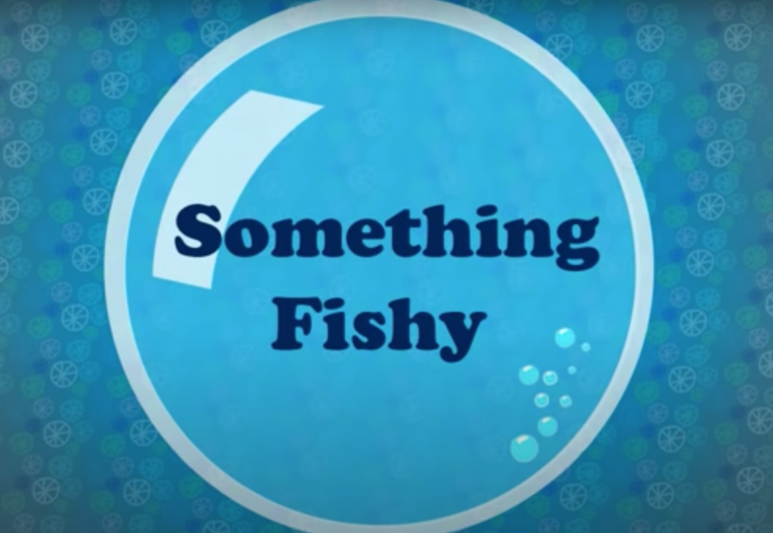

Before you begin to write your diary entry, gather your descriptive ideas by focusing on the verbs and expanded noun phrases that can be used to describe the objects and their movements from the scene.

Object |  | Expanded Noun Phrases | Verb and adverb
Seaweed |  | Tall, towering seaweed | Stood rigidly
Washing machine
Sock fish
Hat turtle
T shirt octopus |  | A spectacular t-shirt octopus with long tentacles | Drifted by energetically
Water
Sunlight
Shark jeans

