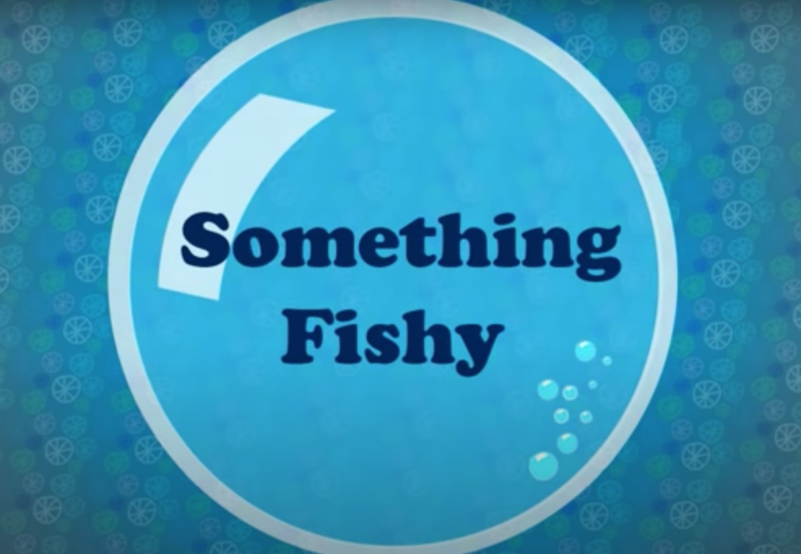

Once you have watched the video, answer the following questions:

Pause at 14 seconds
Where is the young lady?
What is she doing there?
How is she feeling and how do you know?

Pause at 31 seconds
What does the lady see in the washing machine?
Why do you think she looks around the room after seeing them?
What else might she see in there?

Pause at 1 minute
Do you think it was a good idea to go into the machine and why?
Would you have gone inside?
What are the fish made out of?
How about the seaweed?
Where have the coins come from?

Pause at 1min 26 seconds
How do you think the feels after seeing all these creatures?
What might she be thinking?
How many different creatures did she see in total?
What do you think is swimming towards her in the background?
What do you think will happen next?

Pause at 1min 56 seconds
How did the lady feel when she saw the shark and how do you know?
How did she feel when she finally escaped?
How did she feel about the trousers in the end?

Play to the end
Discuss the ending –was it all a dream?

