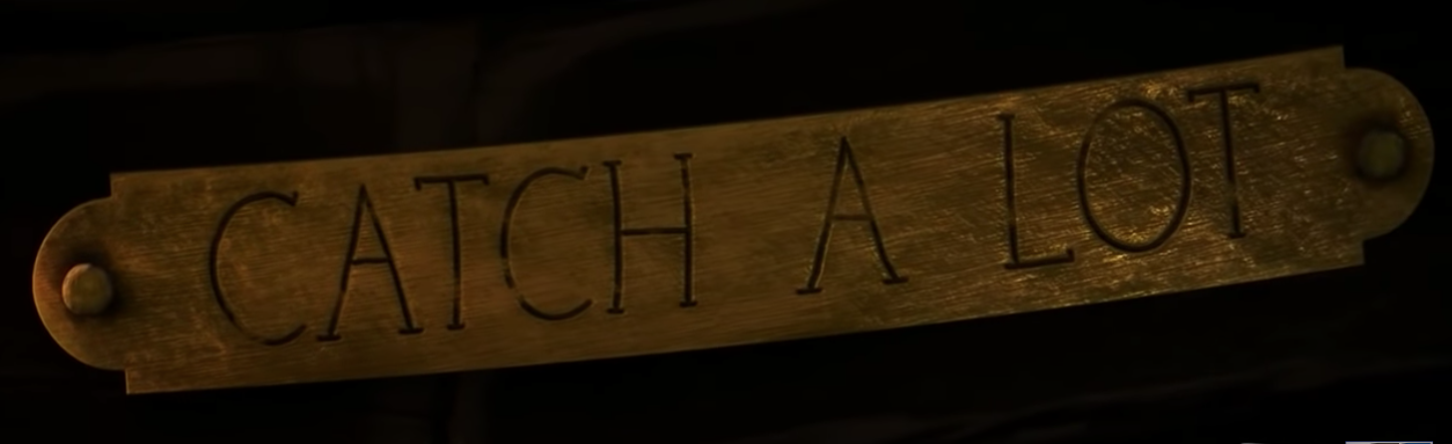

Have a look at an example for Paragraph 3 -
From out of the gathering mists, something moved. An eye. It was definitely an eye. The thick, grey sky slowly began to envelop the small boat, and the unusually calm water chewed at its hull. In sheer panic, the bird launched himself at the larger man and sent him tumbling backwards into the nothingness, over the side of the boat. The boat creaked and groaned. The smaller man fumbled for his lantern and peered over the side of the boat. His father appeared and flung himself, in a panic, over the side of the stricken vessel. Boom. Above them, thunder rumbled as a stark warning that things were about to worsen. The menacing sky grew instantly colder and, almost immediately, the waves began to push and pull the boat in a game of tug of war. The boat fell to the mercy of the pitiless ocean whilst lightning played across the raging sky and watery fists pummelled the sides of the hull.

