Paragraph 1 | Setting the scene  Introducing the characters  The change in weather
Paragraph 2 | An eye appears  Bob reacts  Tim is unaware
Paragraph 3 | Night time and in the middle of a storm  Bob’s is determined to catch the beast  They go on the hunt
Paragraph 4 | Whale appears  Bob, Tim and Simon are flung into the air and have to act quick
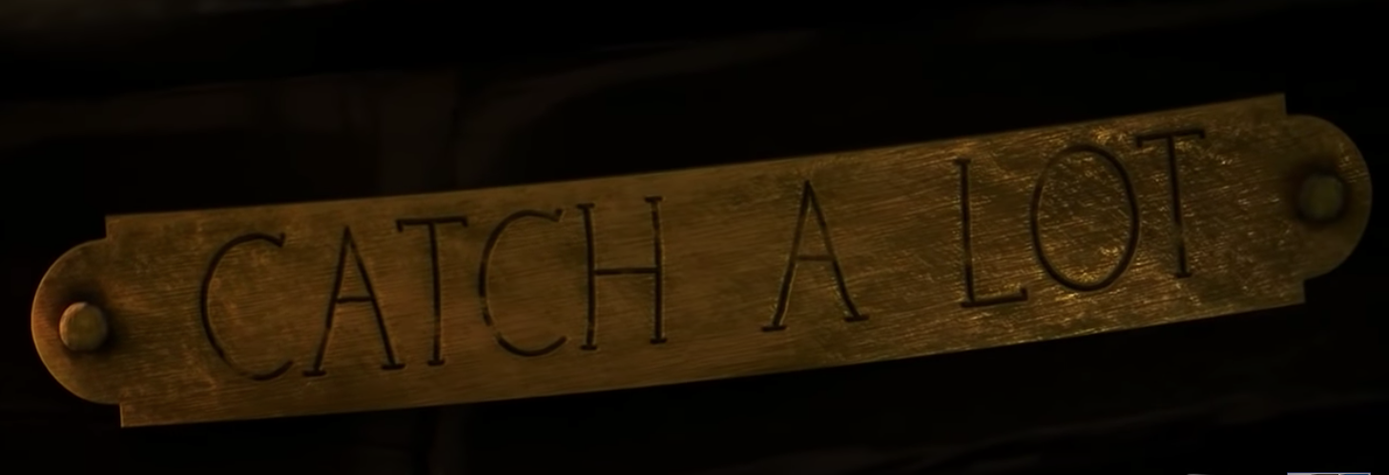

Here is an example of how you could start the first paragraph –

All was calm and still as a wooden rowing boat rocked spasmodically on the cool, clear water. Tim, a tall, thin red-haired fella, sat in the back of the boat straining his unsteady arms to pull on the oars. Behind him, stood Bob, a plump, bearded man, who had a coarse, thick beard. The two fishermen had an unexpected visitor – Simon the seagull, who perched on the edge of their boat looking dazed and unamused.

