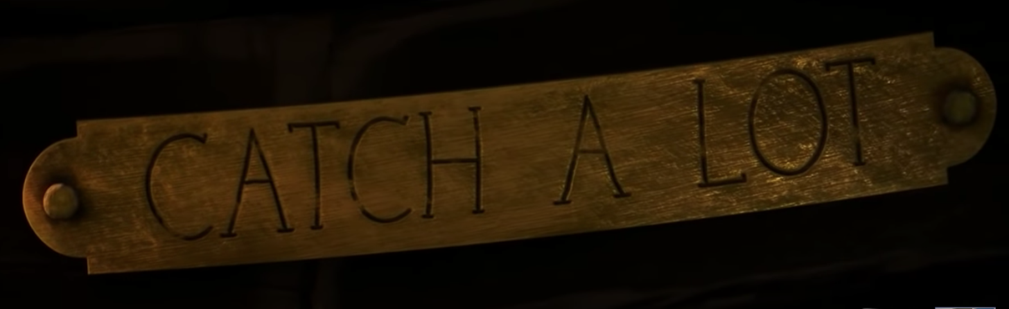

Task 1
Question Time

Pause after a couple of seconds so we see image of boat and two men aboard it.
What time of day is it?
What can we tell about these characters from what they are doing, what they are wearing and their tools?
What do you think it smells like?

Pause as soon as the image pans out.
Why do you think the director has chosen to pan out? What might the mist be indicating?
How is the son feeling?
What actions can you describe to show this?

Pause after the father shakes the son.
We know the father has spotted a whale, how does the director show us that a whale has been found? Why is the father becoming more frustrated?
What do you think he would say to his son if he spoke at this point?
What do you think the son is thinking?

Pause after the eye opens at the side of the boat. How could we describe the whale’s appearance using ‘show not tell’?
How does the director build tension in this section?

Pause after the view from under the boat after the father has climbed aboard.
How is the father feeling at this point?
What questions would the son be asking himself? How has the director used the weather to reflect the mood? Can we think of any synonyms for anger?

Pause when it fades to black.
What do you think will happen next?
Watch the film to the end
Does the final image of father change the way his son thinks about him?

