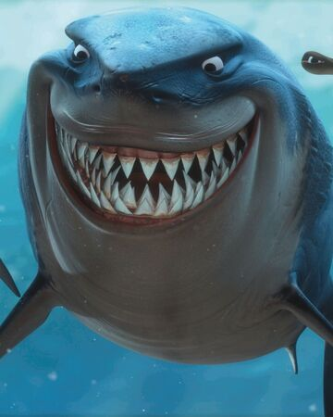
Find 4 interesting facts about the Great White Shark.

