Now that you have chosen your sea creature, let’s begin to build our non-chronological reports.

Today we are going to focus on their physical appearance.

Use the videos and web site links on your class page to research key aspects of your animal’s physical appearance.
Use bullet points to help you record your findings in note form.

Physical Appearance – Great White Shark
What is their typical size?
Are there different types of sharks? Does their appearance differ?
Physical features – you may want to think about why they have these features e.g. why do sharks need fins?
Think about all aspects of their physical appearance – body, teeth, eyes, fins etc
Do they have different sorts of fins?

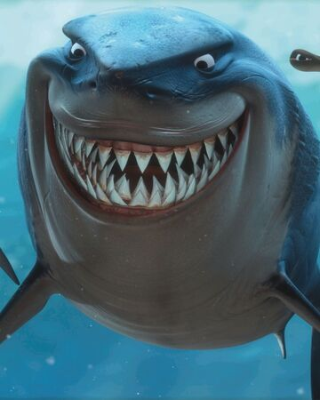

Now that you have gathered your notes, transform your findings into a paragraph.

The Appearance of a Great White Shark
________________________________________________________________________________________________________________________________________________________________________________________________________________________________________________________________________________________________________________________________________________________________________________________________________________________________________________________________________________________________________________________________________________________________________________________________________________________________________________________________________________________________________________________________________________________________________________________________________________________________________________________________________________________________________________________________________________________________________________________________________________________________________________________________________________________________________________________________________________________________________________________________________________________

