Why is the ocean a suitable habitat for your sea creature?
Using your newfound knowledge from your extensive research, think about how the blue tang is suited to living under water. Label the picture below -

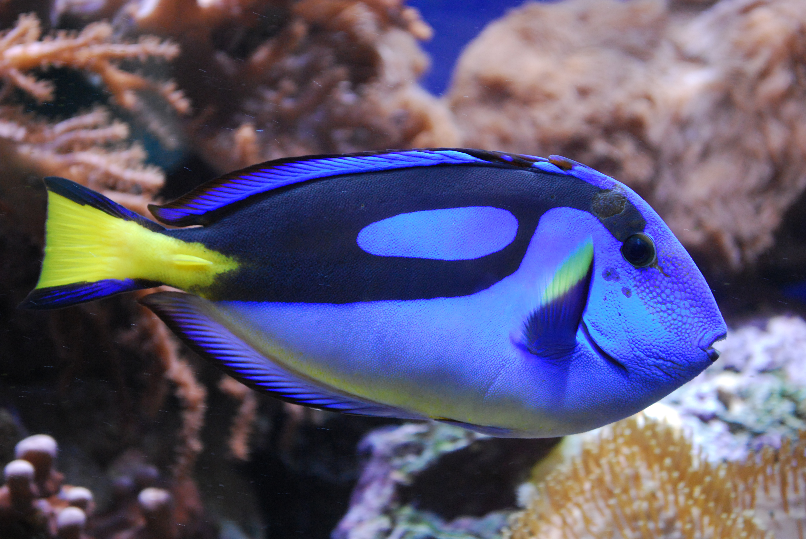

Now, we want you to imagine that in years to come, a larger proportion of the planet is under water and a lot of the world’s species will have to adapt to live under water. Once you have slected an animal below, redesign them so that they can live underwater. Think about –
- Camoflauge
- Size
- Ability to breathe
- Ability to move
- What they will eat, where they will find it and how they will hunt it

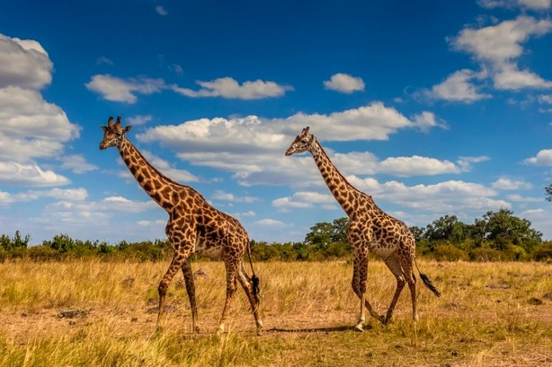
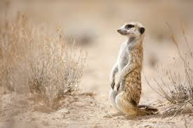
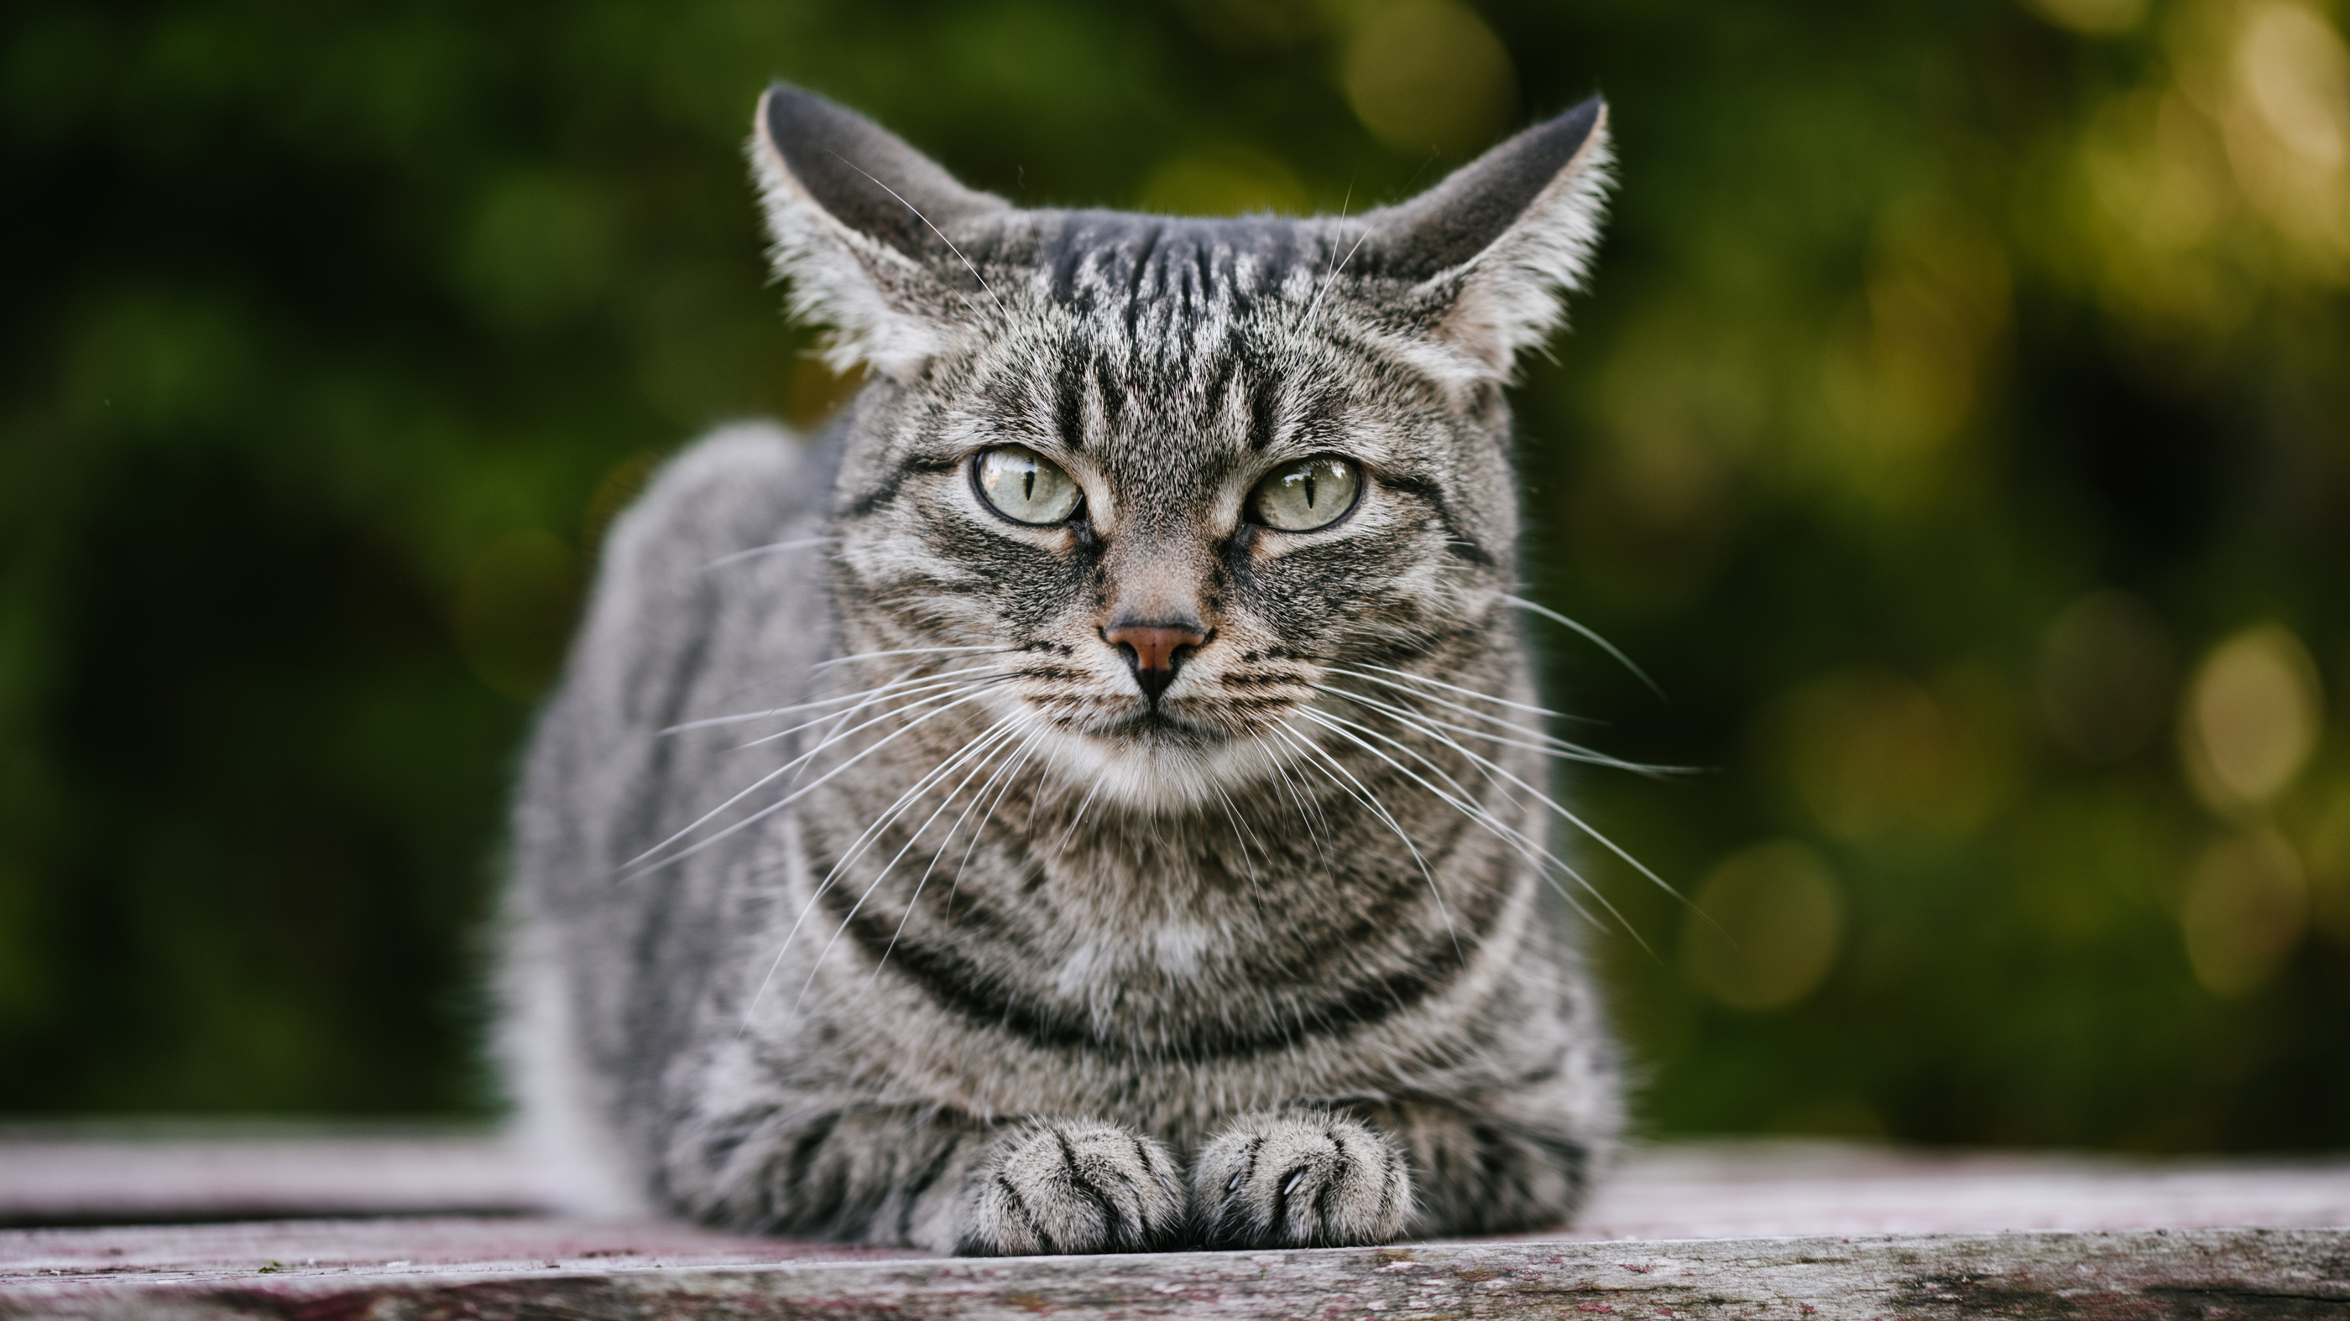
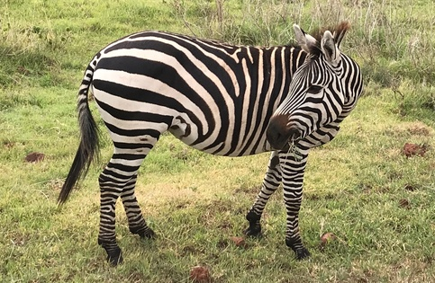
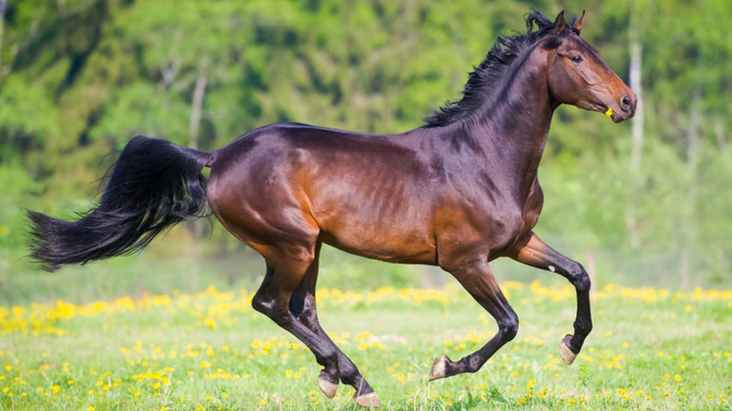
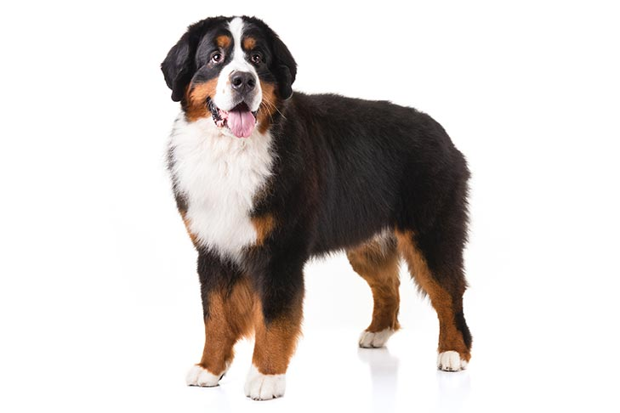
Draw your newly adapted animal below and label the features that will help them adapt to life underwater.

