Dragonworld
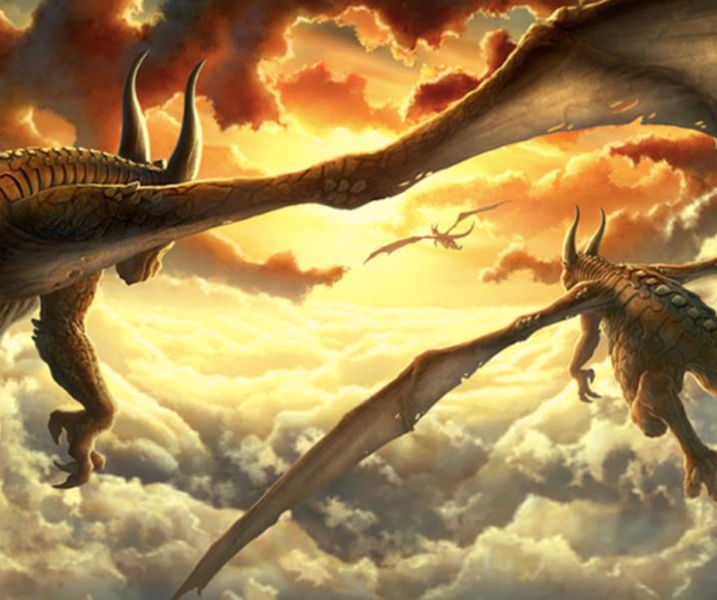

Task 2: Sick Sentences
These sentences are ‘sick’ and need help to get better. Can you help? Can you add an adverb? Can you add an expanded noun phrases?
- The dragon flew through the sky.
- The sun was shining in the sky.
- There were big clouds.

Task 2: The Main Write
Remember that you can you can choose one of the genres below.
- Complete the story
Story Starter
This was their favourite time of day to fly.
As the glowing sun dipped down below the vast horizon, the dragons took flight. The sky looked beautiful. Wisps of pillow-like clouds seemed to part in front of them as they stretched their powerful wings. Like sails from ancient ships, the wings beat in towards the sun’s fire. Thousands of tiny scales that covered the beasts’ bodies glistened like rubies in the dazzling light. As they reached full speed, leaving the world far beneath them, they almost grinned as they thought about where they were going. There would be others like them there. It would be paradise…

- Diary Entry (from a dragon’s perspective)
Think carefully about:
- Including thoughts and feelings
- Using the past tense
- 1st person

