The Troll
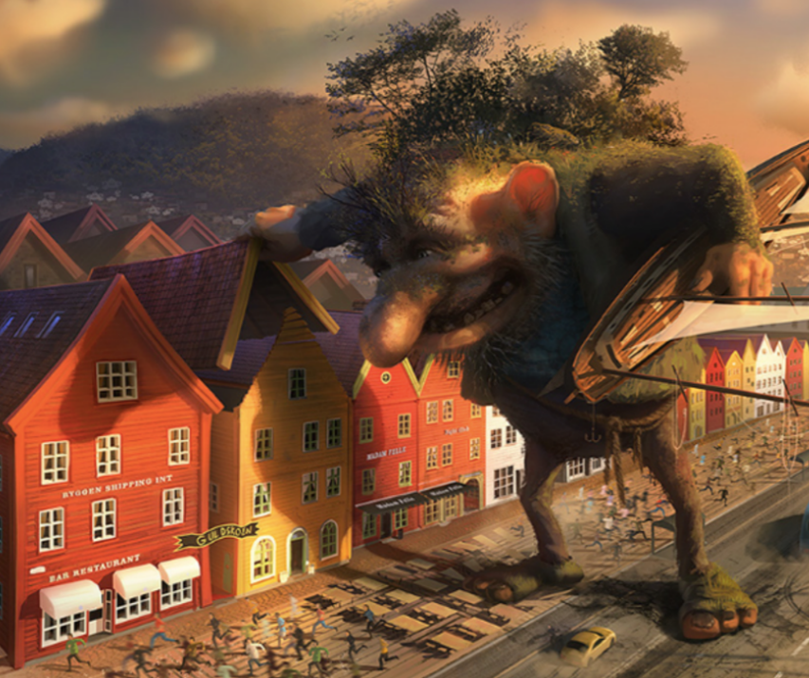
Task 2: Sick Sentences
These sentences are ‘sick’ and need help to get better. Can you help? Can you up-level the description?
- The troll put his hand on the house.
- He had a big nose and yellow teeth.
- He was covered in grass.

Task 3: The Main Write
Remember that you can you can choose one of the genres below.
- Complete the story
Story Starter
Thump! He slammed his enormous, grass-covered foot into the middle of the road, sending shockwaves of dust and debris in all directions. With a loud grunt, the troll wrenched the entire fully tiled roof off a nearby holiday home, with the owners peering helplessly on out of the downstairs windows. He didn’t mean any harm, but he just couldn’t help himself…

- Diary Entry (from either the Troll’s perspective or from the perspective of somebody who lives in the village)
Think carefully about:
- Including thoughts and feelings
- Using the past tense
- 1st person

