The Troll
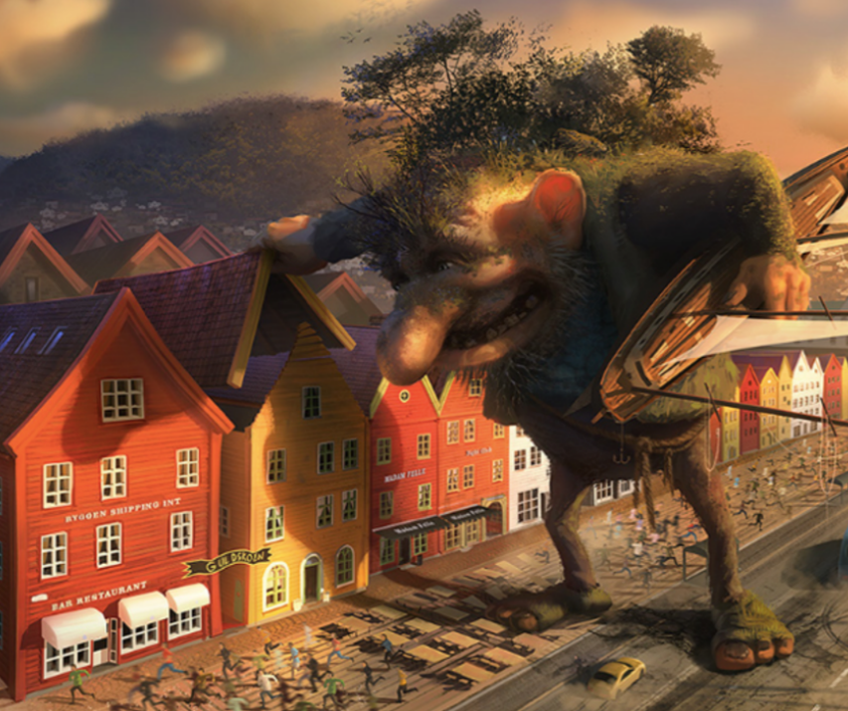
Now that you have chosen your picture, you have the choice for your genre.
- Story – complete the story from the a story starter
- Diary Entry (from either the Troll’s perspective or from the perspective of somebody who lives in the village)

Task 1: Question Time
- What do you think the troll is thinking?
- Do you think he means to cause all this fuss?
- How will the people deal the troll?
- Would you try to catch him or communicate with him?
- When faced with a problem, what are the best ways to deal with it?
- Where do you think the troll has come from?
- What do you think the rope around the troll’s waist is for?

Task 1: Vocab Collection
Use the target below to gather vocabulary that you can use in your writing. Think about:
- Adjectives
- Similes
Once you have your initial ideas, think carefully about where you place them onto the target. Place your most powerful ideas in the centre of the target, and the ideas that still require improvement (pink polished), place around the edge.
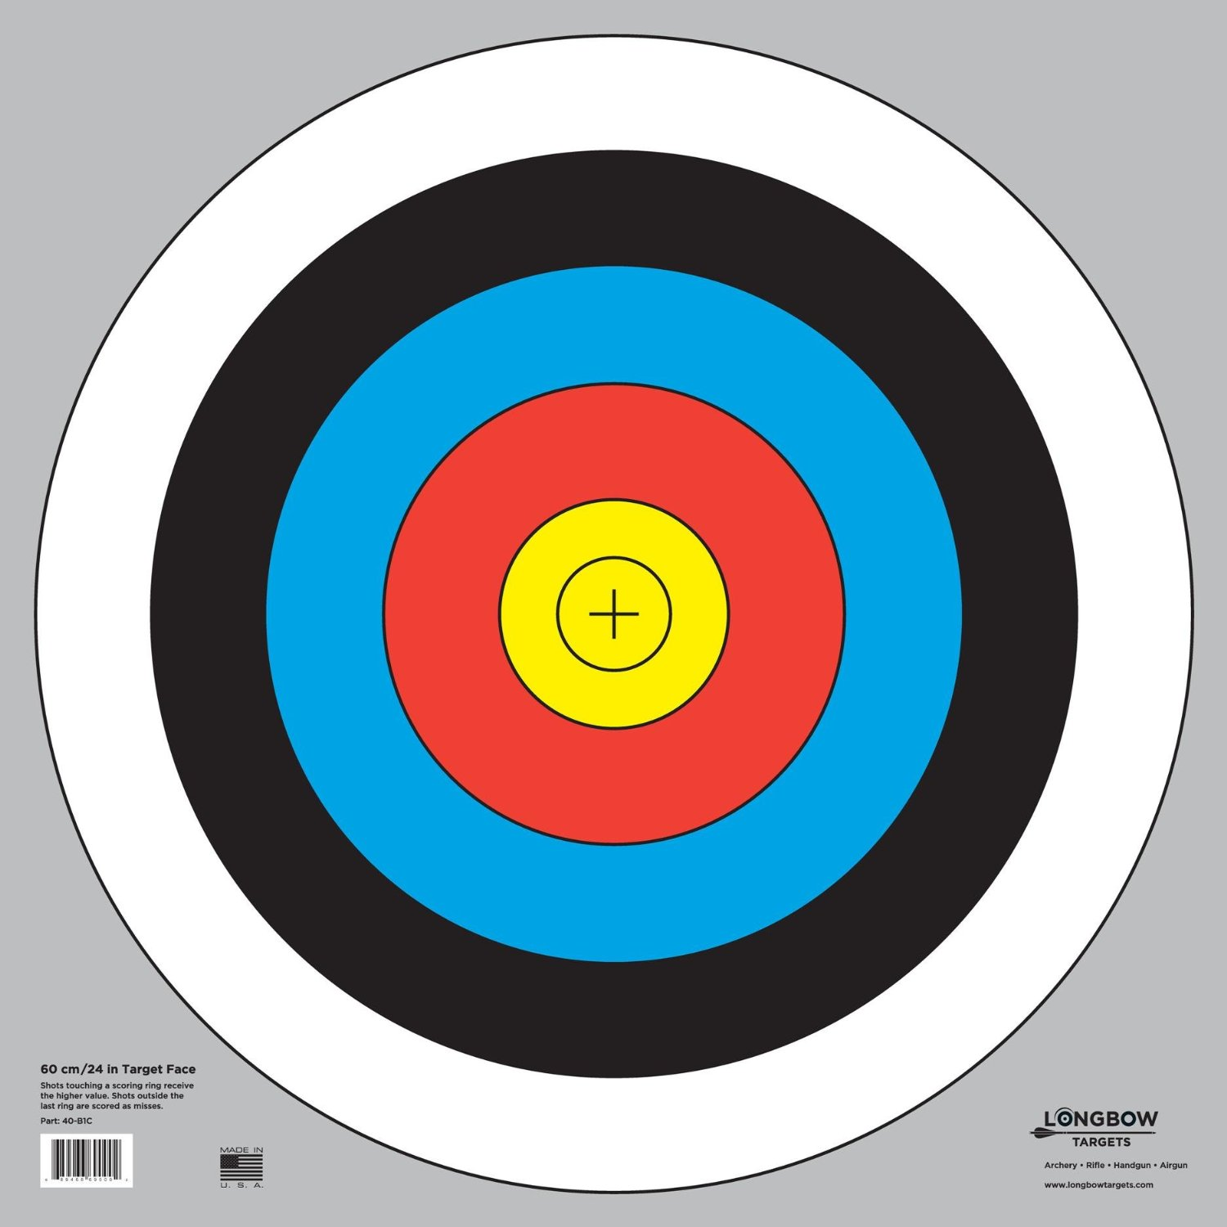
Colossal, intimidating
Giant
Terrifying
Big
Scary

