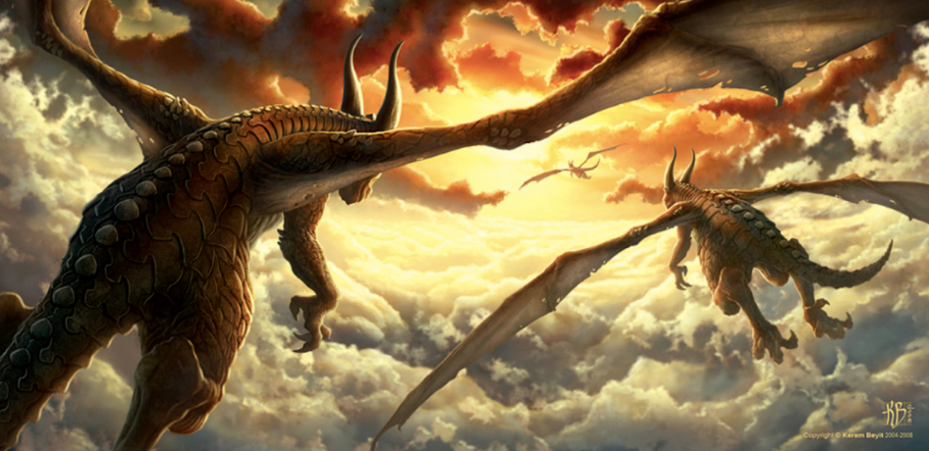
Art Inspired by Dragonworld

Perfect Picture
Can you draw what you think a dragon’s home might look like?
Think carefully about what dragons are fond of.

