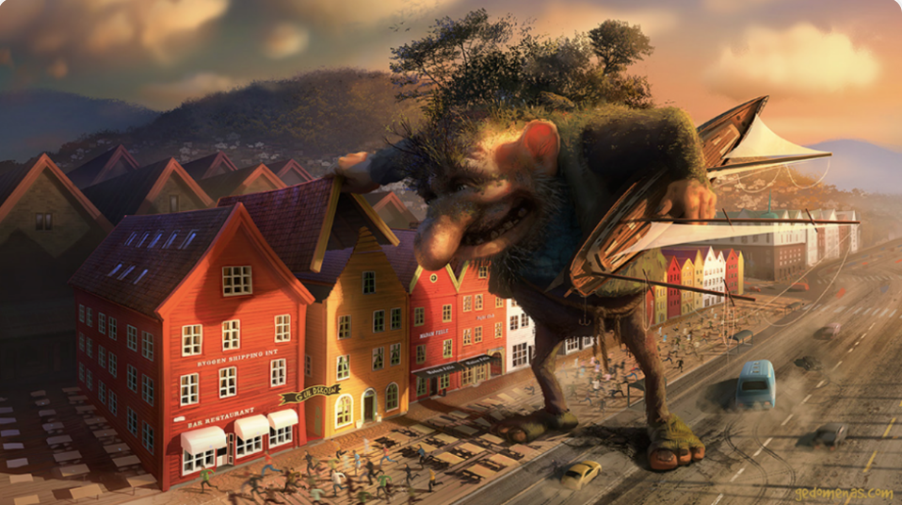
Art Inspired by the Troll

Perfect Picture!
Where do you think the troll lives?
Can you draw or describe what you have imagined?

