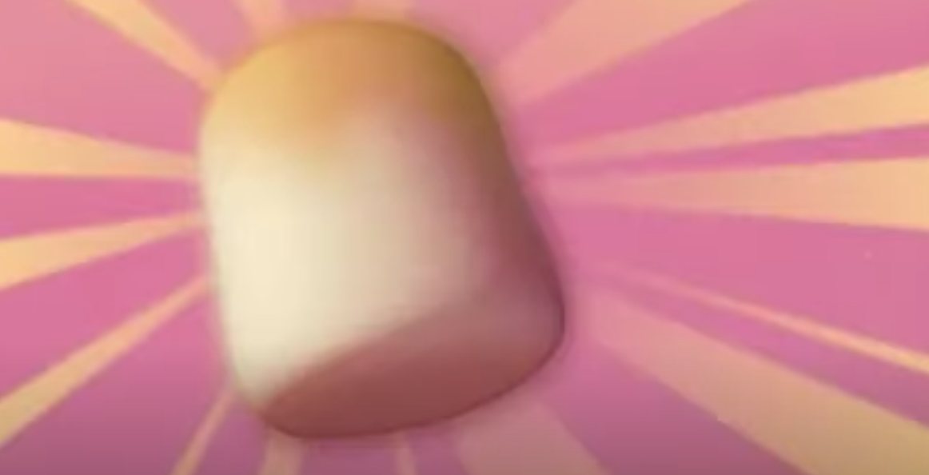
Science Task 1


This week it’s all things marshmallows and your science task is no exception! Help investigate what happens to the creature’s beloved snack when they are put in different liquids.

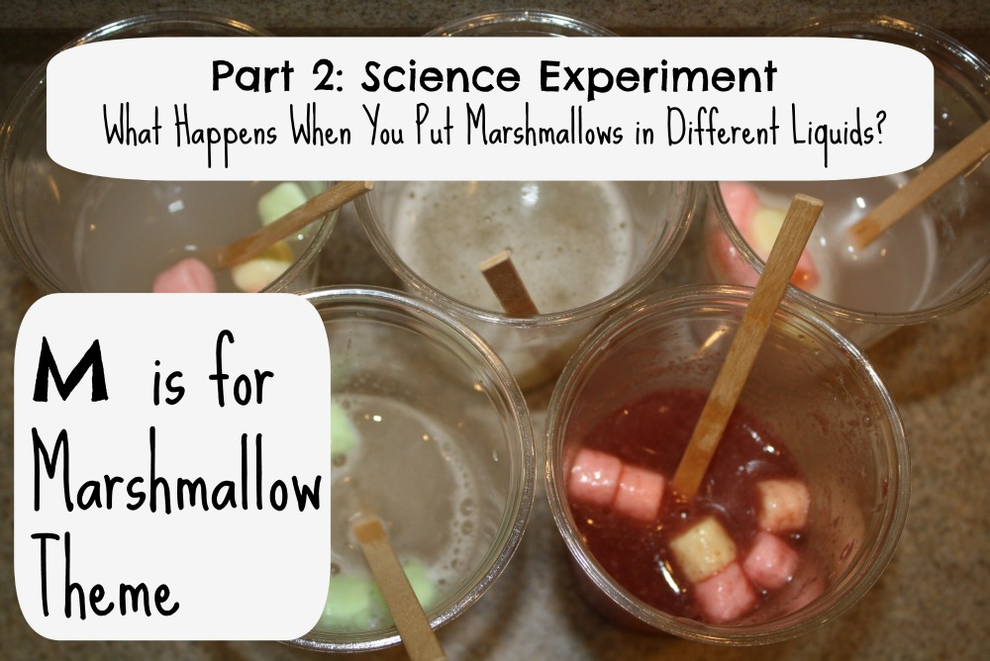

You will need:
- 5 cups or glasses (preferably transparent)
- 5 different liquids (for example – water, a fizzy drink, vinegar, a hot drink, fruit juice, milk, squash, lemon juice, fabric softener or any other liquids you wish to try)
- 5 full size marshmallows or 15 mini marshmallows (3 for each liquid)

You need to:
- Fill each cup with a different liquid, ensuring that there is the same amount in each.
- At the same time, place a marshmallow (or 3 mini marshmallows) in each cup.
- Consider how often you will observe your experiment – will you check on it every hour or will you observe the change over a number of days?

You may want to record your results in a table, with written observations or annotated photos.

