Science Task 2

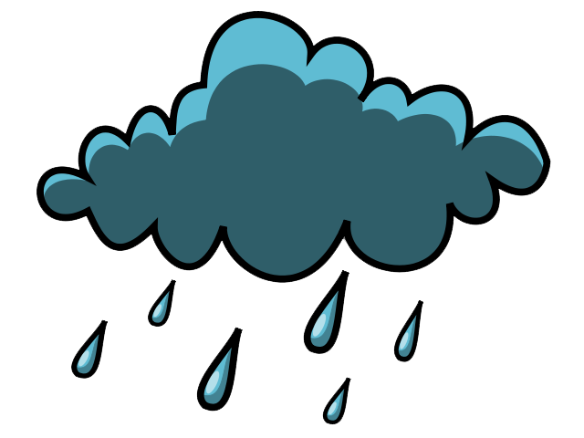
It was a peaceful evening for the young boy, who was camping for the very first time. He had spent days planning his trip and he had come extremely prepared. He’d remembered his sleeping bag, his tent, his water and most importantly his marshmallows. The one thing he had forgotten was his coat. Unfortunately for him, rain was on the way and the boy needs your help.
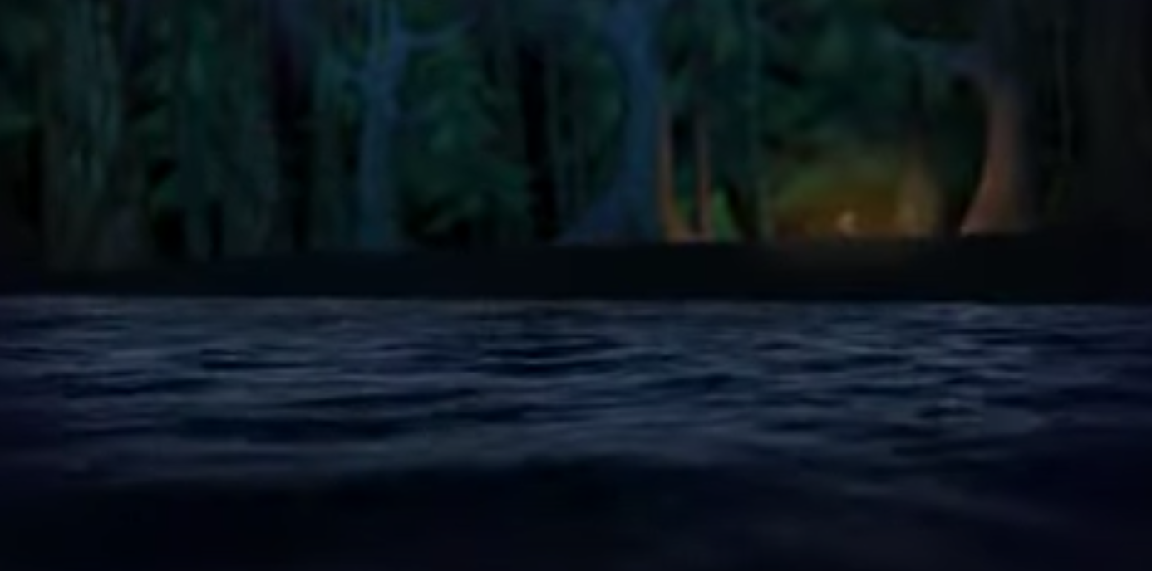
Which material is the most waterproof?
You will need:
- Water
- 4 glasses or small bowls
- A measuring jug
- 4 different materials to test (for example plastic, cloth, foil, cling film, paper or newspaper)
You need to:
- Gather 4 piece of different material, ensuring that they are all the same size.
- Secure the material to the top of a glass or bowl -

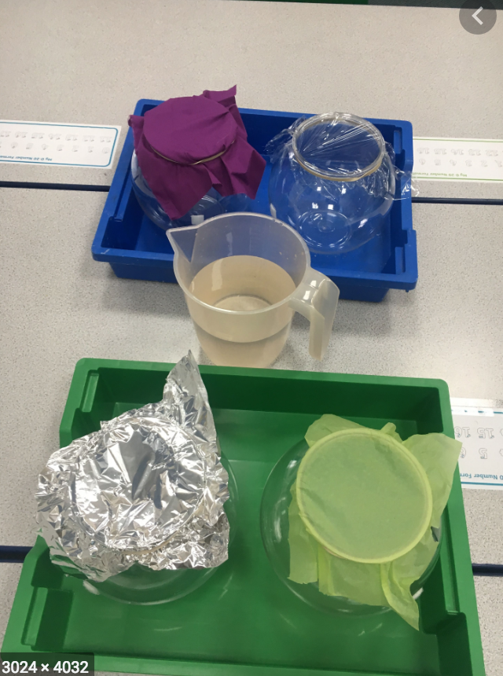

.

- Pour the same amount of water over each material, ensuring that the water that passes through the material is caught in the glass or bowl underneath.
- Measure the amount of water that passed through the material. The material that allowed the least amount of water to pass through is the most suitable material for a waterproof coat.

You may wish to record your results using a table or graph.

Once you have decided on the most waterproof material, you might want to design the boy’s coat. Will it be the same material all over?

