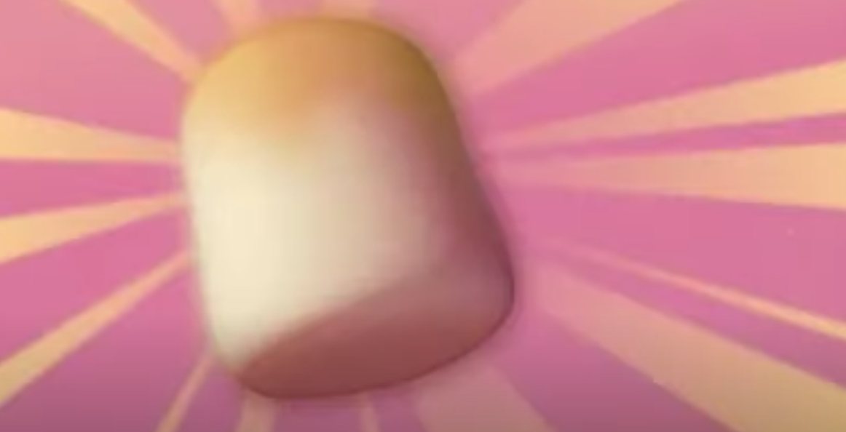
Design and Technology Task 1


This week it’s all things marshmallows! Help the boy share his beloved snack whilst staying at a safe distance from the unpredictable beast.

Your mission is to create a mechanism that will allow the boy to fire marshmallows to the creature from a distance (of at least 5 metres).

Ideas of what you could use:
- A ‘Y’ shaped stick
- Sticks, lollipop sticks, skewers etc
- Elastic bands, hair bobbles or strips of elastic

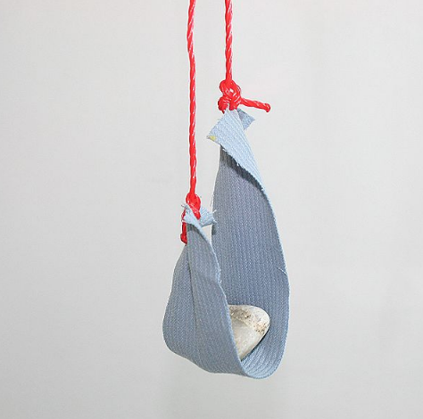
You may wish to use these ideas as inspiration:
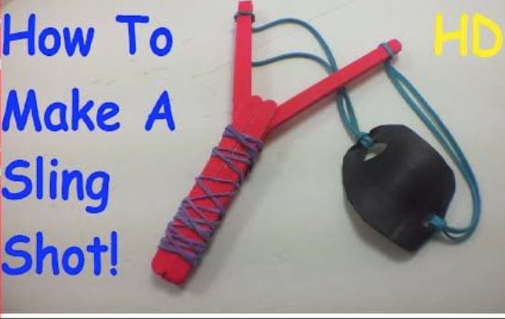
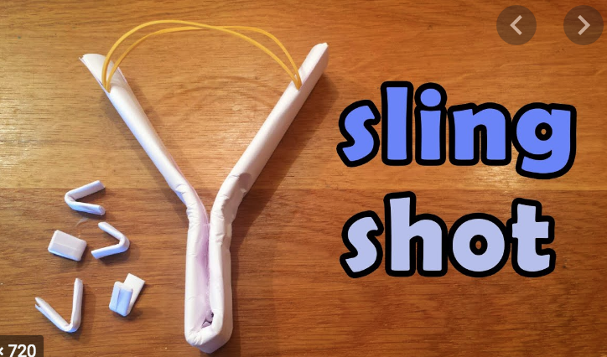
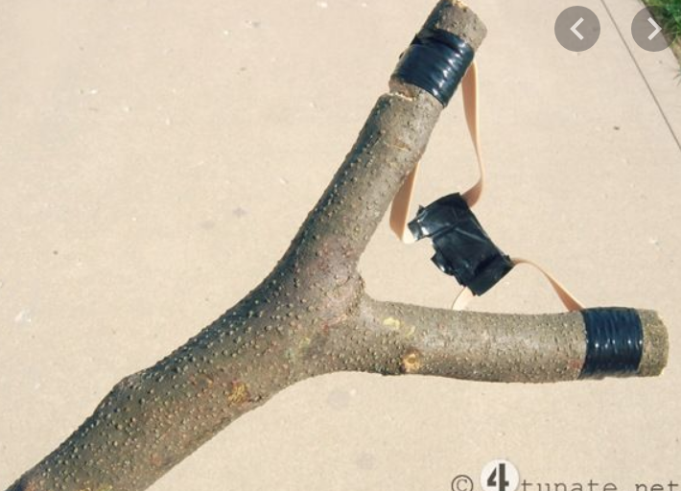

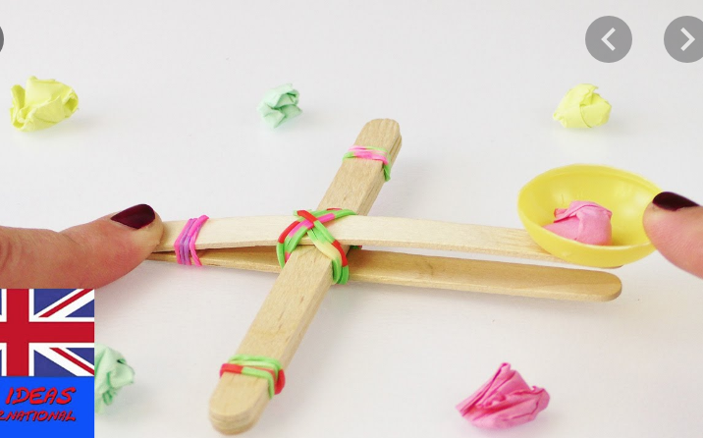
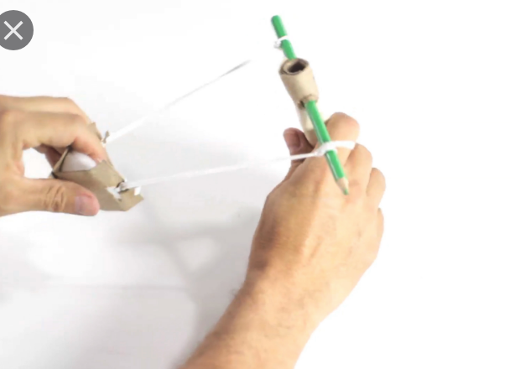
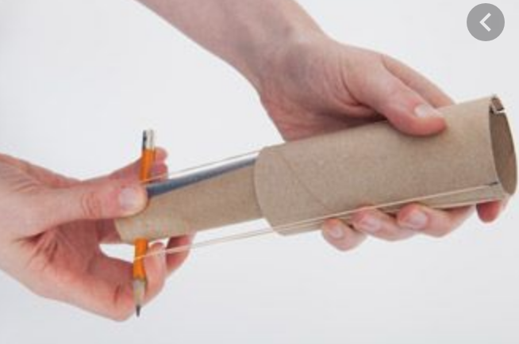
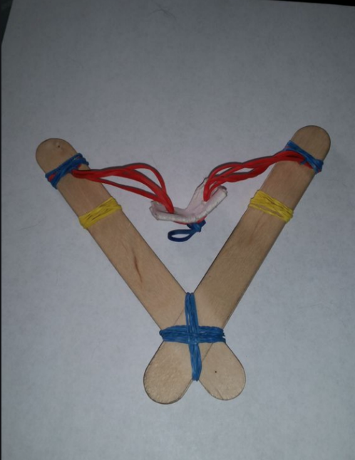

You need to:
- Design and create your mechanism.
- Test your mechanism to ensure it fires an object at least 5 metres.

You may want to record your results in a table, with written observations or annotated photos.

