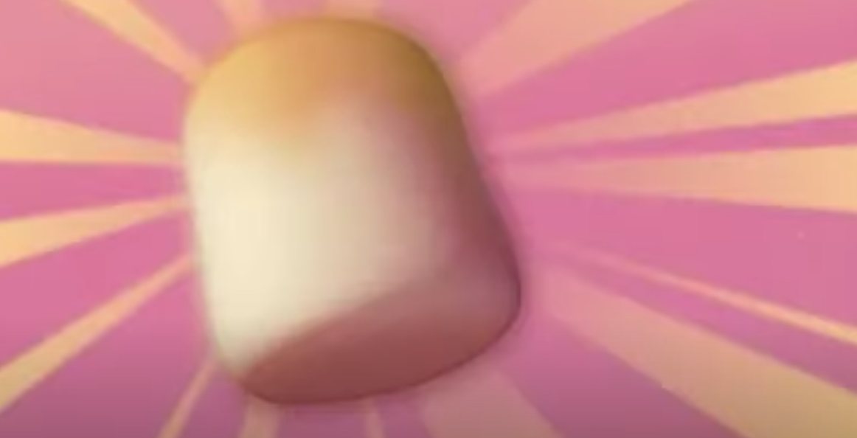
Shadow Puppets Task 2
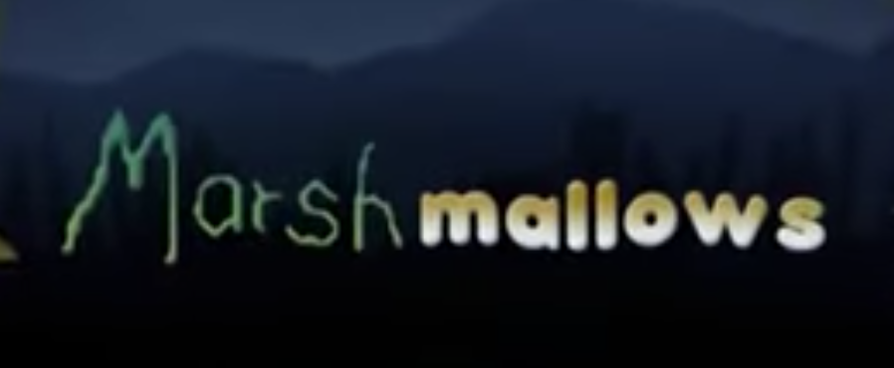

This week it’s all things marshmallows!

Your task is to recreate the story of the creature and the boy using shadow puppets.

You could use:
- Black card or paper
- Kebab sticks, small sticks or lollipop sticks
- A box with a translucent film (you could use tracing paper or baking paper).

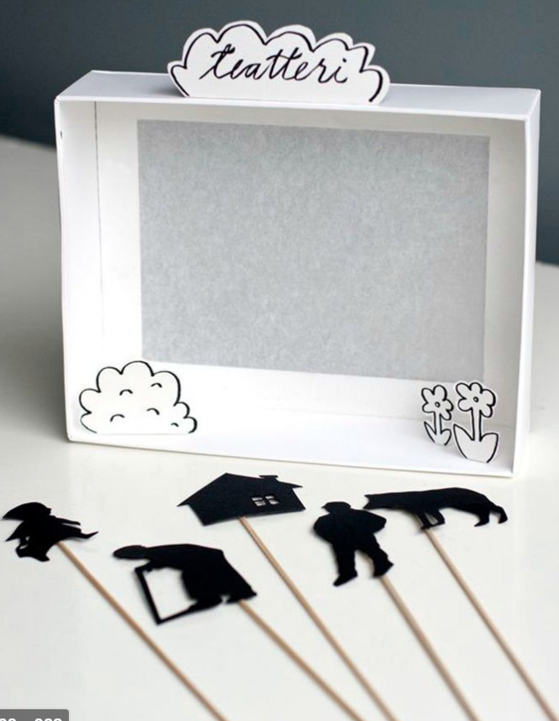
You may wish to use these ideas as inspiration:
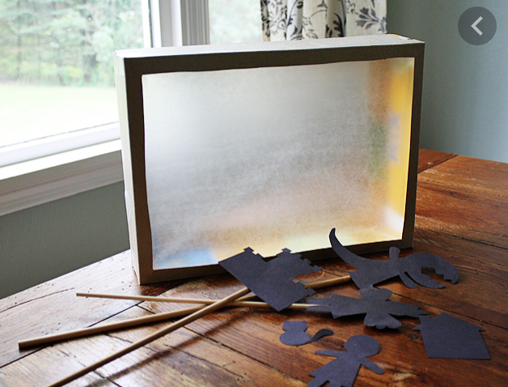
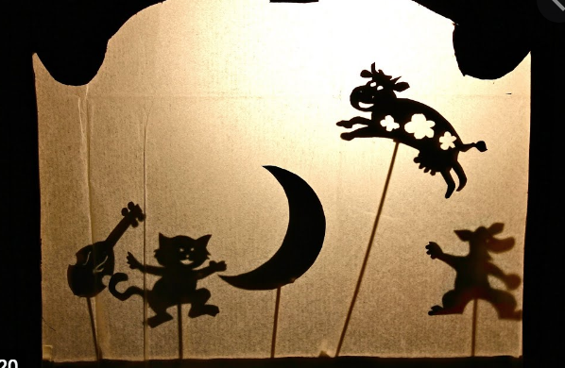

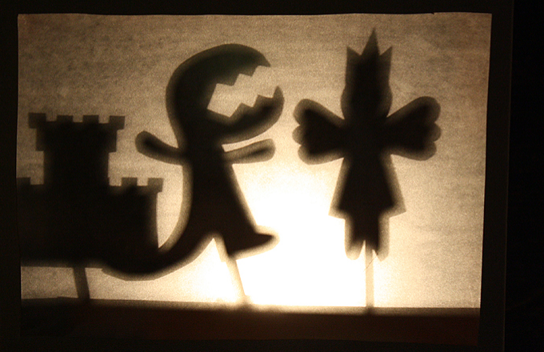
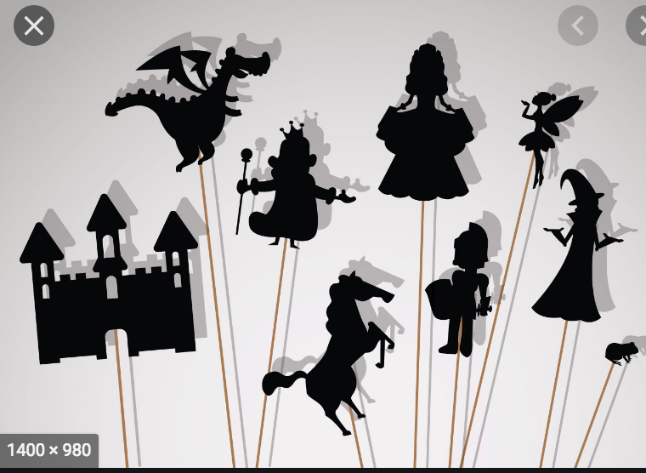
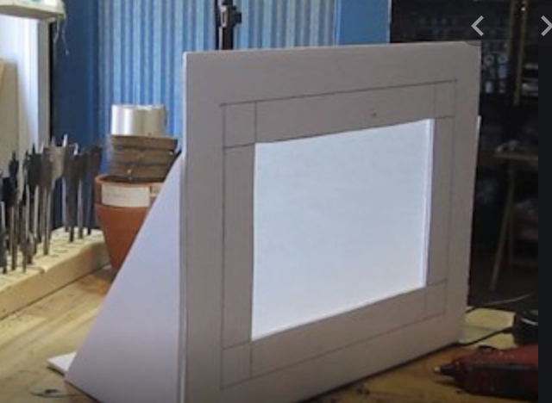
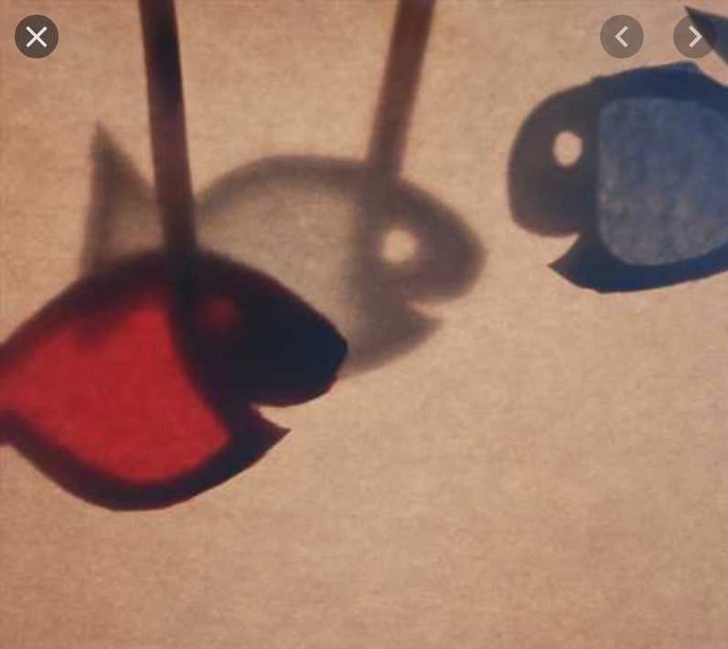

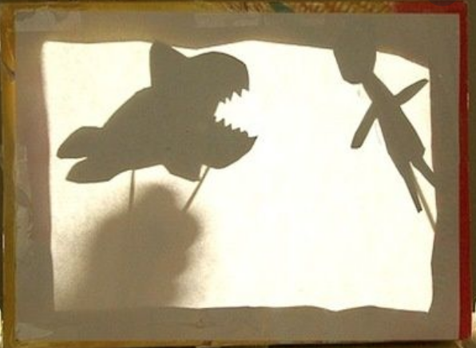
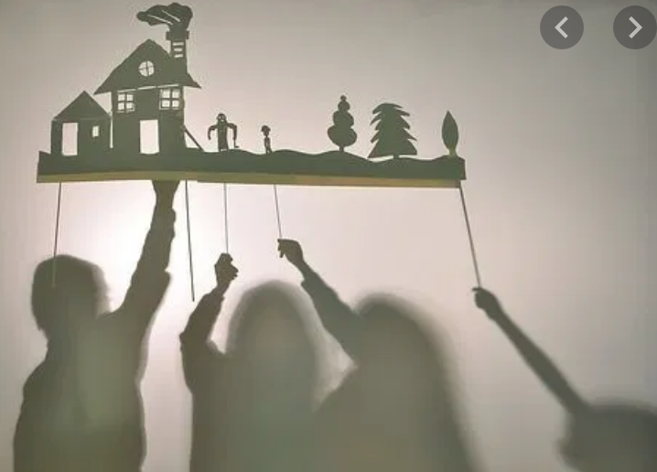

Step 1
Design and create your puppet
Think about their size in relation to each other and how you can make them move.

Step 2
Create your shadow puppet stage
You could use a box with a translucent film or you could use a white sheet or wall.

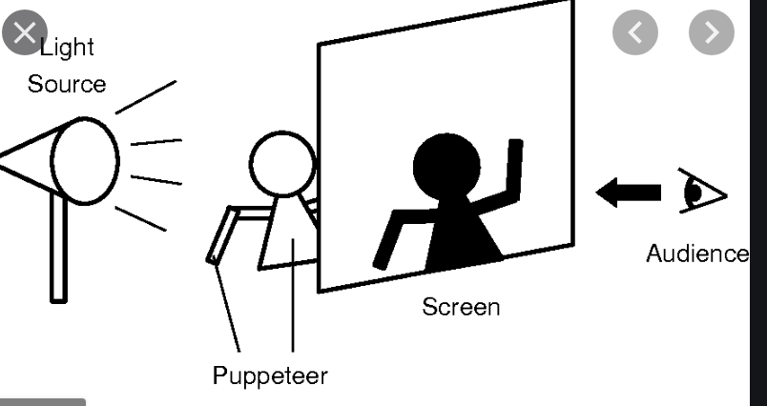

Step 3
The science of shadows
Use your shadow puppets and stage to experiment how shadows are made.
Can you make the shadow appear larger? How?
Can you make the shadow appear smaller? How?
Can you alter the colour? How?

Step 4
Rehearse your puppet show.
You may want to consider narration or speech to tell the story.

Step 5
Perform you puppet show

Gather your family to put on a brilliant performance. You may want to record it or create an iMovie.

