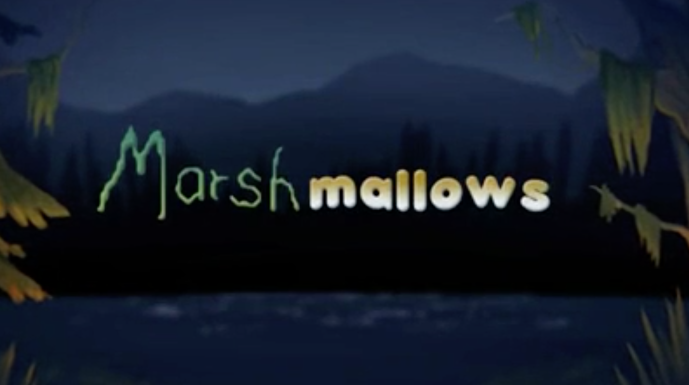

Year 3 and 4
Writing
Task 5

Now you are on to the final section of your story! Complete the starter activity before writing your final two paragraphs.

How can you use imagery to make the monster sound vicious?
Brainstorm your ideas using the pictures below.
To do this, you could use –
- Expanded noun phrases
- Similes
- Metaphors
His razor teeth were back, and they seemed sharper than before.
His evil eyes now glared at the boy, who was now his prey.

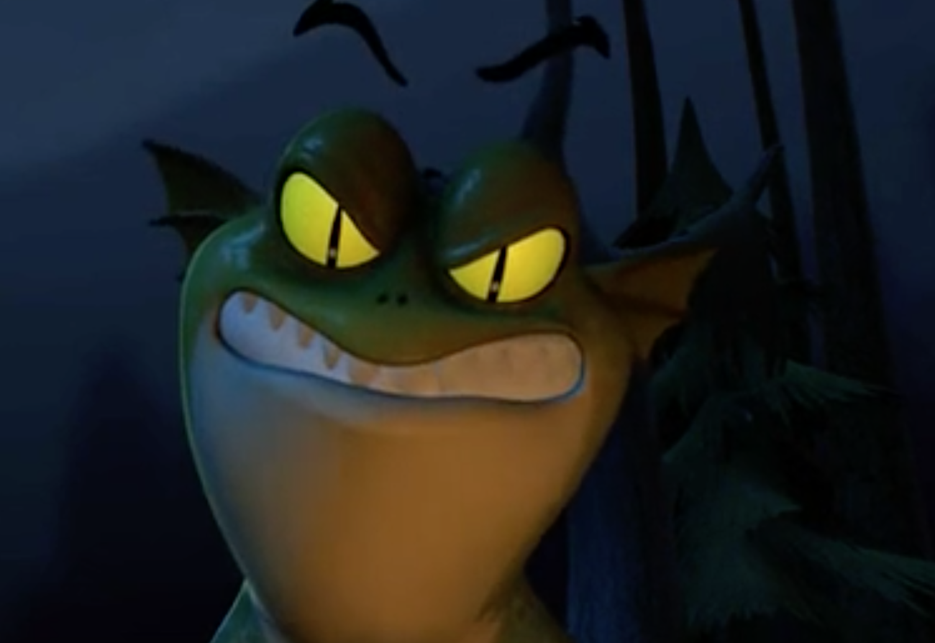

A roar of anger
Ear-piercing

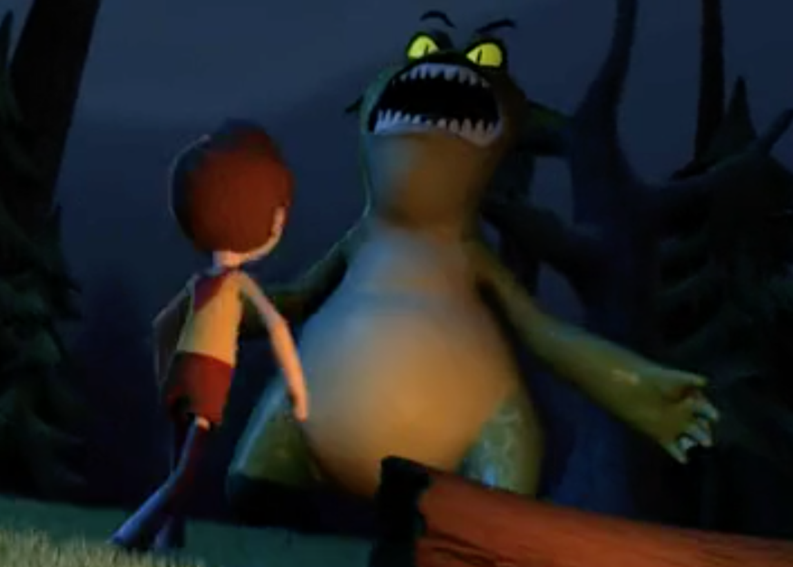

He towered above the boy
Aggressive leap

Paragraph 4

Watch the video from 1 minute 7 seconds to 1 minute 31 seconds.

In this paragraph, you will include –
- The boy realising he has run out of marshmallows
- The monster turning angry
- The monster chasing the boy
- The boy hides behind the pillow

Here is an example of how you could start this section –

The now-friendly monster was still begging for marshmallows, but the boy noticed that they had all gone. What now? Fearfully, he retreated towards the forest. The monster acknowledged this and his evil eyes now glared at the boy, who was now his prey. Immediately, a roar of anger erupted and he leapt aggressively towards the petrified boy.

Paragraph 5

Watch the video from 1 minute 32 seconds to the end of the video clip.

In this paragraph, you will include –
- The monster gets confused and thinks the pillow is a marshmallow
- The boy gives up and hides his face
- The monster chasing after the pillow, which he thinks is a marshmallow
- The boy escaping
- The monster trying to roast the marshmallow
- The monster realising it wasn’t a marshmallow

Here is an example of how you could start this paragraph –

As the boy held the pillow in front of his face, the monster’s eyes strangely lit up. Christmas had come early for this monster as he thought that the pillow was an extra larger, extra tasty, deluxe marshmallow. Yum! The boy lifted his trembling hands and threw the pillow away in fear.

