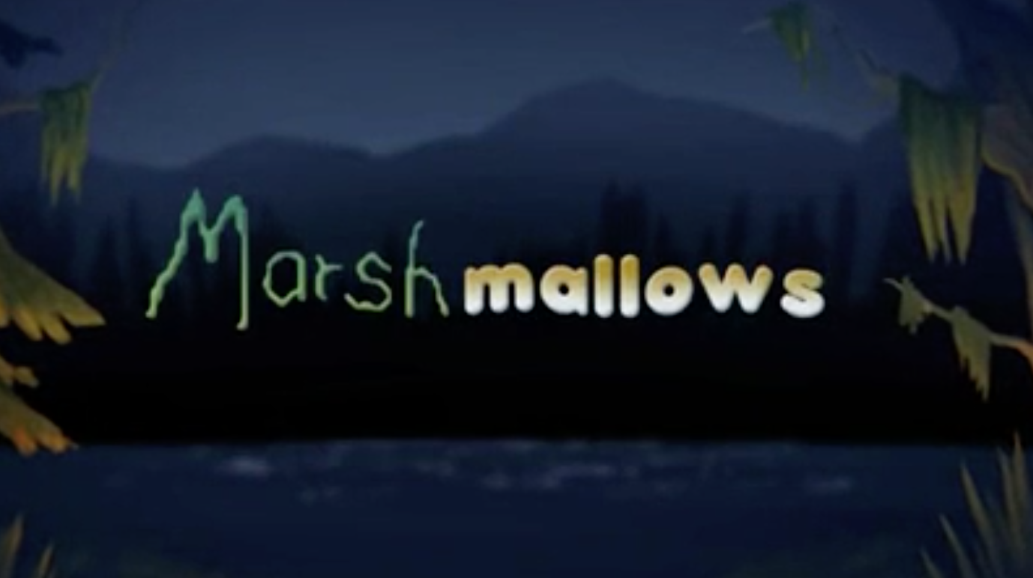

Year 3 and 4
Writing
Task 4

In your next paragraph, the monster’s character completely changes.
Watch the video from 25 seconds to 1 minute 7 seconds.

Can you think about how you will capture the change in the monster?

Can you describe the monster’s moving using verbs and adverbs?
Verb – a word that describes an action, for example walk, run, jump, swim etc

Adverb – a word that describes or gives more information about a verb, for example –

walked speedily

We have included some verbs and adverbs you may want to use.

Verbs
Adverbs

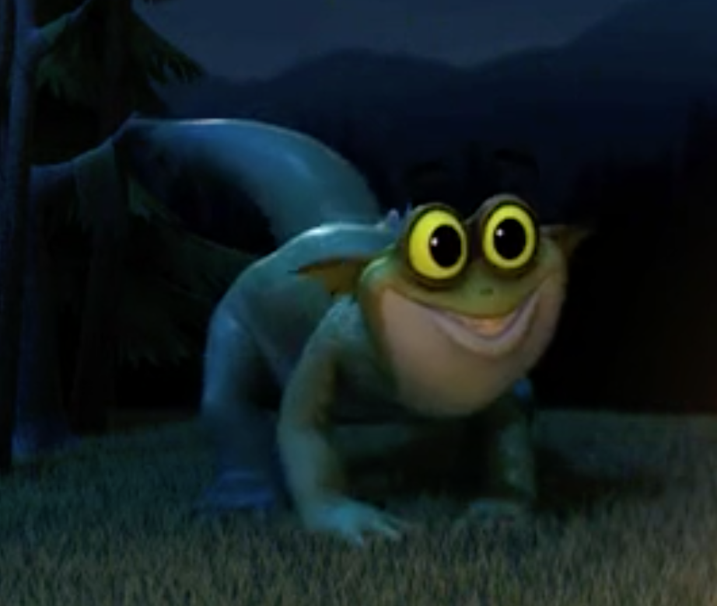

crawled
stealthily

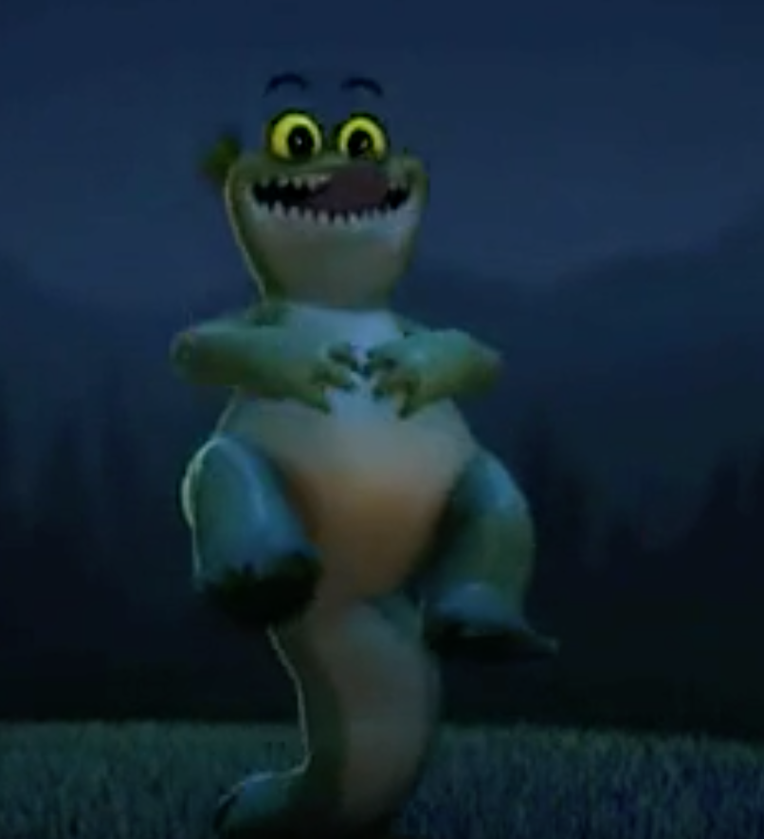
mysteriously

levitated
cheekily

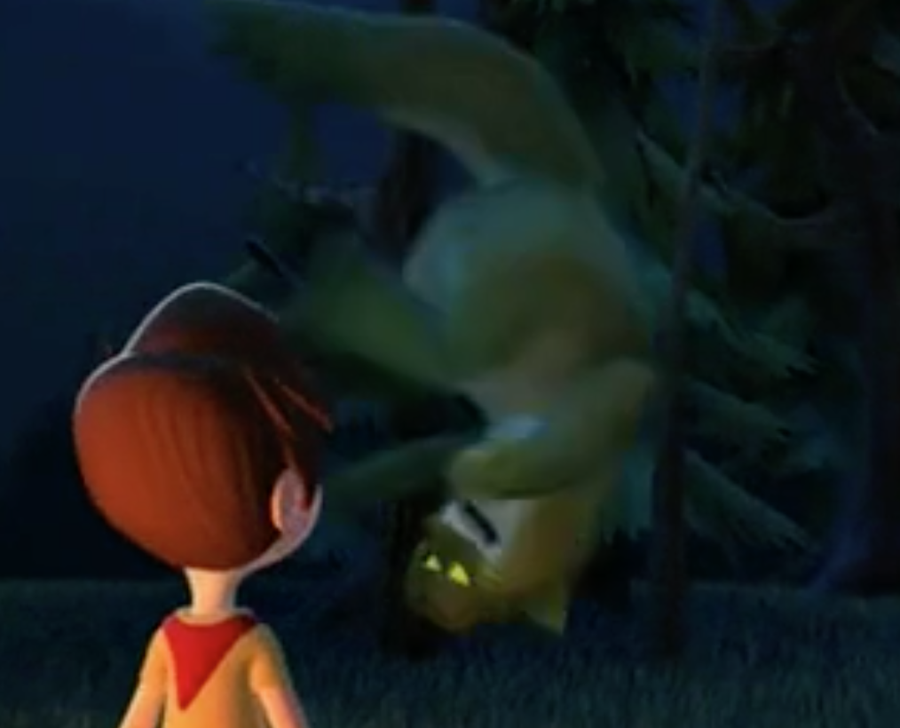
energetically

vigorously
flipped

spun

Verbs
Adverbs
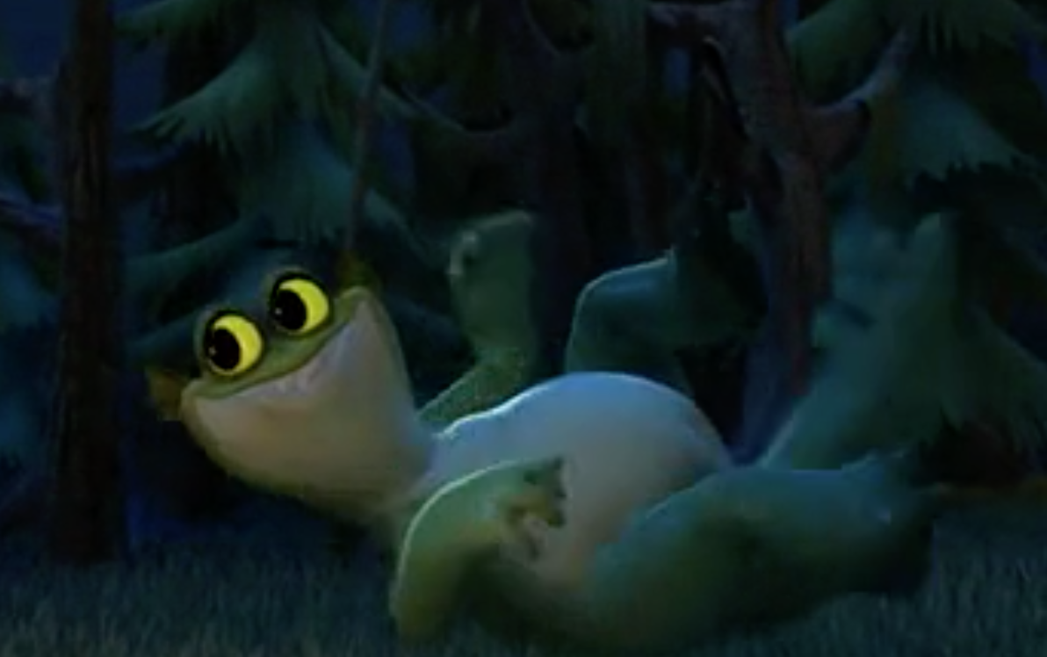

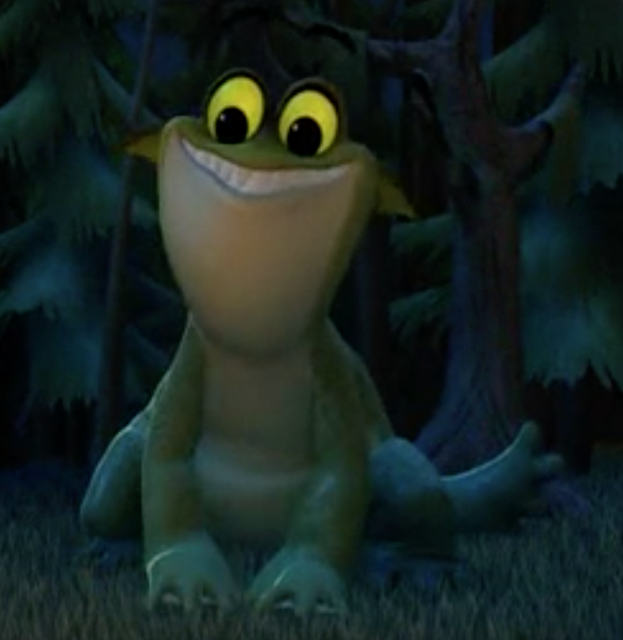

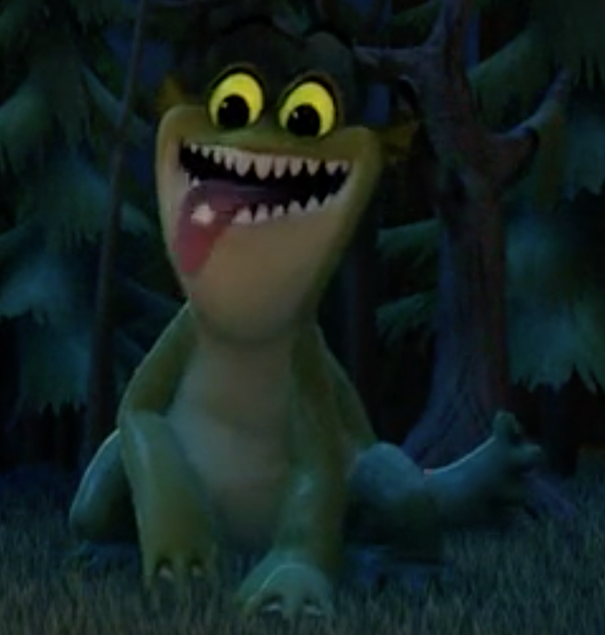

Once you have gathered your ideas, select the most appropriate adverb for each verb.
For example, the monster flipped energetically.

Paragraph 3
In this paragraph, you will need to include –
- The monster admiring the marshmallow
- The boy taking off the marshmallow and the monster eating it
- How the monster acts once he’s eaten the marshmallow
- The boy giving the monster more marshmallows
- The monster picking the boy up

Here is an example of how you could start this paragraph –

With the marshmallow inches from his nose, the monster’s tongue longed for the delicious treat. His eyebrows danced in excitement and he puled a cute face. Yelping like a puppy, the monster begged for the marshmallow. Realising the monster wanted the marshmallow, the boy reluctantly slid it off the stick. Without warning, the monster’s tongue speedily darted to retrieve his prize.

