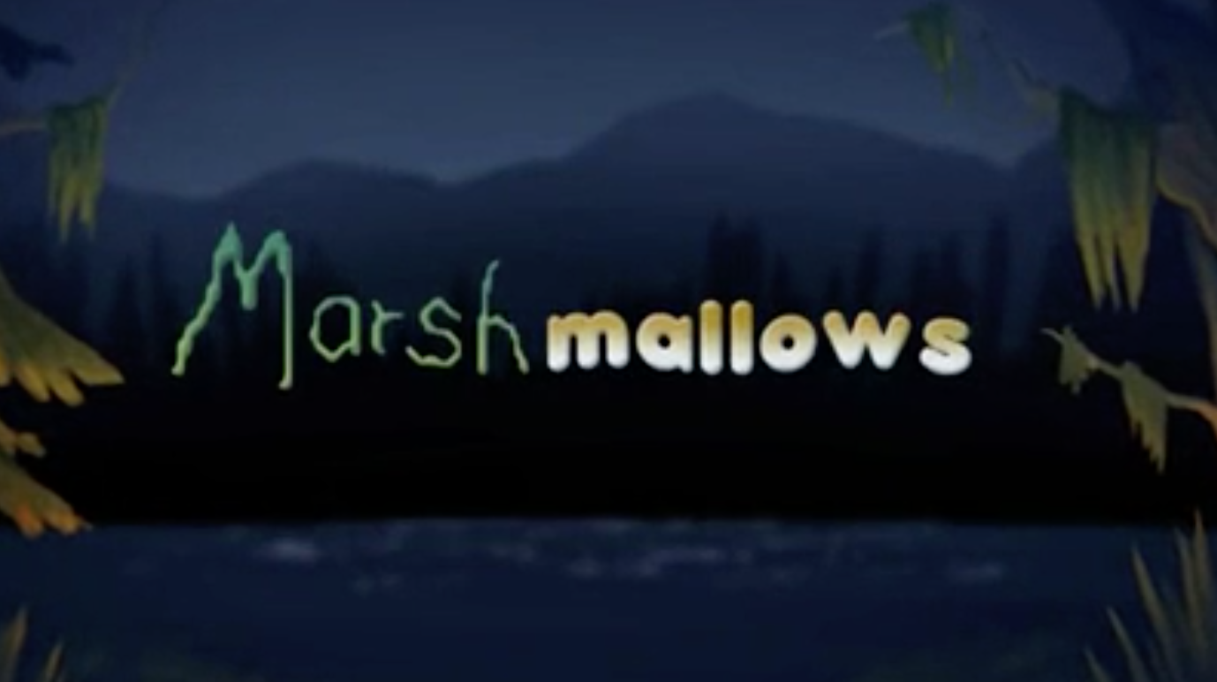

Year 3 and 4
Writing
Task 3

Now, think about how the characters will be feeling when they first meet each other.

Use the pictures below, to record their thoughts and feelings towards one another.

Use thought bubbles to record their thoughts.

Use speech bubbles to record what they would say.

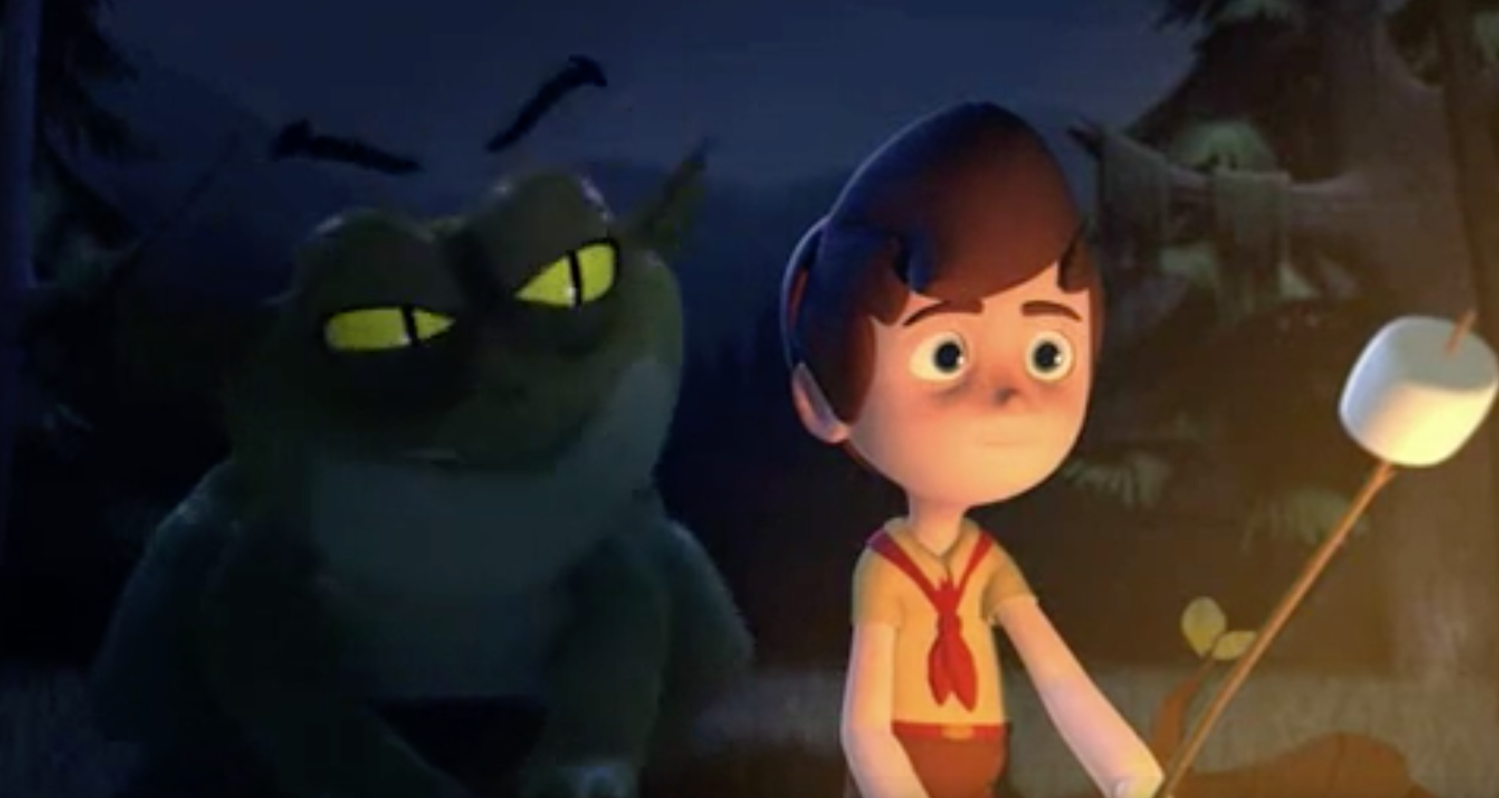

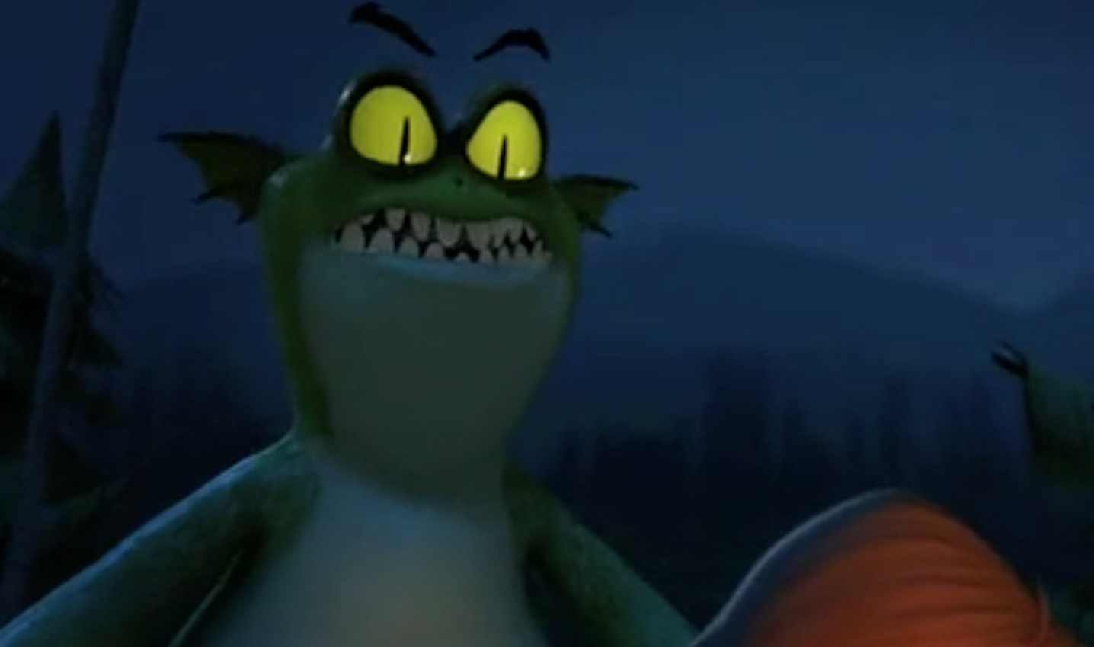

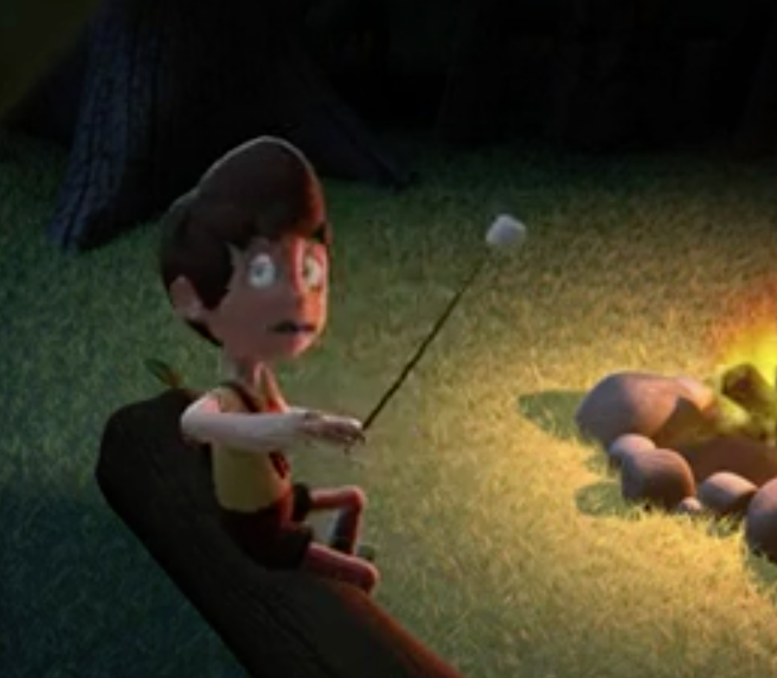

Now watch the video from the start up to 24 seconds.

This will help form paragraph 2. You will need to include –
- The monster appearing in the water and heading towards the boy.
- The monster creeping up on the boy – try to think about how you can describe this.
- The moment the boy realizes there’s a monster behind him and turns around to meet him.

Here is an example of how you could start this section –

A green, peculiar-looking head, with floating eyebrows, appeared from the water. Drawn in by the glowing light, the monster swam towards the shore. As he clambered out of the lake, a strange creature intrigued him. He edged forward. He noticed that the creature was holding something that looked tasty, so he arched over to get a better look. However the boy interrupted his fun as he sensed that something threatening was behind him.

