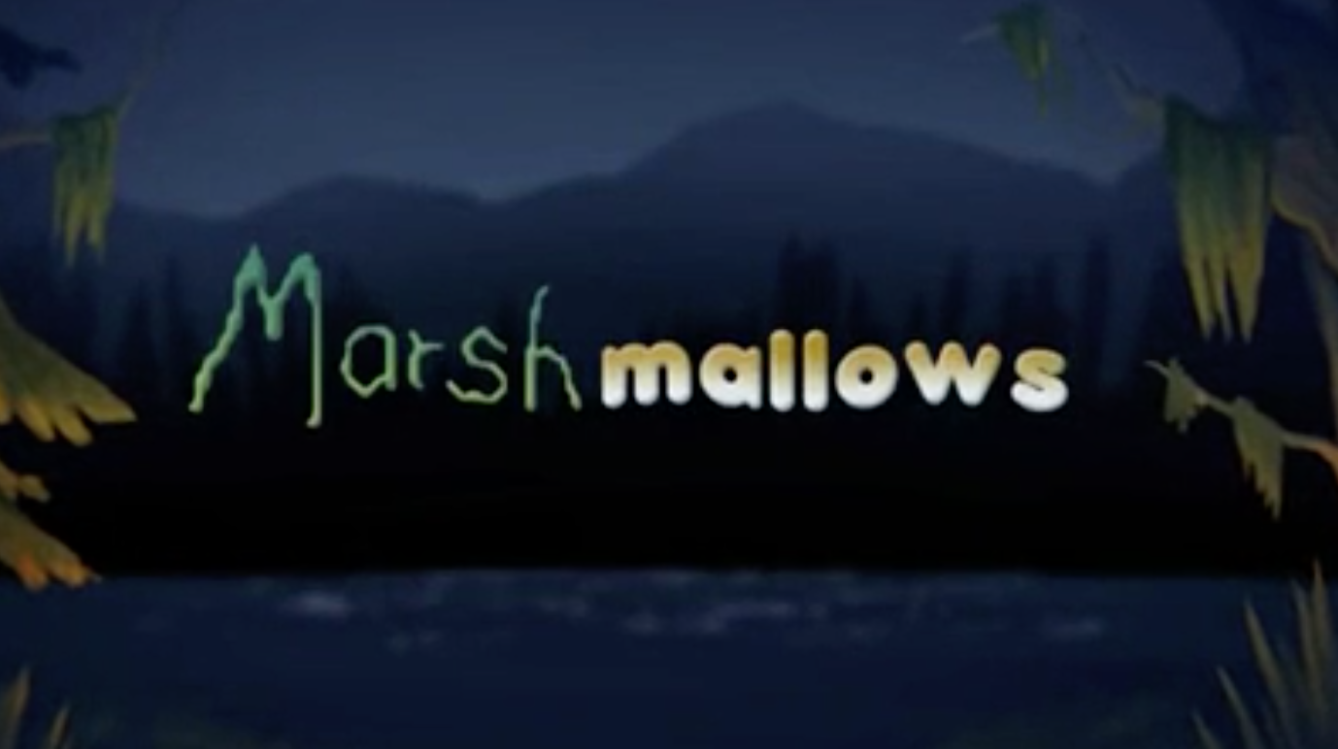

Year 3 and 4
Writing
Task 2

Setting the Scene

Now think about how you would describe the setting. You could use:
- Expanded noun phrases
- Similes
- New vocabulary (use of a thesaurus - https://www.thesaurus.com/)
- Personification

dark
dense
mountains
sky
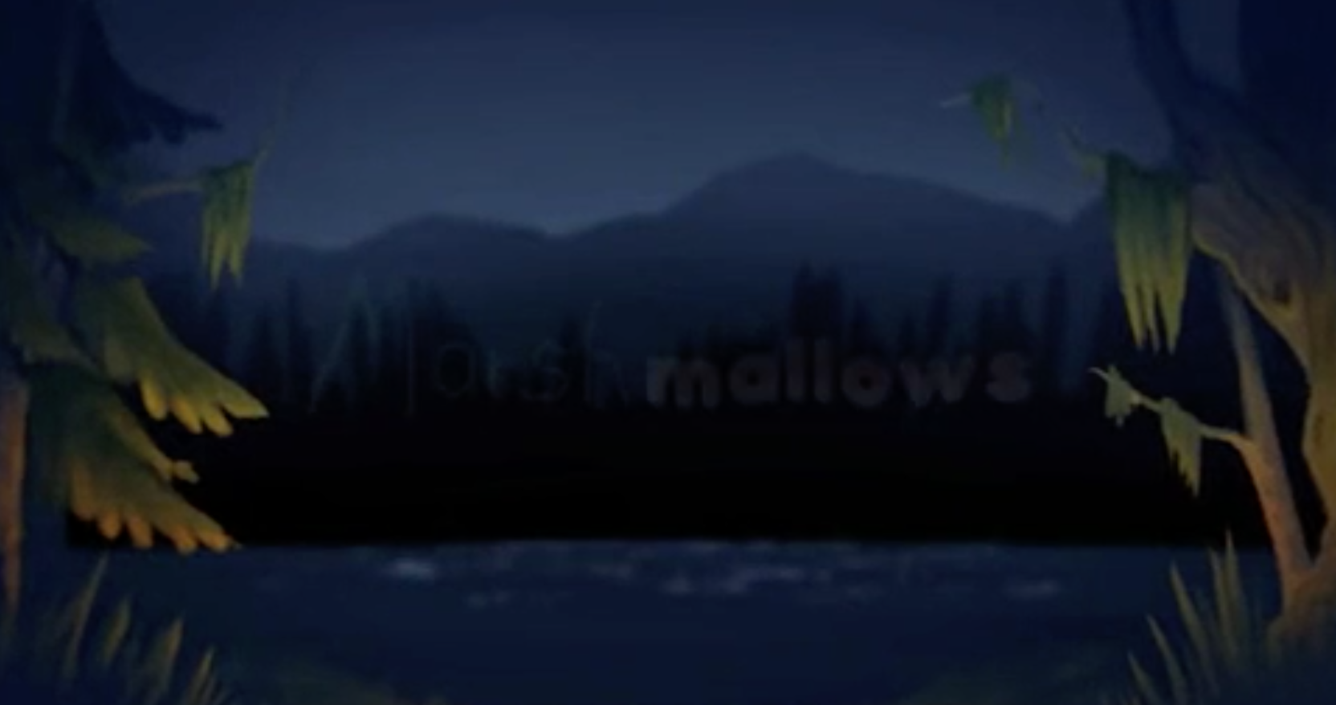
pitch-black

warm
luminous

trees

luminous
torrid
like a beacon
like a lantern
glow
forest
glowing
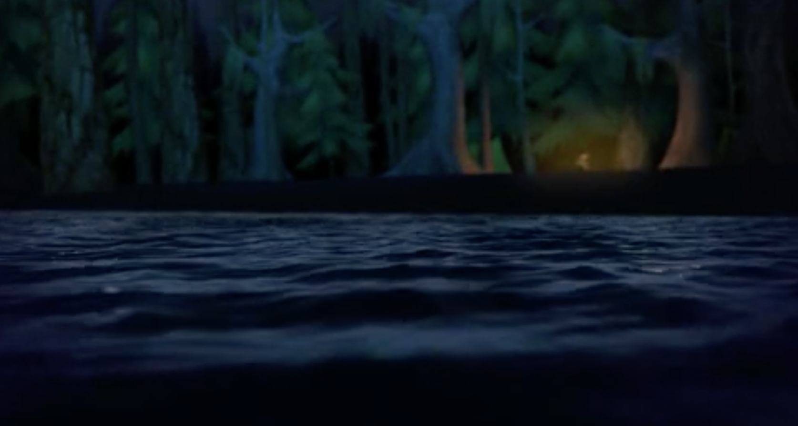
inviting
warm

water

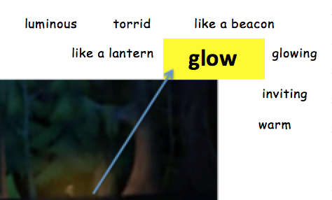
Once you have gathered the vocabulary above, use your ideas to form WOW sentences –

The warm, luminous glow shone like a lantern against the pitch-black backdrop. It was inviting.

Now, use your ideas to compose the opening paragraph to your story.

You may want to use our example as inspiration –

It was silent. The water lay calm and still and mirrored the dark sky above. Towering trees stood tall like soldiers, watching over the water. Each tree varied in shape and size, but the ones that seemed to caress the night sky were the most spectacular. Parting the trees was a warm, luminous gl that shone like a lantern against the pitch-black backdrop. It was inviting. It was the only sign of life for miles. As the fire blazed, a shadow of a small figure appeared. On the opposite side of the lake, a slight ripple interrupted the tranquility. The water’s contents were unknown. What lay beneath the surface?

