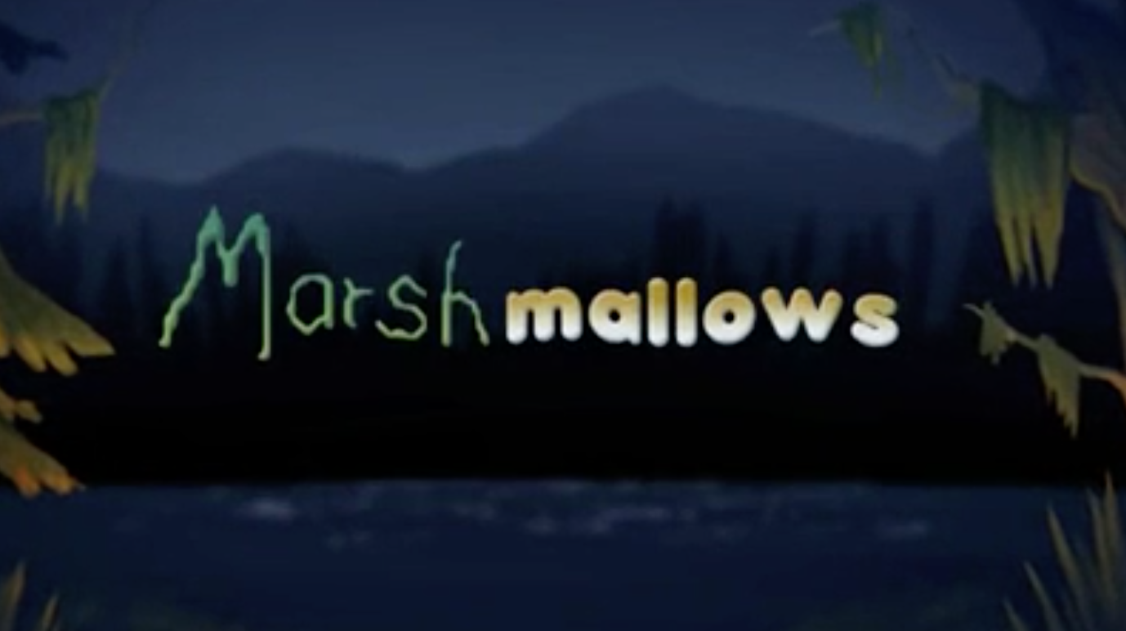

Year 3 and 4
Writing
Task 1

To begin with, you will need to think about the two main characters.

After watching the video, look at the pictures below to gather vocabulary to describe the characters. Please consider both their appearances and their personality traits.

As you will have noticed, the monster has two very different characters – one when he’s feeling content and one when he’s feeling hungry. Consider how your use of vocabulary would change as the characters changes.

When collecting your ideas, remember to consider –
Year 3 | Year 4
- Expanded Noun Phrases  The monster had glowing, piercing eyes.  - New vocabulary (use of a thesaurus https://www.thesaurus.com/)  E.g scary = hair-raising, intimidating, chilling  - Similes  E.g. His teeth were as sharp as a dagger  The monster was determined like a vulture hunting it’s prey.  - Alliteration  E.g. furious face | Expanded Noun Phrases  The monster had glowing, piercing eyes, which illuminated his furious expression.  - Similes  E.g. His teeth were as sharp as a dagger  The monster was determined like a vulture hunting it’s prey.  - Alliteration  E.g. furious face  - New vocabulary (use of a thesaurus https://www.thesaurus.com/)  E.g scary = hair-raising, intimidating, chilling  - Metaphors  E.g. His teeth were razors  His eyes were fire  - Personification  E.g His eyebrows danced  His tongue waved to the marshmallow

The Boy

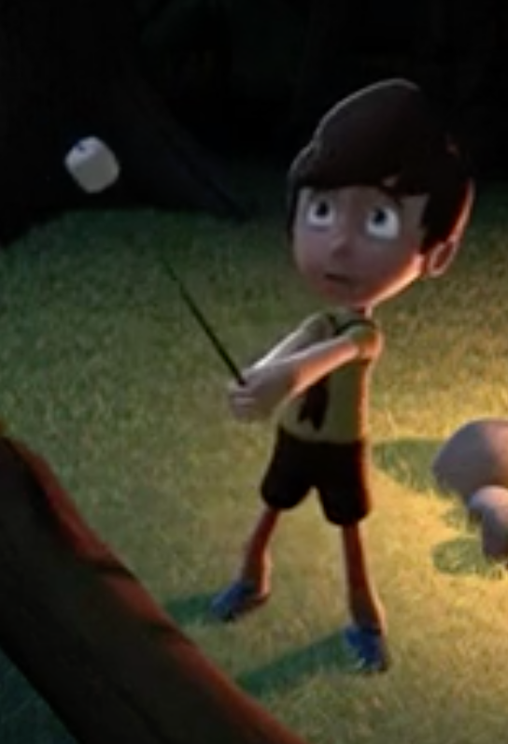

The Monster 1

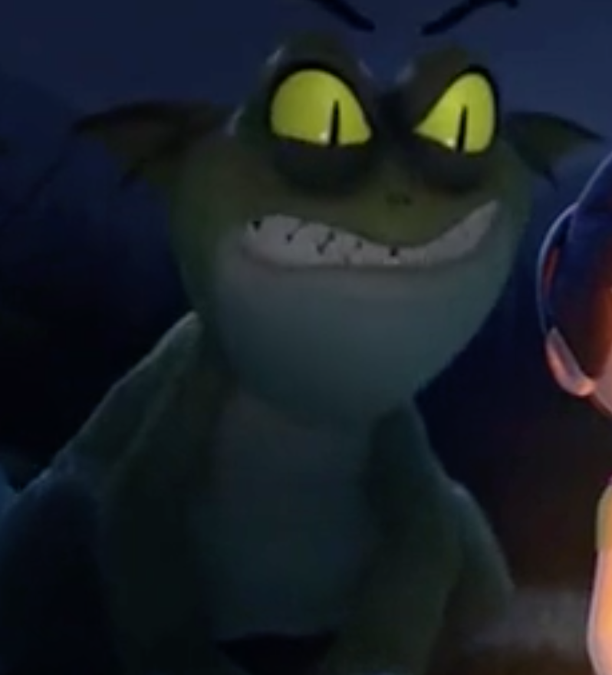

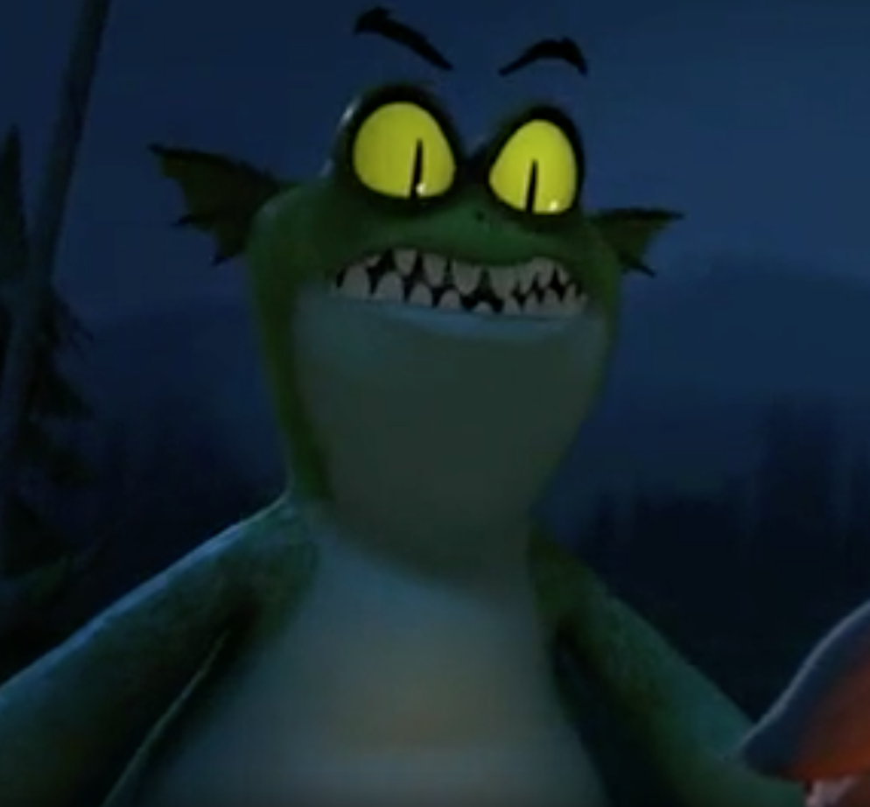

The Monster 2


