Dear my future Year 5 class,
I hope you are as excited as I am that we will be working together next year. As we can’t yet meet in person, I thought I would write to you to let you know a little bit about me…


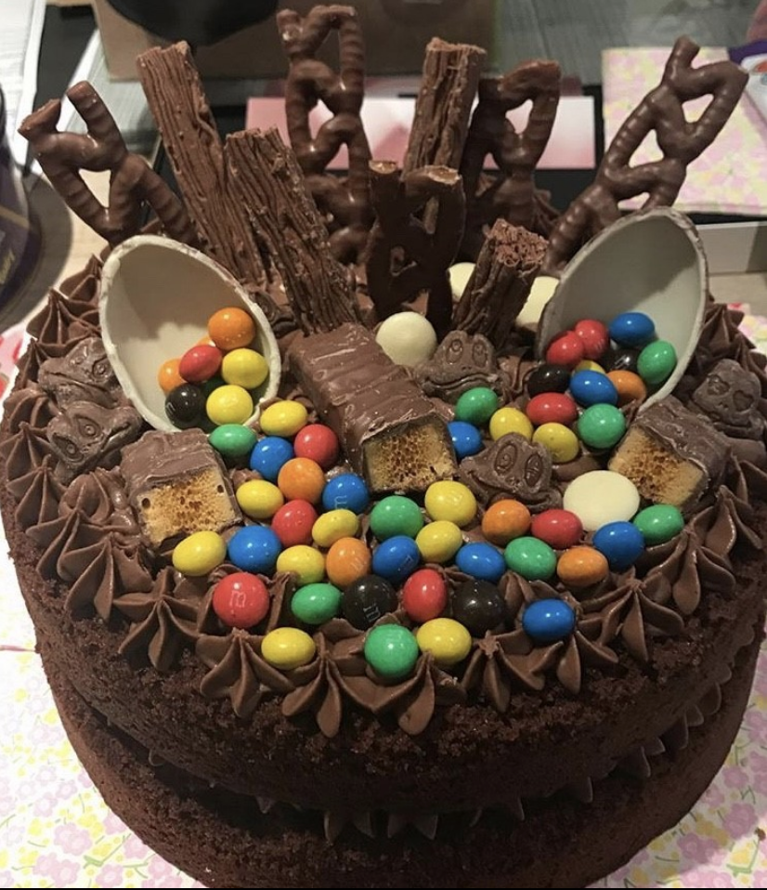
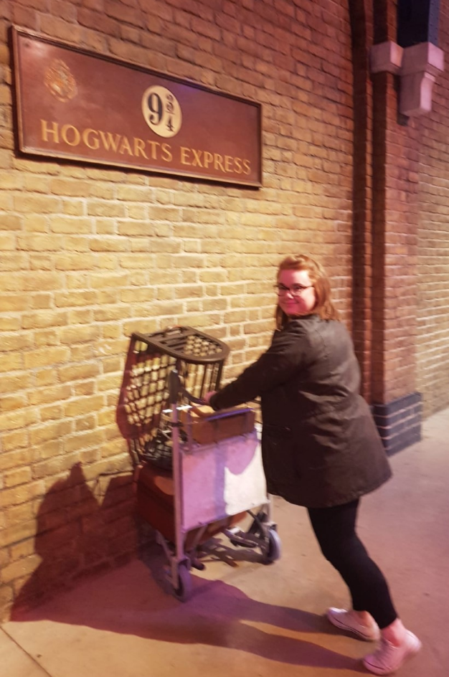
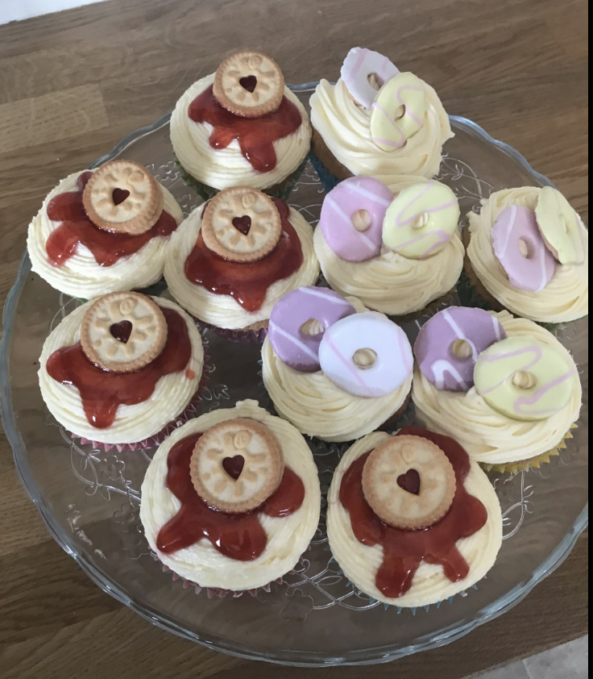
When I’m not teaching, I love nothing more than getting my apron on and baking a cake. Chocolate cake and Jammy Dodger cupcakes are my signature bakes! I absolutely love reading, and as I am sure some of you already know, my all time favourite books are the Harry Potter series (I can’t choose just one, it’s just too difficult). Reading in the garden with a cup of tea is my favourite place to be - especially when it’s beautifully sunny! During lockdown, we had a brand new addition to our house, and he has definitely kept me extremely busy. Chester, my King Charles Cavalier Spaniel puppy, is very cute but very mischievous, and he is obsessed with finding and hiding my socks! I have recently moved house, so my weekends are usually spent with a paintbrush in one hand and a roller in the other. I have also had to learn how to manage our new garden and have been growing my own lettuce, strawberries and tomatoes.


Let me tell you a little bit about next year…Our first topic is ‘Walls and Barricades’, where we will be learning all about the impact of famous and historical walls, including the Berlin Wall and the Great Wall of China.

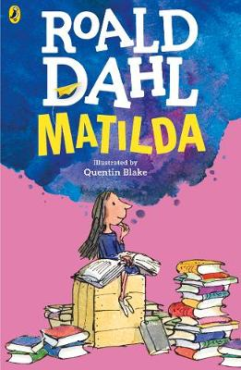
We will start our year by reading Matilda by Roald Dahl. This is one of my all time favourite books, and I know that you will enjoy the comedy and humour it has to offer. This book will be the focus for most of our guided reading sessions and it will inspire some of our writing.


I know that the question on many of your lips will be: ‘Are we doing a Harry Potter topic?’ Well, the answer is…YES! We will be reading Harry Potter in the spring term and the magical world of all things Potter will inspire our learning in lots of different areas.

I know some of you may be feeling a little anxious about returning to school in September, and some of you will be feeling extremely excited. Please know that we will tackle our return to normality together and as a team. Mr Ormesher, Mrs McNally, Mrs Georgiou and I will be there to welcome you on your very first day back, and we will be there for you each and every single day to ensure that you are happy, settled and supported in Year 5.
I am so excited to return to school in September, and I know that we are going to make a phenomenal team. You now know a little bit about me, and I would like to know a little bit about you too, so I would love it if you wrote back to me. It would be great to know what your favourite subjects are, what you do when you’re not in school, what your interests are, what your favourite book is and what you’re most looking forward to in Year 5. It would also be a great opportunity to ask me any questions that you may have about Year 5.
I look forward to reading your letters and I cannot wait to see you all in September and welcome you into Year 5.
Have a wonderful summer break!
Miss Fletcher

