Reading

- Have we experienced Paddington’s adventures?
- Can we relate to Paddington’s feeling on his adventures?
Writing

- Paddington’s life in Peru compared to England
- Is the Queen’s life the same as ours?
- Comparing Aunt Lucy’s life to Paddington’s in England.

Worlds apart
Are All Lives the Same?
Concepts: equality, community, tradition

PSHE

- Do all children have a voice?
- What school life for children in Peru compared with England?
- Can we relate to Paddington’s feeling on his adventures?

Art

- Does everyone access to the same art resources?
- How does art vary within countries and cultures?
- Create art work inspired by Peruvian culture.
RE

- Year 1
  - Christian text: The Good Samaritan.
  - Islamic text: Be My Guest
- Year 2
  - Christian text: Noah’s ark.
  - Islamic text: The Crying Camel

Comparing the aspects of lives within Christian and Islamic faith.

PSHE – school council and class charter
Topic – comparing life in England to life in Peru, comparison of food and culture.
RE – sacred stories (Islam and Christianity)
Art – the study of a Peruvian artist

Reading – Paddington coming to England
PSHE - school council
Topic – studying our local area on a village walk and comparing to a community in Peru
RE – scared stories

Equality
and Diversity
Community

Worlds apart
Are All Lives the Same?
Concepts: equality, community, tradition

Tradition

Topic – picnic, the culture and tradition in Peru and the traditional foods from different cultures
PE – traditional sports games (rules)

Maths

Place Value

- I can sort objects
- I can count objects
- I can count objects from a larger group

- I can represent objects
- I can recognise numbers as words
- I can count from any number
- I can find one more
- I can count backwards within 10
- I can find one less
- I can compare groups by matching
- I can recognise fewer, more and the same as
- I can recognise less than, greater than and equal to
- I can compare numbers
- I can order objects and numbers
- I can use a number line

Addition

- I can recognise parts and whole
- I can use the part-whole model
- I can write number sentences

- I can recognise fact families
- I can find number bonds within 10
- I can add together
- I can add (more)
- I can solve addition problems

Reading

Book:
- Paddington’s suitcase books

Word reading:
- I can continue to apply phonic knowledge and skills as the route to decode words
- I can read accurately by blending the sounds in words that contain the graphemes taught so far
- I can read aloud books closely matched to their improving phonic knowledge

Comprehension:
- I can discuss the sequence of events in books and how items of information are related
- I can become increasingly familiar with and retelling a wider range of stories.
- I can check that the text makes sense to them as they read and correcting inaccurate reading
- I can make inferences on the basis of what is being said and done

VIPERS reading scheme:
- Vocabulary
- Infer
- Predict
- Explain
- Retrieve
- Sequence
Writing

Throughout the year, Year 1 will learn to –

- I can use regular plural noun suffixes –s or –es [for example, dog, dogs; wish, wishes], including the effects of these suffixes on the meaning of the noun
- I can use suffixes that can be added to verbs where no change is needed in the spelling of root words (e.g. helping, helped, helper)
- I understand how the prefix un– changes the meaning of verbs and adjectives [negation, for example, unkind, or undoing: untie the boat]
- I can combine to make sentences
- I can join words and joining clauses using and
- I can sequence sentences to form short narratives
- I can separate of words with spaces
- I can use capital letters, full stops, question marks and exclamation marks to demarcate sentences
- I can use capital letters for names and for the personal pronoun I
Autumn 1

Science

Over the duration of the year our science learning will be covered through planning in the moment opportunities.

We will cover:
- Animals including humans
- Plants
- Seasonal Change
- Everyday Materials

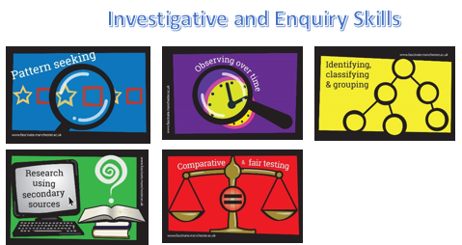
RE

Caring for others
Key questions:
- Who cares for us?
- Who/what do we care for?
- How do Christians care for others?
Christian text: The Good Samaritan
Islamic text: Be Our Guest

Vocab:
Christianity
Islam
Bible
Qur’an
Prophet
Samaritan
Inclusion
Community

Art/DT

Artist:
- Victor Delfin (Peruvian Artist)
Skill Focus:
- Use a variety of tools and techniques including different brush sizes and types
- Mix and match colours to artefacts and objects
- Work on different scales
- Experiment with tools and techniques e.g. layering, mixing media, scraping through
- Name different types of paint and their properties
Colour
- Identify primary and secondary colours by name
- Mix primary shades and tones
- Mix Secondary colours
Texture
- Create textured paint by adding sand, plaster

Music

Charanga

Unit: Hey You!
Style: Old-School Hip Hop
Topic and cross-curricular links: To compose a rap or words to an existing rap, that could link to any topic in school.
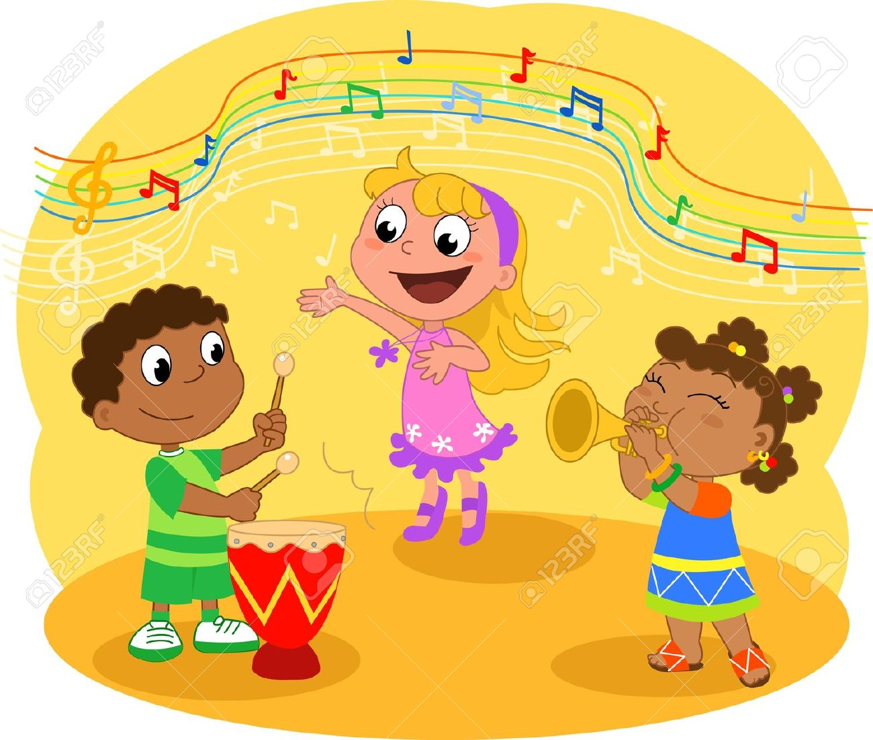

PSHE

Me and My School

Class rules
School Council

• Making choices
• Compromise
• Skills of a representative
•Own skills in relation to School Council
•Class meetings
Computing

Computer systems and networks – IT around us

- Technology in our classroom
- Using Technology
- Developing mouse skills
- Using a keyboard
- Developing computer responsivity



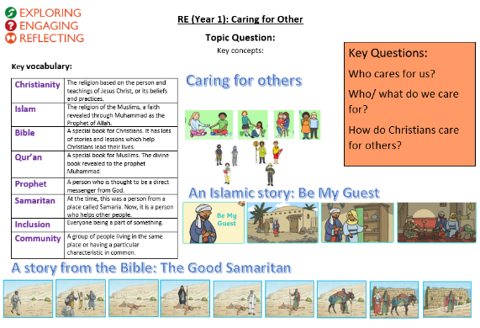

PE

Fundamental Movement Skills

- I can master basic movements including running, jumping, throwing and catching, as well as developing balance, agility and co-ordination, and begin to apply these in a range of activities
- I can participate in team games, developing simple tactics for attacking and defending
Geography

- I can understand geographical similarities and differences through studying the human and physical geography of a small area of the United Kingdom, and of a small area in a contrasting non-European country.
- I can use maps and globes.
- I can analyse a source of information that describes the features of a location.
- I can use aerial photographs to recognise landmarks and basic human and physical features.
- I can use simple fieldwork and observational skills to study the geography of our locality and the key human and physical features of its surrounding environment.

