History

Was there a happy ending to the Great Fire of London?

What were the positive and negative impacts of the Great Fire of London?
Reading

Do all characters experience the same ending?

Do all stories have a happy ending?

How do fair ytales and traditional tales compare?
Do they both have happy endings?
Writing
Year 1 – The Three Billy Goats Gruff
The goats have a happy ending and live in luscious grass. However, the troll lives a sad and miserable life without a happy ending.

Year 2 – Little Red Riding Hood
Little Red and granny live happily and the wolf goes hungry and sad.

To write an alternative ending where the characters experience a different ending (switch places).

Fire, Gun-Powder, Treason and Plot

Is there Always a Happy Ending?

PSHE

Do your choices always make a happy ending?
Do all friendships have a happy ending?
Does everyone enjoy school experience?
RE

Year 1:
Christian Text: Jesus’ first miracle – water into wine.
Islamic link: Ramadan

Year 2:
Christian Text: Jesus’ Birth

Do these stories have a happy ending?
How do these stories impact people’s understanding of happy ending?

The Christmas Story – was it a happy ending?

Reading

Book: The Three Billy Goats Gruff

Word reading:
- I can continue to apply phonic knowledge and skills as the route to decode words
- I can read accurately by blending the sounds in words that contain the graphemes taught so far
- I can read aloud books closely matched to their improving phonic knowledge

Comprehension:
- I can discuss the sequence of events in books and how items of information are related
- I can become increasingly familiar with and retelling a wider range of stories.
- I can check that the text makes sense to them as they read and correcting inaccurate reading
- I can make inferences on the basis of what is being said and done

VIPERS reading scheme:
- Vocabulary
- Infer
- Predict
- Explain
- Retrieve
- Sequence

Writing

Throughout the year, Year 1 will learn to –

- I can use regular plural noun suffixes –s or –es [for example, dog, dogs; wish, wishes], including the effects of these suffixes on the meaning of the noun
- I can use suffixes that can be added to verbs where no change is needed in the spelling of root words (e.g. helping, helped, helper)
- I understand how the prefix un– changes the meaning of verbs and adjectives [negation, for example, unkind, or undoing: untie the boat]
- I can combine to make sentences
- I can join words and joining clauses using and
- I can sequence sentences to form short narratives
- I can separate of words with spaces
- I can use capital letters, full stops, question marks and exclamation marks to demarcate sentences
- I can use capital letters for names and for the personal pronoun I

Maths

Addition and Subtraction
- I can find a part
- I can subtract (finding a part)
- I can recognise fact families
- I can subtract (how many left?)
- I can subtract on a number line
- I can add or subtract 1 or 2

Geometry
- I can recognise and name 3D shapes
- I can sort 3D shapes
- I can recognise and name 2D shapes
- I can sort 2D shapes
- I can make patterns with 2D shapes
- I can make patterns with 3D shapes

Consolidation of:
Place Value (1-10)
Addition and Subtraction
Geometry

Autumn 2

DT
Design :
- have own ideas
- explain what I want to do
- explain what my product is for, and how it will work
- use pictures and words to plan, begin to use models
- design a product for myself following design criteria
research similar existing products
Evaluate:
- talk about my work, linking it to what I was asked to do
- talk about existing products considering: use, materials, how they work, audience, where they might be used
- talk about existing products, and say what is and isn’t good
- talk about things that other people have made
- begin to talk about what could make product better
Food:
- describe textures
- wash hands & clean surfaces
- think of interesting ways to decorate food
- say where some foods come from, (i.e. plant or animal)
- describe differences between some food groups (i.e. sweet, vegetable etc.)
- discuss how fruit and vegetables are healthy
- cut, peel and grate safely, with support
Science
Over the duration of the year our science learning will be covered through planning in the moment opportunities.

We will cover:
- Animals including humans
- Plants
- Seasonal Change
- Everyday Materials

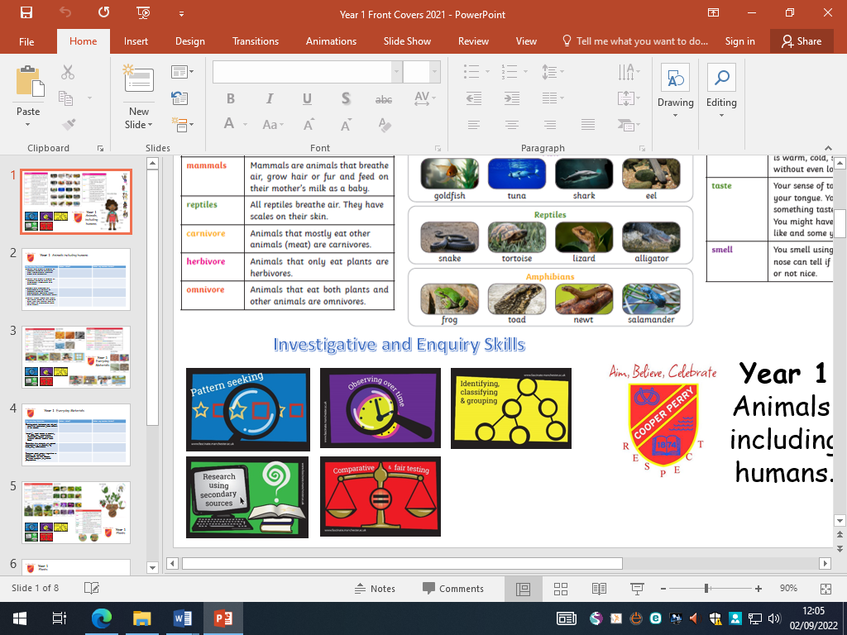

RE
Belonging

- Learners should be able to identify and describe groups people belong to and suggest why this might be important to people.
- Learners should be able to identify and describe ceremonies which are special to faith communities and suggest why they are important to believers.
- Learners should be able to link faith stories with beliefs, ceremonies and actions.
- Learners should be able to identify special ceremonies from their own experience and explore their own related feelings as well as those of others.

Music

Charanga: Rhythm In the Way we Walk

Listen and Appraise
- Rhythm in the Way We Walk by Joana Magona
- The Planets, Mars by Gustac Holst
- Tubular Bells by Mike Oldfield

Musical Activities
Learn and build upon knowledge and understanding of the interrelated dimensions of music.

Perform the Song
Learn the Banana Rap
PSHE

Me and My Relationships

I can recognise things which make us special and unique.
I can describe the range of groups they belong to.
I can recognise and respect similarities and differences between people.
I can describe types of families.
I can explain why families are special.
I can identify ways that families care for each other.
I can identify and describe a person who is special to them.
I can describe a good friend.
I can demonstrate skills to be a good friend.
I can recognise friendly and unfriendly behaviours.

Computing
- I can make marks on a screen and explain which tools I used
- I can draw lines on a screen and explain which tools I used
- I can use the paint tools to draw a picture
- I can make marks with the square and line tools
- I can use the shape and line tools effectively
- I can use the shape and line tools to recreate the work of an artist
- I can choose appropriate shape
- I can make appropriate colour choice
- I can create a picture in the style of an artist
- I know that different paint tools do different jobs
- I can choose appropriate paint tools and colours to recreate the work of an artist
- I can say which tools were helpful and why
- I can make dots of colour on the page
- I can change the colour and brush sizes
- I can use dots of colour to create a picture in the style of an artist on my own
- I can explain that pictures can be made in lots of different ways
- I can spot the differences between painting on a computer and on paper
- I can say whether I prefer painting using a computer or using paper

History

I can identify and define a source.
I can describe the past, using key words and phrases to refer to chronology, including: past, before, now, then and now.
I can describe features of the past, using evidence gathered from sources.
I can identify significant people and explain what they did in the past.
I can identify the different ways the past is represented.
I can analyse a source to find out about an element of the past.
I can question the past.
I can identify significant people and explain what they did in the past.
I can explain why people did the things they did.
I can compare and contrast photographs of people or events to identify differences in the ways of life.

PE

Netball

I can participate in team games.
I will be able to communicate effectively.
I can stop when they are holding the ball
I can chest pass the ball.
I can move when they are not holding the ball
I can shoot with some accuracy

