Maths
Choose 1 or 2 from the following each day before you complete the starter for that day.
https://www.bbc.co.uk/teach/supermovers/ks1-maths-the-2-times-table-with-bridget-the-lioness/zrrx92p
https://www.bbc.co.uk/teach/supermovers/ks1-maths-the-5-times-table/zhbm47h
https://www.bbc.co.uk/teach/supermovers/ks1-maths-the-10-times-table-with-webster-the-spider/zm32cqt
Times Table Rockstar
https://www.youtube.com/watch?v=9C4EN7mFHCk
https://www.youtube.com/watch?v=gfRVYPcfecE
https://www.topmarks.co.uk/maths-games/7-11-years/multiplication-and-division
Now complete these on your own.
You can just write the answers in your exercise book, no need to print.

Monday
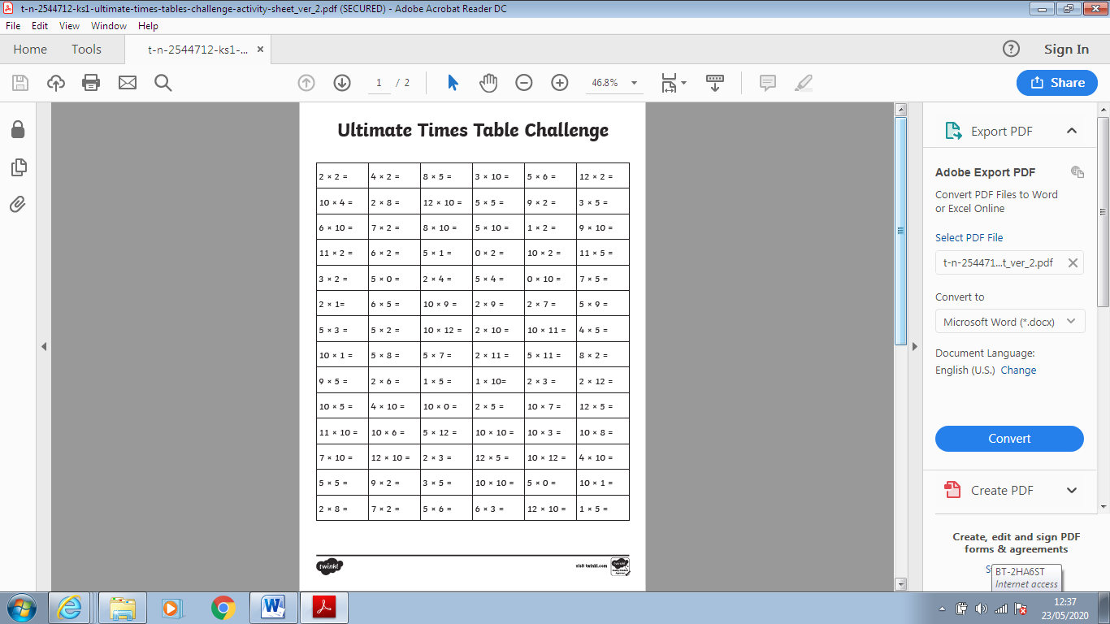

Tuesday

Wednesday
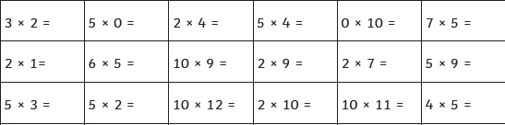

Thursday
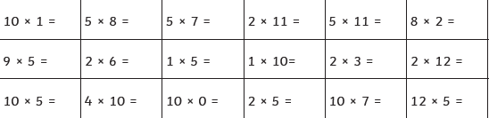

Friday


