English

Reading:
Continue reading your own books and quizzing on accelerated reader.
I’ve attached a couple more reading comprehension activities which you can either complete independently or with an adult.
Also visit: https://literacytrust.org.uk/family-zone/ for activities to support with reading at home.

Hand-writing:
Please continue to practice letter formation and begin joining when you are ready!

Spellings:
Continue to work through the lists on the class page. We are now in term 3a for those of you in group 2/3.

Information text writing:
I think anyone who has made it into space must be a pioneer!
Your task is to research at least one person who has travelled to space and find out why they are a pioneer and create an information text about them. I have attached an example information text as well as some key features for you to try to include.
I’d start by reading about your chosen person/people in books, watching videos online, and asking family members what they know.
Then plan out your report – what are the most important pieces of information that you must include?
Following that, write a first draft of your report and get an adult or older sibling to check it for you. Finally, re-draft your report – you could hand-write it, type it, create a Powerpoint, or present it on a video! The choice is yours.

Maths
You will need: a clock – ideally an analogue and digital clock as well as a stop-watch.
Time can be one of the most fun areas of maths to teach, and also one of the most frustrating!
Children, who are brilliant at number work, can find time very tricky; and those who find number work hard often thrive when it comes to telling the time.
These activities can be adapted to suit your child whatever their time telling ability. Generally time is taught in the following sequence:
- Learn to read O’clock time
- Learn to read half-past
- Learn to read quarter to and quarter past
- Learn to read the time to the nearest 5 minutes
 | Warm-up | Main activity | Extension tasks
Monday | Times Table Rockstars  Hit the Button – number bonds and double and halves. | To create a timetable of my day.  Create a timetable of your day at home. Draw clocks showing the different times things take place. Be as creative and adventurous as you like! | Can you also write the digital time for each event?
Tuesday | Times Table Rockstars  Hit the Button – number bonds and double and halves. | To make my own analogue clock.  Get crafty and make an analogue clock with moveable hands – you will then be able to use this to help you practice telling the time. | Make a sun-dial in the garden. (I know some of you have already tried this!)
Wednesday | Times Table Rockstars  Hit the Button – number bonds and double and halves. | To read the time on an analogue clock.  Use the clock you made to practice reading the time. Play time bingo – write or draw five different times down. Use the analogue clock to display different times. If it’s on your board, tick it off! | Throughout the day, stop and challenge your child to read the time. This is the best way to learn.
Thursday | Times Table Rockstars  Hit the Button – number bonds and double and halves. | To understand how to measure time.  Use a stop watch to measure how long it takes to complete different activities. I have attached a list of suggested activities but you could try your own. | Total the times: how long did it take to do two or three of the activities?
Friday | Times Table Rockstars  Hit the Button – number bonds and double and halves. | To understand how to measure longer periods of time.  Using the months of a year, create a family calendar of dates throughout the year that are important to you. You can choose how to present your calendar. | How many days/weeks/months are there between different events in the calendar?

I have attached some sheets you may wish to use to reinforce this learning.
Topic
Pioneers:
In keeping with your English research, your tasks this week are all space themed! Take you pick:
Make a galaxy in a globe!  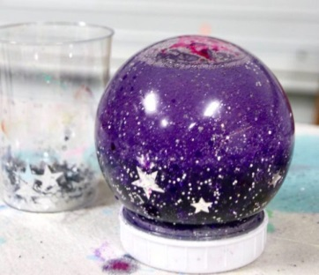 | Make an alien!  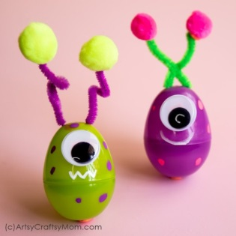 | Solar system bingo!  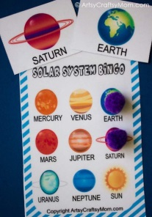
Make a rocket bookmark! 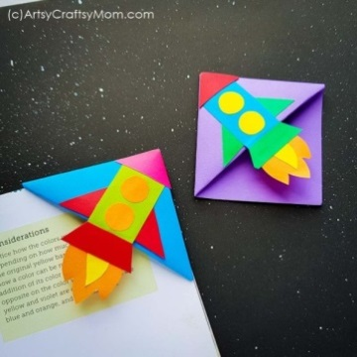 | Space sun catchers!   | A recycled CD planet!  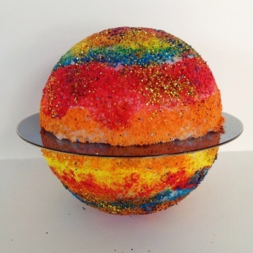
Create a simple rocket! 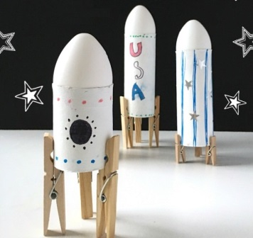 | A moon rock!  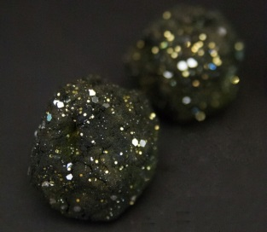 | Make a puzzle!  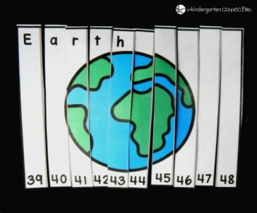
What about a space themed wreath! 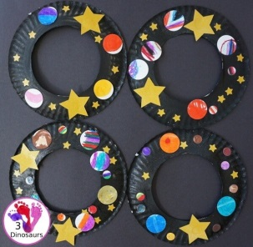 | A tin foil moon!  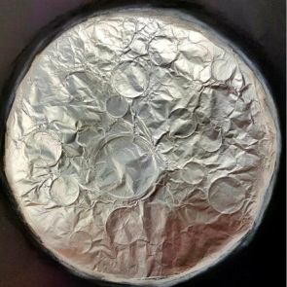 | Paper rocket craft!  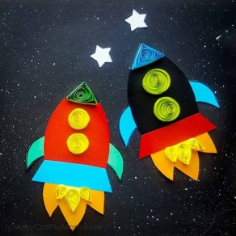
A space themed mobile!  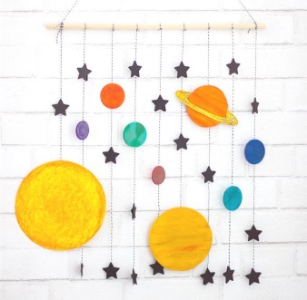 | Straw rockets!  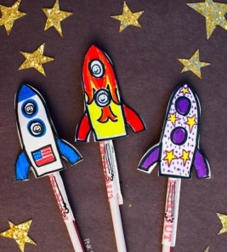 | Galaxy play-dough!  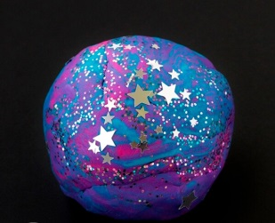
More aliens!  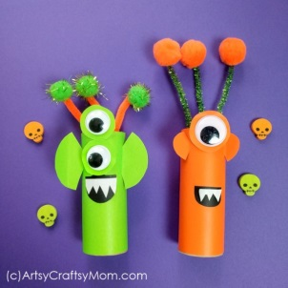 | Star constellations!  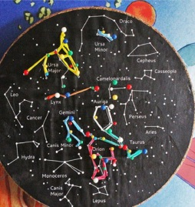 | Space shuttle!  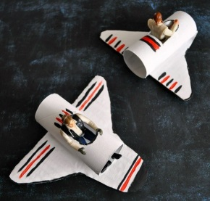
Outer space sensory bin!  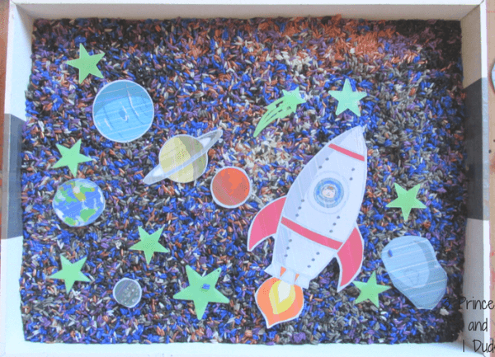 | Constellation cards!  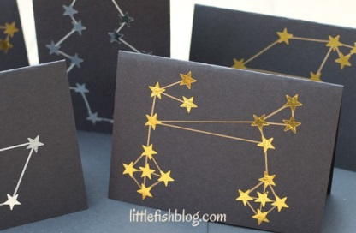 | Or something of your own imagining!
Find further instructions at: https://artsycraftsymom.com/outer-space-crafts-for-kids/

Science
These suggestions draw on different areas of science from the Year 2 curriculum.
Plants:
Explore how plants take up water. Place a stick of celery in different coloured cups of water and observe what happens over a couple of days.

Living things and their habitats:
Find out how camels are suited to living in deserts, and how polar bears are suited to living in cold temperatures.
https://www.bbc.co.uk/bitesize/clips/zchxpv4
https://www.bbc.co.uk/teach/class-clips-video/science-ks1-ks2-wonders-of-nature-polar-bears-in-their-habitat/z73ygwx

