Year 1 and 2 English
This week your task is to write a story.
Below is an idea of how to structure your story writing over the week.
Please see uploaded examples to help you.
Monday | - Plan your story  - Decide on the characters, setting, object, problem and resolution  Use the story planning sheet to help you.
Tuesday | - Write the beginning of your story
Wednesday | - Write the middle of your story
Thursday | - Write the end of your story
Friday | - Re-read and edit your work

Don’t’ know what to write a story about?
Here are a few ideas, you don’t have to use the examples given you can use your own ideas if your wish.
Characters
 | 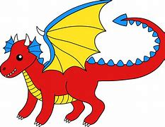 |  | 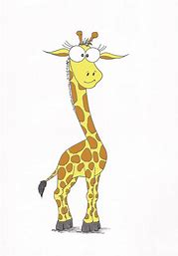 | 

Settings
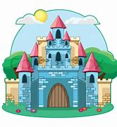 |  |  |  | 

Objects
 |  |  |  | 

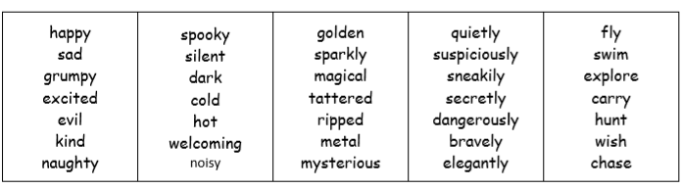
Interesting words

Be creative!
I look forward to reading all of your stories! 😊
Don’t forget to email me your work gharper@cooperperry.staffs.sch.uk

