English

Reading:
Continue reading your own books and quizzing on accelerated reader.
I’ve attached a couple more reading comprehension activities which you can either complete independently or with an adult.
Don’t forget to re-create a book cover and email it to me.

Hand-writing:
Please continue to practice letter formation and begin joining when you are ready!

Spellings:
Continue to work through the lists on the class page. Keep using the spelling ideas I shared last week.

Make a comic strip:
This week’s task is to produce a comic strip!
You should choose a character you love – this could be an existing superhero; a pioneer you have learnt about; or a character of your own creation.
How to create your comic strip:
- Create your characters – real or imagined.
- Brainstorm ideas
- Write and draw
- Review your comic
Watch this video to explain each step: https://www.youtube.com/watch?v=ufOXBuGhVWg
You can create your comic book however you want. You could draw and write by hand, or use an online platform to help you. You could take photos of people or toys and then edit the photos with text.
I have attached some templates you may choose to use as well as some activities on dialogue.
I’m looking forward to seeing what you create!

Maths
You will need: you will need to contact friends and family for their opinions!
 | Warm-up | Main activity | Extension tasks
Monday | Times Table Rockstars  Hit the Button – number bonds and double and halves. | To gather data and make a tally chart.  Be as creative as you like! You will need to contact as many people as possible to gather their data on your chosen topic e.g. favourite food, favourite thing to do in lockdown, favourite superhero. Record the results as a tally. | Discuss the data: which category was most/least popular? How many more people chose X than Y? How many people voted altogether?
Tuesday | Times Table Rockstars  Hit the Button – number bonds and double and halves. | To create a block diagram using data I have collected.  Using the tally chart you create, make a block diagram (similar to a bar chart). I have attached a template to help if needed. | Discuss the data:  What if we doubled or halved the number of people who voted? What if we asked people about…?
Wednesday | Times Table Rockstars  Hit the Button – number bonds and double and halves. | To create a real life pictogram.  Empty your sock drawer out and sort your socks into groups based on colour. Now lay them out in lines so you can compare the colours. This is a real life pictogram – each item must be the same size and spaced evenly. | Discuss the data.  What else could you use to create a real life pictogram?
Thursday | Times Table Rockstars  Hit the Button – number bonds and double and halves. | To create a pictogram.  Carry out a new survey – maybe do a traffic count on your daily walk; or sort your lego – how many blocks of each colour do you have? You could sort your books according to colours or author. Then draw your own pictogram to share your date – remember each picture must be the same size and spaced evenly. | Can you make on picture represent two items?
Friday | Times Table Rockstars  Hit the Button – number bonds and double and halves. | You can choose!  I’ve attached a statistics assessment to summarise some of this week’s learning.  I’ve also attached some outdoors maths challenge cards. | Create your own outdoor maths challenge.

Topic
Pioneers:
Create your own super-hero. They might be part of your comic strip for English.
Design their costume, give them a super power and don’t forget to name them!
Then try out some of these:
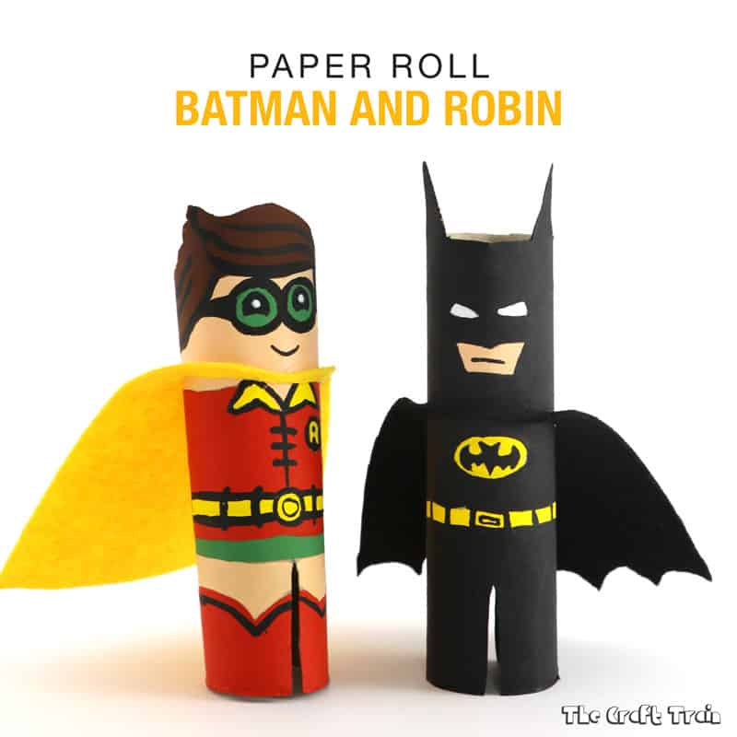  Loo roll heroes! | 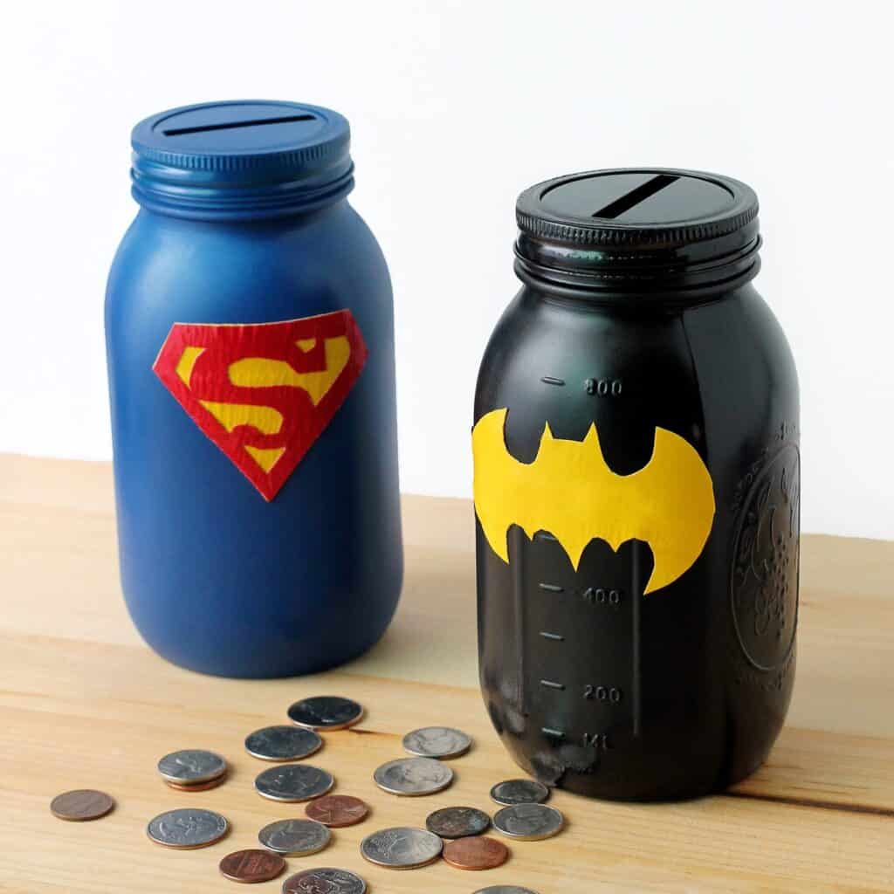  Super savings! | 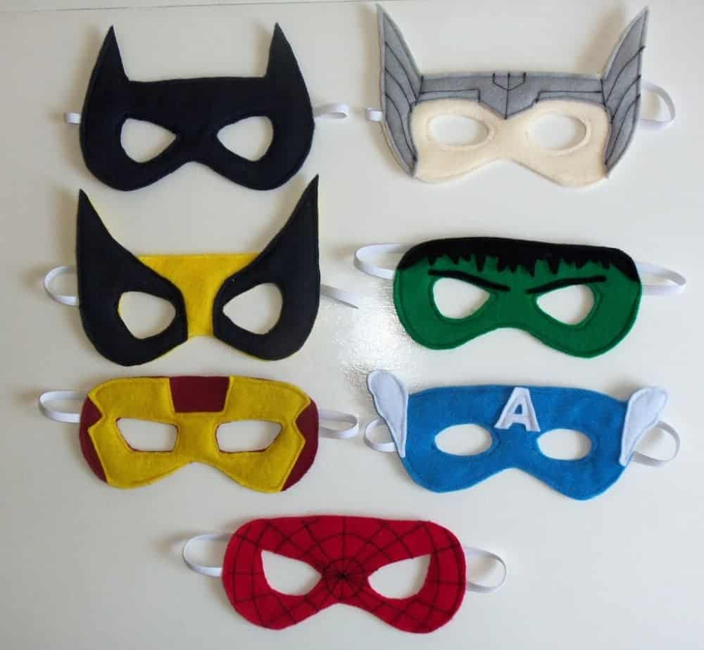  Who is behind the mask?
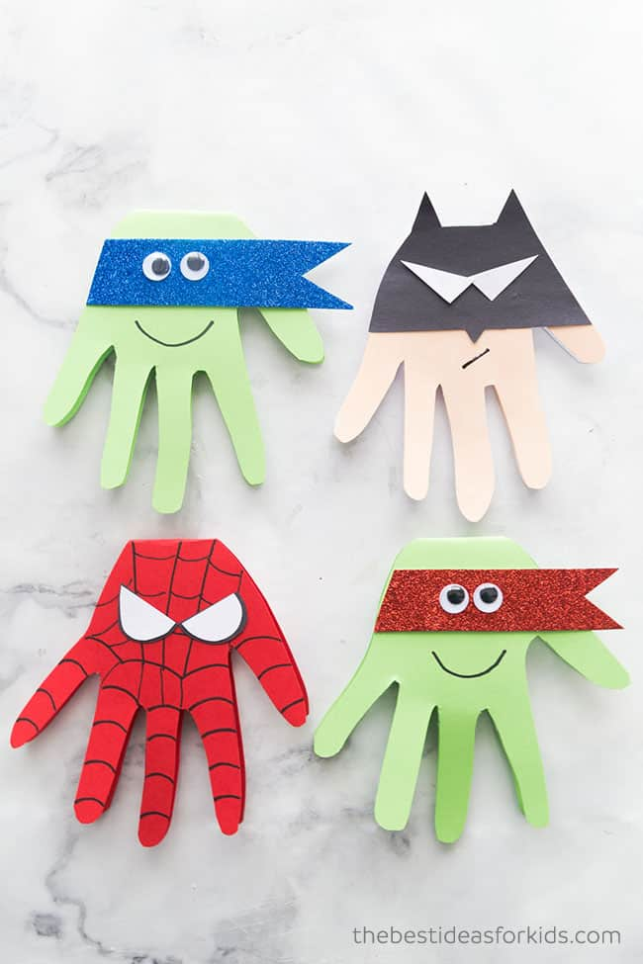  Heroic hand-prints! | 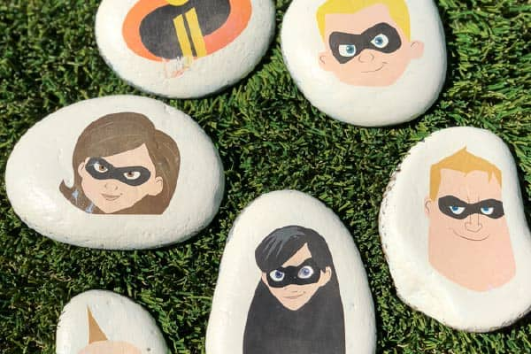  Super stones! | 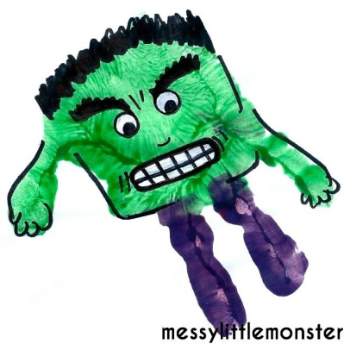  Hulk hand-prints!
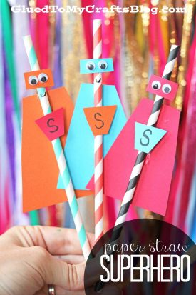  Super hero straws | 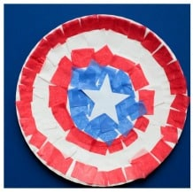  Shields! | 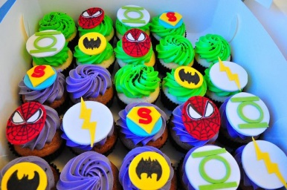  Cool cup cakes!

Science
These suggestions draw on different areas of science from the Year 2 curriculum.
Materials:
Try these reindeer rockets (you don’t have to make a reindeer!!)
Make sure you make predictions before you begin and then discuss what happened after.
https://youtu.be/BXLhKuyciHE
Once you have completed the experiment, you could write a set of instructions for others to follow.

