English
Continue reading, spelling and hand-writing practice. Then have a go at these shorter writing activities throughout the week:
 | Main activity | Extension tasks
Monday | Make a time capsule and write a letter about life in lockdown. | Get your family members to join in and write a letter too.
Tuesday | Scrap book poetry. Cut up old magazines or newspapers to make a poem:  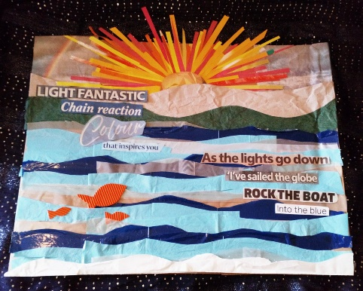 | Perform your poem aloud.
Wednesday | I have managed to get hold of some eggs and flour! Write out your favourite recipe for me to try at home. I’ll send photos of whatever I bake! | Try this recipe out, it’s one of my favourites:  https://bromabakery.com/copycat-levain-bakery-chocolate-chip-cookies/
Thursday | Black out poetry. Get a piece of writing from a newspaper or magazine. Black out all the words you don’t want. Leave a few to make a poem:  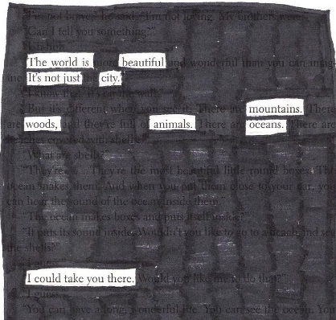 | Perform your poem aloud. Could you learn it off by heart too?
Friday | Hide something around the house.  Write a set of instructions for your family to follow to find what you have hidden! | Challenge your family to hide something for you to find using their instructions.

Maths
You will need: I’ve attached a handy parents’ guide. This week should be fairly practical again.
 | Warm-up | Main activity | Extension tasks
Monday | Times Table Rockstars  Hit the Button – number bonds and double and halves. | To use the language forwards, backwords, left, right, clockwise, anticlockwise to describe movement.  Use the map attached or create your own. Move a toy around the map using the above language. | Clockwise and anticlockwise will be new to the children. Explore which direction to turn by looking at a clock and turning yourselves, as well as your toy.
Tuesday | Times Table Rockstars  Hit the Button – number bonds and double and halves. | To turn a picture clockwise and anti-clockwise.  Draw a simple picture – or even better make a potato stamp. Practice recreating the picture by turning it a quarter clockwise or anti-clockwise.  Here is how it might look:  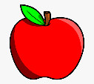 | Draw a picture and rotate it – can your child identify how many quarter turns clockwise or anticlockwise it has taken?
Wednesday | Times Table Rockstars  Hit the Button – number bonds and double and halves. | To use the language forwards, backwords, left, right, clockwise, anticlockwise to describe movement.  Set up an obstacle course outside (weather dependent). Blind fold a member of your family and direct them around it using the language you have been practising. | Let your family member direct you around the course – can you follow their instructions?
Thursday | Times Table Rockstars  Hit the Button – number bonds and double and halves. | To use compass directions to describe position.  Make your own compass to help you remember the position of the four compass points. Use it to direct your family members around the house! | Can you learn a rhyme to remember the compass points? Maybe you could make your own?
Friday | Times Table Rockstars  Hit the Button – number bonds and double and halves. | To use compass directions to describe position.  Draw a treasure map – or use the ones attached – and describe the position of different images using the four compass points. | What is the point between north and west? Or between south and east? Add these to the compass you made yesterday.

Topic
Pioneers:
It’s your chance to be a pioneer!
Think about the people you have learnt about and the things they did to change the world or make things better. Some of the things they did were for fun, some were more serious.
Your task is to pioneer your own creation. Here are some ideas:
Re-write the words to your favourite song and record your performance! | Create another Rube Goldberg machine – but name it after yourself! | Design or make a robot to help solve a problem to do with lock-down.
Create a self-portrait to celebrate what makes your special. | Create a dance or gymnastics routine and record your performance. | Can you make a short film?  Try a stop motion animation film.
Invent a new recipe! You can only use ingredients in your house – you can’t go out and buy anything extra! | Design and make a new board game. | Write a quiz to play with your friends and family over video chat.
Create your own map of where you live with everything that is important to you on it. | Write to the Prime Minister telling him about what you want to see changed. | Set up a food bank collection point outside your house.
Make cards to send to your local care home or key workers. Put a smile on their face! | Set me a challenge. I promise I’ll try to complete them! | Do something to raise money for a charity of your choice. Why not team up with some of your class mates or family to make the challenge as big as possible!

Science
These suggestions draw on different areas of science from the Year 2 curriculum.
Plants:
We had lots of plants growing in our classroom and I didn’t manage to rescue them all. Draw what you think will have happened to them. Can you explain why they might look this way?

Materials:
Have a go at making a shadow message. Think carefully about the lettering and which direction to hold your sign so that it can be read.



