English

Reading:
Continue reading your own books and quizzing on accelerated reader.
I’ve attached a couple more reading comprehension activities which you can either complete independently or with an adult.
Also visit: https://literacytrust.org.uk/family-zone/ for activities to support with reading at home.

Hand-writing:
Please continue to practice letter formation and begin joining when you are ready!

Spellings:
Continue to work through the lists on the class page. I have attached a document with some spelling games which you might like to try out.

Letter writing:
Year two spent six weeks looking at letter writing having read The Day the Crayons Quit – so are pretty much experts now!
The task this week, is to choose a pioneer and write a letter to them.
Who to pick? The choice is yours – pick someone who you have an interest in. Perhaps think about a significant musician or band who are pioneers in their own field. Or an actor or artist. You could choose a significant sports-person – perhaps someone who holds a world record. Or how about an author?
What to write? Structure the letter into three sections:
- Explain why you are writing.
- Tell them why you admire them.
- Ask them some questions about what they do.
If you are writing to someone living, find an address and post your letter!
I’ve attached some letter writing prompts to help you out.

Maths
You will need: coins (real or pretend), items to make a shop with.
You may find you cover several of the objectives in one go if you play shops. I have added some sheets to re-inforce the focus of each day.
*When picking prices for your shop, most children are confident with working with numbers 0-100 – but they may not yet be confident with adding amounts that total more than 100. For those children who find maths harder stick to numbers 1-20. And for those who are very capable mathematicians go for amounts over £1.00.
 | Warm-up | Main activity | Extension tasks
Monday | Times Table Rockstars  Hit the Button – number bonds and double and halves. | To make an amount using different coins.  Using coins if possible – how many different ways can you make an amount of money? E.g. 10p can be made using ten 1p coins; five 2p coins; two 5p coins; one 10p coin – or a mixture of 1p, 2p and 5p coins. | Can you make 75p using only silver coins?  Can you make 50p using only three coins?  Make 45p using the fewest possible coins.
Tuesday | Times Table Rockstars  Hit the Button – number bonds and double and halves. | To use coins to make different amounts.  Set up a shop at home – a food-shop, toy-shop, clothes shop – you pick! Label items with prices.*  Using coins if possible, children must pay for items using the exact amount. | If you only have 10p left, how much more would you need to buy…?
Wednesday | Times Table Rockstars  Hit the Button – number bonds and double and halves. | To add amounts of money.  Continuing to use your shop, buy more than one item at a time. Here is how we have learnt to add:  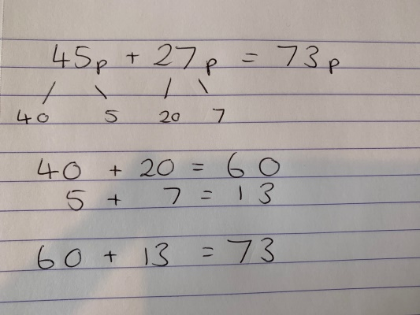 | SALE! What would your prices be if all the even prices were halved?
Thursday | Times Table Rockstars  Hit the Button – number bonds and double and halves. | To find change.  Again, you will need to use your shop – or make a new one!  This time, the focus is on finding change. If you pick at item that costs 35p but only have a 50p coin, how much change will you get? Here is how we have learnt to subtract numbers within 100:  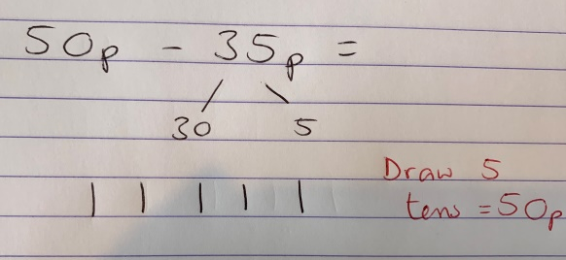  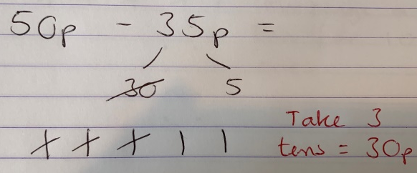  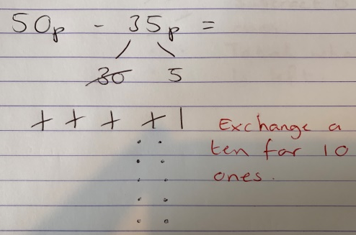  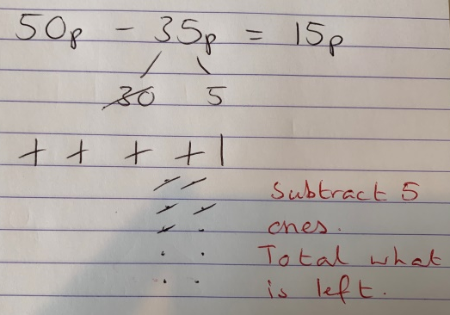 | Choose two or more items to buy. Total their cost first and then calculate change.
Friday | Times Table Rockstars  Hit the Button – number bonds and double and halves. | To solve problems involving money.  Use the problem solving cards. Use coins to solve them if you can. The stars show you the level of challenge.  * easier  ** medium  *** harder | Write your own money based problem.

Topic
Pioneers:
Famous people often have their portrait painted, or a sculpture made of them. This is so we can remember them and celebrate their success.
Choose someone to create a portrait or sculpture of. It could be the person you choose to write to, or someone else you admire.
Here are some ideas to get you started. I can’t wait to see what you come up with!

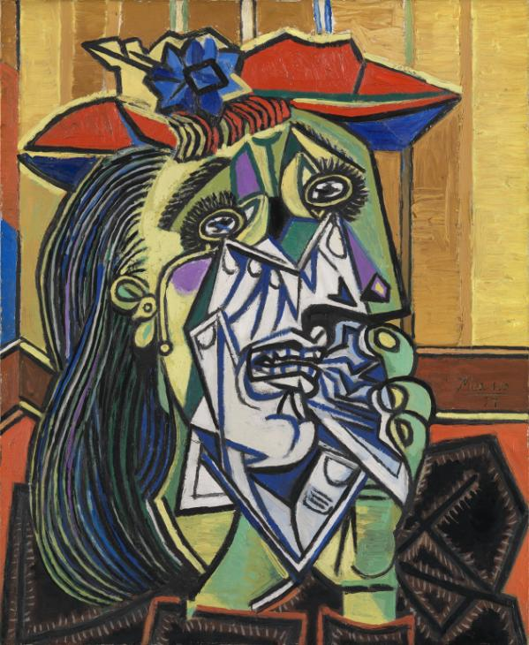  A Picasso themed portrait! | 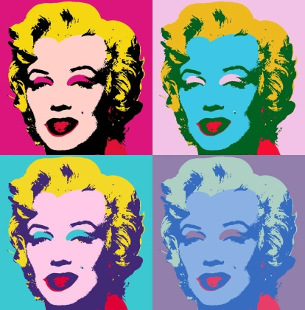  An Andy Warhol pop art portrait! | 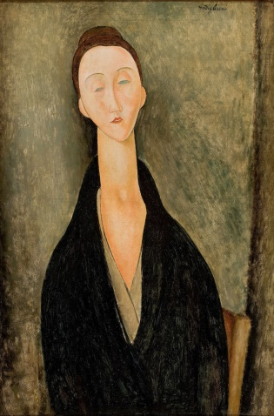  A Modigliani portrait – long necks and faces!
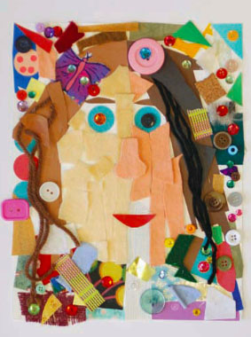  Collage a portrait! | 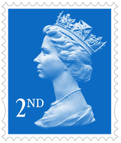  Put someone’s picture on a stamp! | 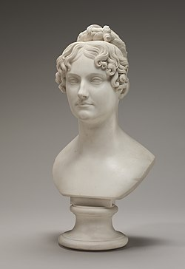  Can you sculpt someone?!

Science
These suggestions draw on different areas of science from the Year 2 curriculum.
Plants:
I had a photo of a very healthy bean plant this week – keep caring for your plants. Photograph them or drat them to keep a record of how they grow.

Living things and their habitats:
If you made a bug hotel, carry out some observations. Has anything moved it yet? What else could you do to attract wildlife?

Materials:
Invisible ink! Try this out:
You will need:
- Half a lemon
- Water
- Spoon and bowl
- Cotton bud
- White paper
- A lamp
Instructions:
- Squeeze some lemon juice into the bowl and add a few drops of water.
- Mix the water and lemon juice with the spoon.
- Dip the cotton bud into the mixture and write a message onto the white paper.
- Wait for the juice to dry so it becomes completely invisible.
- When you are ready to read your secret message or show it to someone else, heat the paper by holding it close to a light bulb.

