We have been continuing with the x2 tables this week. Have you got faster?
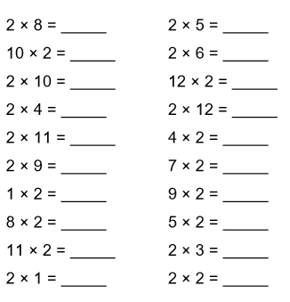
We have been continuing with the x2 tables this week. Have you got faster?

