We have spent a week on x5 tables. How fast will you be?
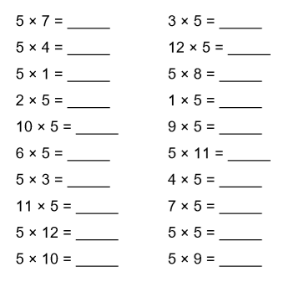
Time Taken: __________________

We have spent a week on x5 tables. How fast will you be?
Time Taken: __________________

