This week we have been learning the two times tables.
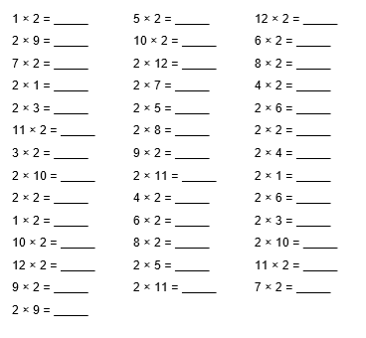
Time Taken:
This week we have been learning the two times tables.
Time Taken:

