We will be moving on to x5 tables next week. How fast will you be?
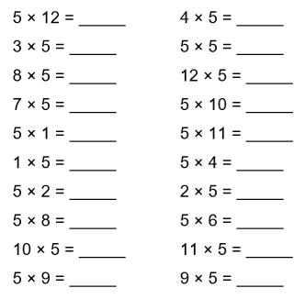
Time Taken: __________________

We will be moving on to x5 tables next week. How fast will you be?
Time Taken: __________________

